PROBLEMS
A nuclear war could:
- Destroy much of planet earth
- Kill billions of people
- Contaminate everything with deadly radiation
- Blow ash and dust into the stratosphere and block out the sun for years, preventing any plants from growing, and causing “nuclear winter” that would kill nearly everything
For these reasons – and because of the worsening climate crisis – the Bulletin of the Atomic Scientists set the “Doomsday Clock at only 90 seconds to midnight – the closest it has been since 1953.
A huge number of experts – scientists, top-level military professionals and diplomats, and well-informed laypeople – are alarmed that our survival is in extreme danger from nuclear weapons. Nuclear weapons are not reasonable and not practical. But most politicians and news media think it’s not realistic to abolish nuclear weapons. Most Americans are not even paying attention!
For decades the U.S. has had a policy of launching nuclear weapons in a “first-strike” to start a nuclear war. The U.S. designed, built and deployed nuclear weapons to do exactly that. We must stop the madness!
The Constitution says only Congress can declare war, but since 1945 every president has had his finger on “the button” and could unilaterally start a nuclear war and destroy everything on earth.
SOLUTIONS
Well informed people have been urging solutions at the federal level AND organizing at the grassroots level to ABOLISH nuclear weapons – and to reduce the risks in some strategically smart ways even before we abolish them entirely.
People have organized opposition to nuclear weapons from 1945 to the present. Historian Lawrence Wittner researched that and found that when people are quiet the nuclear dangers increase, but when we organize opposition we push the governments back and reduce the dangers. See his book Confronting the Bomb for solid information and encouragement.
In 2017 the United Nations General Assembly approved the Treaty on the Prohibition of Nuclear Weapons” (TPNW) by an overwhelming majority (122 of the UN’s 193 member states). By June 2022, 62 nations have ratified the Treaty, so they are updating their national laws to prohibit the possession, development, testing, use and threat of use of nuclear weapons. We urge all other nations – including the U.S. and the 8 other nuclear nations – to ratify this treaty and ABOLISH ALL nuclear weapons worldwide!
The Olympia Coalition to Abolish Nuclear Weapons – and our statewide coalition, Washington Against Nuclear Weapons (www.wanwcoalition.org) – have been working to stop bad legislation and to promote good legislation at Congress. We oppose provocative new weapons. We urge “No First Use” legislation. See this brochure’s center back panel and contact us for more information.
SMART LOCAL ACTIVITIES
Since our founding in May 2017, the Olympia Coalition to Abolish Nuclear Weapons has organized and accomplished many strategically smart activities, such as:
- Holding a gigantic banner on an I-5 overpass over I-5 nearly every week. (See photo on back of page)
- Staffing information tables
- Gathering signatures on relevant petitions
- Meeting with staffers of our U.S. House and Senate members
- Convincing Olympia City Council to pass a resolution opposing nuclear weapons
- Dealing with relevant state legislation
- Showing several relevant films and facilitating community discussions
- Organizing a public celebration of the 2017 Nobel Peace Prize awarded to the global organization (www.icanw.org) that convinced the U.N. General Assembly to approve the TPNW and a celebration of TPNW’s first anniversary in January 2022. (See previous column).
- Conducting speaking engagements in many public places and through computer video methods
- Conducting a highly informative and inspiring 4-part online course ten times for people nationwide and worldwide
- Producing and airing TV programs about the current nuclear crisis
- Sharing information through our e-mail list
- Meeting every month to accomplish even more. Please join us!
We hold this banner on an overpass over I-5 in Olympia for one hour every week. Many motorists honk and wave their support! The public is on our side! We need your help to increase our outreach and build a stronger grassroots movement!

We set up this display in the Olympia Timberland Library for a full month in early 2018 as part of our outreach:
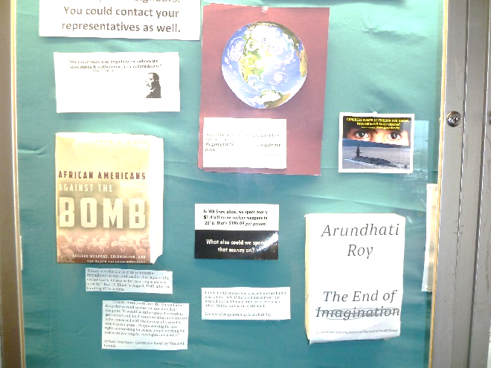
More volunteers will help us increase our vigorous outreach activities.
Please join us!
JOIN US!
The Olympia Coalition to Abolish Nuclear Weapons includes many individuals and several local organizations. We meet every month (using Zoom during the pandemic). We welcome new people. We continually organize and carry out a variety of strategically smart local activities.
Olympia Coalition to Abolish Nuclear Weapons
(360) 491-9093 glen@parallaxperspectives.org
Our coalition includes these members:
Fellowship of Reconciliation’s Olympia chapter
(360) 561-3627
Veterans for Peace’s Olympia chapter #109
(360) 357-1060 vfp109@protonmail.com
www.vfp109.com
Green Party of South Puget Sound
Contact Pat at 360-951-9538
facebook.com/groups/gpsp
twitter.com/GreenPartySPS
Rachel Corrie Foundation for Peace and Justice
(360) 754-3998
www.rachelcorriefoundation.org
Olympia Friends Meeting (Quaker congregation)
(360) 754-4028 www.olympiafriends.org
We invite more individuals and organizations to join us!
We are an active member of this statewide coalition:
Washington Against Nuclear Weapons
(206) 547-2630 www.wanwcoalition.org
See information posted at the Nuclear Weapons
part of www.parallaxperspectives.org
Let’s work together to abolish nuclear weapons!

Olympia Coalition
to Abolish
Nuclear Weapons

We work in a variety of strategically useful ways in the Olympia area and also as part of a statewide coalition.

To contact us, see the middle of the back page.
We look forward to connecting with you!

