“Glen’s Parallax Perspectives” is a series of TV programs offering fresh ways for people to see issues such as foreign policy, social and economic justice, the environment, governmental functioning, and so forth. We provide voices and viewpoints that are rarely heard in mainstream media.
Mainstream media, politicians, and culture see the world in conventional ways. Therefore, in order to solve problems, we need to see things in fresh ways. Glen Anderson created this TV series to help people see things differently so we can solve problems at all levels from the local to the global.
This series title refers to “parallax,” which is the view you get by looking from a different perspective. For example, put one finger in front of your nose and another finger farther away. Close one eye. Then open that eye and close the other. Your fingers will seem to move. This is called a “parallax” view. This TV series invites you to look at issues from fresh perspectives.

Each program airs three times a week (currently every Monday at 1:30 pm, every Wednesday at 5:00 pm, and every Thursday at 9:00 pm) for the entire month on Thurston Community Television (TCTV), channel 22 for cable TV subscribers in Thurston County, Washington. TCTV is part of Thurston County Media. You can see their schedule at www.tcmedia.org
You can also watch the program summarized below through your computer at www.parallaxperspectives.org. All episodes of “Glen’s Parallax Perspectives” are posted on this blog’s “TV Programs” part and also in one or more of the categories listed in the right side of the blog home page. Also, see information about various issues at the category headings at www.parallaxperspectives.org.
Glen Anderson (360) 491-9093 glen@parallaxperspectives.org
This document provides a little more information than we could squeeze into the one-hour TV program. I encourage people to watch the interview and also to read this document for additional information and links to more sources of information. This document ends with a great list of sources of information.
I saved this document in Word format with live links. If this document does not load or print properly for you, please e-mail me at glen@parallaxperspectives.org and I’ll promptly send you the links you request.
Please invite other people to watch this video and/or read this thorough summary through these parts of my blog, www.parallaxperspectives.org, including the categories for “TV Programs” and “Middle East” and “Peace.”

“Israel and Palestine: Background and Context”

Glen’s Parallax Perspectives TV Series

December 2023

Glen Anderson (360) 491-9093 glen@parallaxperspectives.org

Glen welcomed viewers and introduced this month’s topic and guests:

Glen said this month’s interview in the “Glen’s Parallax Perspectives” series provides important background and context for the crisis of violence in Israel and Palestine that is going on at the end of 2023.
The American people are alarmed by the news, but very few people understand the background and context in which the current violence arose. If we understand that, we can urge our government to take actions that are smarter and more humane than what our government is doing now.
He said that several times every week for many years he has been holding hold signs in downtown Olympia. His signs call for peace and human rights. He showed on the screen two examples:
We all share
one earth

All people are one
human family
The first sign: If the American people and our government understood this, we would have a better foreign policy.
The second sign: We should not let anyone – no politician or anyone else – divide us from each other based on differences in nationality, race, religion, sexual orientation, or any other demographic variable. If we understand that all people are one human family, then we can live together peacefully and respect every person’s human rights.
He said he wants the American people – and our government – to support these profound values. He wants these values to guide how the U.S. interacts with other nations around the world.
The TV program you are watching now opposes violence on all sides. We oppose war crimes. We need a ceasefire to stop all of the violence now. We want to protect all civilians. We need to be even-handed and hold all political entities to the same humane, nonviolent standards.
He said that during this hour we will explain clearly that we cannot merely return to the status quo from before Hamas attacked Israel on October 7, 2023. We must solve the underlying problems.
He introduced and welcomed two exceptionally well-informed guests who helped us explore this topic during the TV interview:
- Cindy Corrie is very active in the Rachel Corrie Foundation for Peace and Justice. She has studied extensively, visited the region many times, and interacted with many people there.
- Larry Mosqueda, Ph.D., also has studied the issues extensively, visited the region, and taught about Israel and Palestine at the college level.

The problem did not start on October 7, 2023.
Hamas’s attack was not “unprovoked.”

Glen said that in order to help our TV viewers understand what is happening in the region, he showed on the TV screen a map of where Israel and Palestine are located.
You can see these small geographical areas at the eastern edge of the Mediterranean Sea south of Turkey and northeast of Egypt:
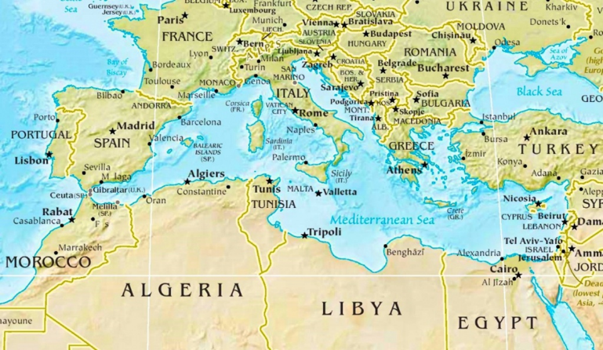
Next he showed this map of the State of Palestine, which shares borders with Israel:
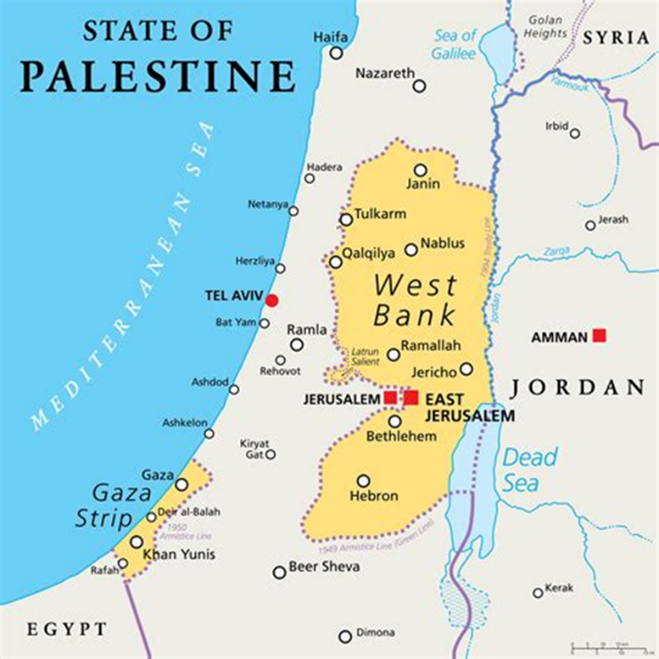
You can see the current area of conflict – Gaza – in the SW, near Egypt. You also can see the West Bank of the Jordan River. We discussed this too during this interview.

People have lived in this area for many thousands of years. In just a moment Cindy will mention just a bit of that history. But first, Larry summarized some of the context from the past 75 years.
Larry said that even if we don’t know exactly what has happened in the past 24 hours or the past few days, we do know what has happened in the past 75 years since the state of Israel was created.
In 1948 when the state of Israel was created, another thing that happened is referred to as the Nakba. This word means “catastrophe,” and he said even some Israeli officials have ben using that word lately. That political event was a catastrophe for the people of Palestine. He said some extremists in Israel’s government are calling for a second Nakba to occur.
He said that in 1948 Jewish people were a minority of the total number of people living in what is now the greater Israel area. He said that in the Six-Day War of 1967, Israel’s military took over Egypt’s Sinai area and parts of Jordan and Syria. He said that Israel is one of very few “advanced” nations that does not have firm borders yet. Borders with Egypt and Jordan have been negotiated, but not yet with Lebanon or Syria. He described Israel as an expansionist settler colony state.
He said the “occupied territories” of the West Bank and Gaza are illegal. He said even the United Nations uses the term “occupied territories.” He said about half of the people in the West Bank are Palestinians.
Glen said that international law specifies that when two countries are at war and one country conquers part of the other country, it is illegal under international law to move people from the conquering nation into the newly conquered land and settle there. But this is exactly what the government of Israel has done to Palestinian lands it has conquered by deliberately moving Israeli settlers to build homes there.

We did not have time to say these facts now on TV, but we did say some of this later in the interview:
The roots of the current conflict started long before October 7, 2023. Nor was this “unprovoked” as the mainstream media would have us believe. 2023 is the 75th anniversary of the violent creation of the state of Israel. Palestinians and much of the world call this event the “Nakba” or “The Catastrophe.”
For 75 years Israel’s government has been taking lands away from Palestinian people and oppressing them. Israel has been militarily occupying the West Bank and Gaza since 1967. The siege and control of Gaza have been horrendous for the past 16 years.
The UN has been tracking deaths in the conflict. Data from 2008-2020 show 5590 Palestinian deaths and 251 Israeli deaths.

Gaza’s early history:

Glen said that when he posts this video to his blog, he will post a document (which you are reading now) with links to many sources of information, including a Wikipedia post that very thoroughly explains Palestine’s history over thousands of years. To dig deeply into that long history, see this: https://en.wikipedia.org/wiki/History_of_Palestine
The area most in conflict now is Gaza. For this TV interview, he asked Cindy to summarize briefly some of Gaza’s early history.
Cindy said people have lived in Gaza for thousands of years. Its geographical location near the Mediterranean Sea and the intersections of Mediterranean nations, Asia and Africa has meant that a huge amount of trade passed through there and maritime shipping was significant.
Gaza’s location and prominence also caused it to be conquered over and over again by various empires, including Romans, Mongols, and even Napoleon. She said Gaza has experienced conflict and war throughout its history.
Christianity was brought to Gaza, and some Palestinians are Christians nowadays. She said that when she and Larry visited the area in 2009 she met with a Christian pastor who was a refugee from 1948 when he was only about seven years old. He told her that only once was he and his family able to return to Haifa (inside Israel), where his family had come from. He said he remembered visiting the house that had been taken from them, and his mother connected with the Jewish woman who lived next door there, and they fell into each other’s arms and wept about what had happened in 1947-1949.

She said after Christianity had been introduced in Gaza, Islamic conquerors arrived. It became the dominant religion, and Arabic became the dominant language. These have remained.

She said that Gaza was part of the Ottoman Empire from the 1500s until the end of World War I.

When World War I was ending, Britain was dominant there, and the Balfour Declaration laid out a different future to replace the Ottoman Empire. Arthur Balfour, the United Kingdom’s foreign secretary, devised this as a promise to create a Jewish nation in order to encourage Zionist Jews in the UK, the U.S., and elsewhere to support World War I. (See Wikipedia’s explanation at this link: https://en.wikipedia.org/wiki/Balfour_Declaration). Balfour’s promise laid the groundwork for what developed in the 1940s.

Glen said when Cindy mentioned the Ottoman Empire, he wanted viewers to know that it was based in Turkey. This region has been a crossroads of many, many militaries passing through and occupying places from time to time.

He said that he understands that the ordinary local people who lived there got along with each other just fine; the problems came from external forces that conquered and dominated them. He said that the local neighbors got along OK without being disrupted by artificial divisions inserted to mess things up.

What happened in 1947-1948?

Glen said that a moment ago, Larry had mentioned the creation of the State of Israel about 75 years ago. This was very disruptive to the Palestinian people, the indigenous people whose lands were taken away from them by the new nation of Israel.
When we were preparing for this TV interview, Cindy told me that in 1948 many Palestinian who lost their lands became refugees fleeing to Gaza.
Glen said the massive disruption that occurred from 1947 to 1949 is called the Nakba, which means “catastrophe.” Wikipedia defines it as “the violent displacement and dispossession of Palestinians, and the destruction of their society, culture, identity, political rights, and national aspirations.” Wikipedia says this is ongoing, even though most Americans do not know about the Nakba. This Wikipedia link provides more information: https://en.wikipedia.org/wiki/Nakba Glen thanked Cindy and Larry for telling us about during this TV interview.

1967 6-Day War:

In 1967 a war occurred for 6 days. It has become known as “the 6-Day War.” This made the problems we are discussing even worse. When we were preparing for this TV interview, Cindy told Glen that many Palestinian people fled to Gaza as refugees from lands conquered by Israel’s military. We did not have time to discuss this during the TV interview. People can research this from reliable sources.

Israel’s government and settlers have been stealing Palestinian lands.
See maps of shrinking Palestinian lands – and expanding “Occupied Territories.”
Glen said that for three-fourths of a century now, the government of Israel has been allowing Israeli settlers to steal land from the indigenous Palestinian people. Israel has been occupying Palestinian areas that have recently been commonly referred to as the “Occupied Territories.” He showed this map of how much Israel has shrunk Palestine from 1946 to 2012:
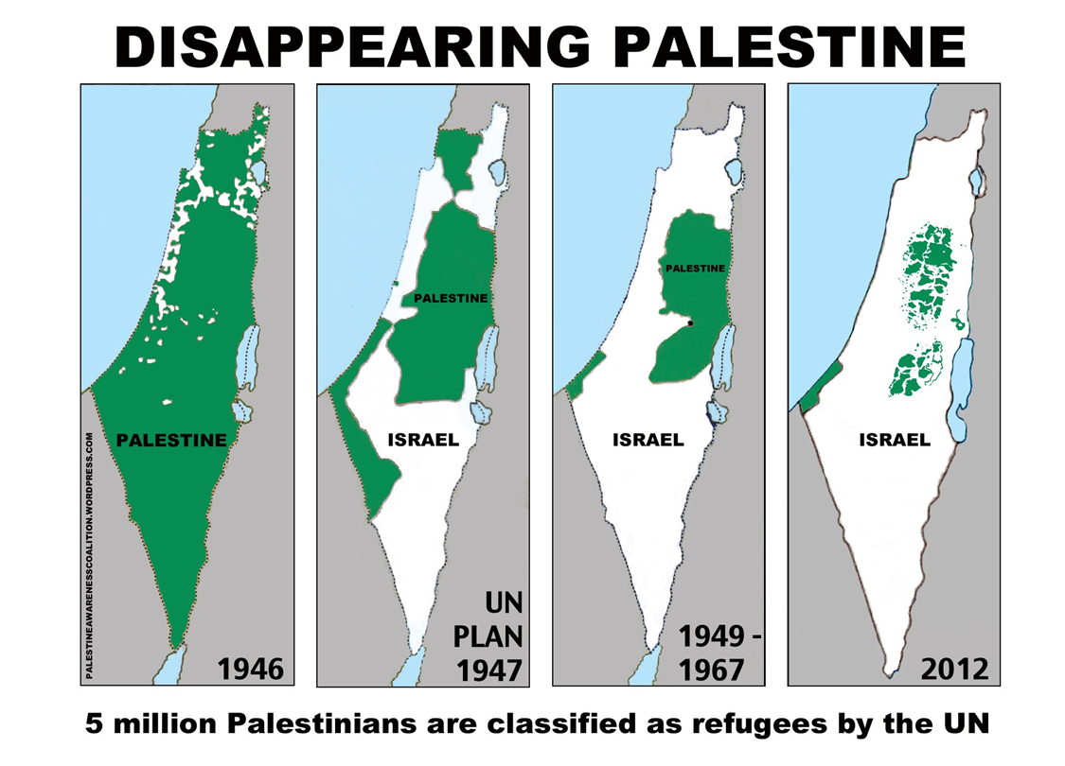

Glen said Israel’s government has stolen land from Palestinian people and aggressively helped settlers build their own houses on lands stolen from Palestinians. Israel’s government also supports the settlers’ violent attacks upon Palestinian people in these occupied territories.
He showed this map of Israeli settlements in 2020. In the middle of this image, the dark blue shows Israel. The subset on this image’s right side shows green Palestinian areas that are actually occupied by Israel and more than 250 red dots showing Israeli settlements and outposts on the West Bank. He repeated that international law prohibits a conquering nation from settling its people on lands that its military has conquered. He said the American people do not know this important background for the current – and ongoing – crisis in that region.

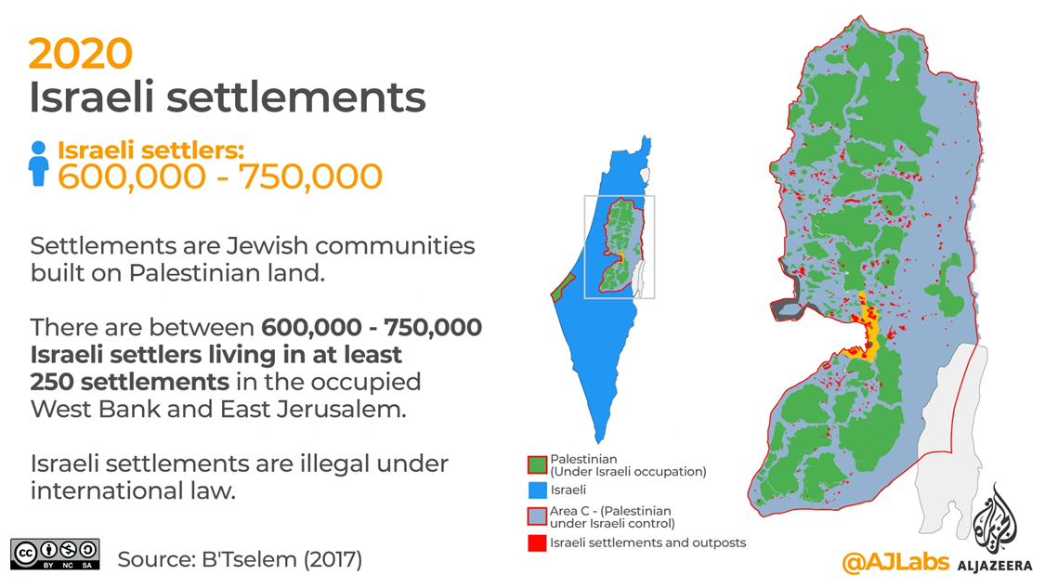

The First Intifada (1987-1993) and beyond:

Glen said two important movements of Palestinian people acting boldly to assert their rights were known as “intifadas.” The word intifada means rising up and shaking off to stop oppression in Gaza and in the West Bank area west of the Jordan River. The First Intifada continued from 1987 to 1993. Nearly all of those activities were nonviolent. The Second Intifada ran from 2000 to 2005. A few of those activities included some violence.
Cindy added that the First Intifada was very creative and largely nonviolent. She said everybody became engaged with it. She said the first time she and her husband Craig traveled to the region they spent some time in a town near Bethlehem. They were with one of the founders of the International Solidarity Movement, which is the nonviolent movement that their daughter Rachel volunteered with in Rafah, Gaza. That person invited them to lunch at his family’s home, where they also met his family.
Cindy said later she read a book about what women in that area of the Occupied West Bank were doing during the First Intifada. A photo in that book showed that family’s mother when she was much younger. At that time she had a sewing shop. The First Intifada included various kinds of nonviolent resistance against the occupation. For example, many Palestinian businesses were refusing to pay taxes that would fund Israel’s occupation of their lands. Israel’s military retaliated against her nonviolent refusal to pay taxes by invading her sewing shop and destroying pretty much everything. This occurred about twenty years before Cindy and Craig met her.

Larry provided these links to information about the First Intifada, Oslo Accords and the State of Palestine:
- Main articles: First Intifada and Oslo Accords
- From 1987 to 1993, the First Palestinian Intifada against Israel took place. Attempts at the Israeli–Palestinian peace process were made at the Madrid Conference of 1991.
- Following the historic 1993 Oslo Peace Accords between Palestinians and Israel (the “Oslo Accords”), which gave the Palestinians limited self-rule in some parts of the occupied territories through the Palestinian Authority, and other detailed negotiations, proposals for a Palestinian state gained momentum. They were soon followed in 1993 by the Israel–Jordan peace treaty.

The Second Intifada (2000-2005) – and Jimmy Carter’s criticism of Apartheid:

Cindy said the Second Intifada included more violence – including some suicide bombings.
She and her husband Craig have made five trips to the region, including one in 2003 while the Second Intifada was underway. When we were preparing on the phone for this interview, Cindy told Glen that when they traveled within the region, they were repeatedly obstructed by many checkpoints set up by Israel’s military. She told him that at that time there were about 21 or 22 Israeli settlements in Gaza. At that time, the settlements took up about 40% of the land there.
Glen said that when we were preparing for this TV interview, Larry had said that in 2007 Jimmy Carter wrote a book titled, Palestine: Peace Not Apartheid. In 2007 many people criticized Jimmy Carter for saying the oppression there really was apartheid. We remember how cruel South Africa’s white racist government was in oppressing its Black majority. Israel’s current oppression of Palestinians apartheid repeats that cruelty.
Larry provided this additional information:
Jimmy Carter’s labeling of Israeli policies as apartheid has been corroborated by recent in-depth reports by leading Human Right groups such as Amnesty International, Human Rights Watch, B’Tselem, and The Israeli Information Center for Human Rights in the Occupied Territories.
Larry has information from many important Jewish groups and Israeli luminaries who – while not excusing the gross excesses of some of the Hamas attacks, especially on the first day – point out the root causes of the violence are Israeli repression, oppression, and occupation. For example, Jewish Voice for Peace stated while on 10/7/23, that they were terrified for their loved ones on the ground, “The Israeli government may have just declared war, but its war on Palestinians started over 75 years ago. Israeli apartheid and occupation – and United States complicity in that oppression – are the source of all this violence. Reality is shaped by when you start the clock.

Rachel Corrie’s bold nonviolent efforts – and what Israel’s military did to her:

Glen said Cindy’s daughter Rachel Corrie was a close friend of his before she went to Gaza more than 20 years ago in early 2003 to work with other international volunteers to nonviolently protect the homes of Palestinian people that were being bulldozed by Israel’s military. That’s when Cindy became very much interested in our topic – and very knowledgeable and active.

He said that even then – and still nowadays -- Israel’s military has been bulldozing down the homes of Palestinian families so Israel’s settlers can steal their lands and build homes for themselves. He said he has read that Israel’s military has been bulldozing down Palestinian schools.

Rachel was nonviolently protecting a Palestinian family’s home from being destroyed by a bulldozer made by the Caterpillar company in the U.S. and operated by the Israeli military. The bulldozer drove over the top of Rachel and killed her on March 16, 2003.

He said people in Olympia who knew her have been keeping Rachel’s memory and work alive – especially through the Rachel Corrie Foundation for Peace and Justice (https://rachelcorriefoundation.org). In just a few minutes we would talk about this organization’s work, which he said is important for people in the Olympia community and also worldwide.
We were tight on time, so we did not have time for Cindy to mention that Rachel talked about the Israeli military violence settlements that prevented Palestinian children from seeing the ocean, even though it was nearby. If we had enough time, Cindy could have explained that Israel’s government lied about what happened to Rachel in 2003, and Israel’s government publicized their lies to Congress.

Escalating repression and apartheid:

A moment ago, Larry told us about the apartheid that Israel’s government is imposing upon Palestinian people. This crisis has been escalating – and escalating – and escalating. As a result, over the decades, Palestinian people’s extreme sufferings – and frustrations – also have been escalating.
Now after the attack that occurred on October 7, 2023, perhaps the American people are open to understanding the background and context for that attack. That’s why we are conducting this interview.
Glen said that after we share some more information about the problems, we will pivot toward recommending smart, compassionate solutions.
He said we can indeed solve problems if we have good information and good hearts.

In 2006 Cindy and Craig traveled, talked with people, experienced realities:

Glen said that in the U.S., our politicians and mainstream news media have distorted the realities. The organization Hamas violently attacked Israel. Israel retaliated by slaughtering thousands of innocent Palestinian people who do not belong to Hamas. About 40% of the people Israel’s military have killed since early October were children who did not attack Israel. He said international law prohibits this kind of retaliation against an entire civilian population.

He said this is a recurring pattern. American politicians and news media blur everything together and promote violence against any and all Muslims when only a small number of extremists cause problems. (And actually some Palestinians are Christians.) Now the U.S. is experiencing a big increase in hate crimes here in our country against people who are perceived as Muslim or Arab – and also against Jews.

Cindy summarized some important information about the 2006 election in Palestine and what has happened since. She said she and Craig visited Gaza and the West Bank in early 2006. At that time the Palestinian Authority was in place in Gaza. She said people were very much excited about the upcoming election, because there had not been one for a long time. Many candidates were running for various governmental positions. Posters were everywhere. She said the Fatah Party was running multiple candidates, but Hamas was better organized about choosing which candidates to run. Hamas won with a plurality, not a majority. Also, different parts of Palestine voted differently. In Rafah, at Gaza’s southern end where Rachel had served, Fatah won the local election.

She said Jimmy Carter’s organization was there, observed the election, and said it was run well, so it was a legitimate election. Cindy said the U.S. and Israel immediately refused to accept the results of the election. This caused turmoil. She said she was told that before the election, some voters were feeling pressure from the U.S. government to vote in certain ways. People resented the U.S.’s attempts to sway the election. The U.S. and Israel tried to overthrow the government – and in 2007 they imposed a blockade to hurt the new government and the population. This blockade has persisted ever since.

We did not have time for Glen to say this:

When a few extremists from Saudi Arabia – which supplies a lot of oil to the U.S. and receives billions of dollars of U.S. military weapons – attacked the U.S. on September 11, 2001, the U.S. did not attack Saudi Arabia. Instead, the U.S. violently attacked Afghanistan, overthrew their government, and installed an oil company leader to run Afghanistan for the U.S.

After that, the U.S. overthrew Iraq’s government in another war for oil – and tried to extract Iraq’s oil for the benefit of U.S. oil companies. Meanwhile, the U.S. continues to arm Saudi Arabia, which continues to oppress its own people and make war in Yemen and elsewhere.

Glen objected to the U.S. government and mainstream news media promoting propaganda and violence instead of understanding the realities.

Israel’s blockade of Gaza started in 2007:

Glen said in 2007 Israel started a brutally cruel blockade of Gaza. It has persisted for 16 years. He said every region in the world needs to be able to import the things they need: food, building materials, and everything else. Israel has made Palestinian people suffer horribly by denying them basic imports they need in order to live.

He said when people suffer unjustly, it’s natural for them to feel resentment. When people feel resentment, some people will react in ways that are not peaceful. He said we need to understand why violence occurs. This is not the same as excusing violence; we must understand why it is a natural reaction to horrible cruelty and suffering that has been imposed upon the people for many years.

We did not have time for Cindy to say this:
When we were preparing for this TV interview, Cindy told Glen more information. Israel’s government was determined to oppress and repress Palestinian people. Israel figured out that they can live with the status quo in Gaza with occasional military violence against the people. In 2008-2009 Israel’s military conducted Operation Cast Lead, which Israel killed many Palestinians. Also, in 2012 she and Craig went there with the organization called Interfaith Peace Builders. Israel conducted a week of violence against Palestinian people. Israel conducted more campaigns of violence that killed many Palestinians in 2014, 2018 and 2021.
For many years, Israel’s government has been severely restricting Palestinian people from traveling outside of Gaza to get medical procedures. Cindy knows about a Palestinian woman who needed medical treatment for a relatively minor health problem, but she was not allowed to leave Palestine in order to get health care, so she died for lack of treatment.
Cindy also said students were restricted from leaving Gaza – and restricted from returning to Gaza. She and Craig visited the family of a young man from there who went away for college and had not been able to return home for 4 years.
Long ago, people in Gaza fished off their coast in the Mediterranean Sea, but Israel’s government restricts the areas and prohibits them from areas with better fishing.
Raw sewage runs into the Mediterranean Sea because Israel’s government prevents them from having safe sewage treatment.

The ongoing Nakba continues with violence and other abuses of Palestinians:

Glen said he believes that NOBODY should use violence against ANYBODY.

But the governments of Israel and the U.S. – and the U.S.’s mainstream news media – have a one-sided approach. They keep failing to oppose – or even acknowledge – the violence that Israel’s military and settlers keep using against Palestinians.

But when Palestinians fight back, people assume that their violence came out of nowhere. Everybody condemns Palestinians and supports violent retaliation against the entire Palestinian population – including children and other totally innocent people.

The three of us have been explaining that the Nakba (the catastrophe) from 1947 to 1949 is still ongoing. Israel’s military and settlers continue to attack innocent Palestinian people, destroy their homes and schools, and steal their lands.

If we want to actually STOP THE VIOLENCE in the region, we must STOP Israel’s violence and cruelty that is at the root of the crisis.

The movement for Boycott, Divest, Sanctions (BDS):

Glen said one nonviolent method that people worldwide have been using for a number of years is to apply economic pressures. People can boycott Israeli products, sell investments in Israeli businesses, and impose economic sanctions on Israel. This movement for boycott – divestment – sanctions grew.
This BDS movement replicates the worldwide movement that applied strong economic pressures decades ago on South Africa’s racist apartheid government. This movement of economic pressure helped to stop apartheid there. We can do this again now to stop Israel’s apartheid oppression of Palestinians.

More information about Israel’s escalating militarism and cruelty:

This section of this typed document includes some things we said on TV and some additional information.

Most Americans do not know that Israel has a huge industry producing military weapons – and selling them to other nations. Israel became a huge exporter of military weapons to other parts of the world. Israel has been testing some of them in Gaza and using those experiences as “selling points” to convince other nations to buy them. Some Arab countries have muted their criticism of Israel in order to get military weapons from Israel (and the U.S.).

Some of what Israel has been doing in Palestine actually are WAR CRIMES as defined by international law. The highly expert Center on Constitutional Rights produced a report on Israel’s GENOCIDE and the U.S.’s full support and complicity for that. See this: https://ccrjustice.org/stop-the-genocide The International Criminal Court needs to prosecute Netanyahu and others for these war crimes.
Glen’s April 2023 TV program interviewed Joanne Dufour, an expert in International Humanitarian Law. She is exceptionally well informed about the United Nations, International Humanitarian Law, international courts, war crimes, and related issues. She explains them clearly so ordinary people can understand. She informs people about exciting, positive ways to protect peace, human rights, and fairness worldwide. You can watch the TV video and/or read a thorough summary of what we said at this link: https://parallaxperspectives.org/international-courts-and-war-crimes-tv-online

Larry added that the U.S. government is one of the major funders of criminal activities in other countries – and our government knows it is funding criminal activities. He said Palestine’s people have a legal right to resist. If some methods of resistance are not productive, that does not deny their legal right to resist. Israel does not have a legal right to impose its will upon Palestine as if Palestine were Israel’s colony. He said the United Nations recognizes that Israel’s occupation of the West Bank is illegal. Israel’s occupation of Gaza since 1967 has been illegal, and the ongoing siege oppressing Gaza also is illegal. He said the American people have a responsibility to stop our U.S. government from supporting Israel’s government’s crimes in Palestine.

Larry said he recently heard a British professor at Oxford say the only way Israel can have peace is if the Palestinians have justice. He also mentioned a professor from Purdue who had written a paper in 2006 and needed very little updating in 2009 and again now. He said what Israel is doing to Palestine now at the end of 2023 will cause more problems for Israel in 2030 and 2040. He said the solution is peace, not genocide.

Criticizing the cruelty of Israel’s government is NOT “anti-Semitism.”

Glen said he wants to address some people’s accusations that when we criticize what Israel’s government we are being anti-Semitic. No, we are not. We are criticizing governmental policies. When governments do cruel things – and when governments violate international laws – we do need to criticize those actions by governments. Disagreeing with the actions of Israel’s government is NOT at all criticisms of Jewish people as people or the Jewish faith as a religion. Our quarrel is with a government’s behavior.
He said that, in fact, one of his concerns about this crisis is that Israel’s government is actually HURTING the Jewish faith by violating some of its core ethical values:
- The First Commandment says we must have no other gods besides the one true God. But Israel’s government violates that commandment by worshiping the false idol of nationalism and the false idol of military violence. They should put their faith in God instead of military weapons.
- Other commandments prohibit coveting anything that belongs to our neighbors. But Israel’s government is breaking that commandment by coveting their neighbors’ lands.
- Then – in order to take those lands for itself, Israel’s government breaks two other commandments: “Thou shalt not steal” and “Thou shalt not kill.”
He said he is concerned that Israel’s government is horribly violating the core ethical principles of the Jewish faith. The government is actually perverting the faith of many Jewish people there and elsewhere in the world.
Indeed, some of the strongest criticism of Israel’s government have come from Jews – including rabbis – both within Israel and in other countries who want that government to stop abusing Palestinians. A great many Jewish organizations – including Jewish Voice for Peace (https://www.jewishvoiceforpeace.org/) and the Jewish Peace Fellowship (http://www.jewishpeacefellowship.org) – strongly oppose the cruelty of Israel’s government.

Ceasefire now:

We conducted this interview on November 14, 2023 – more than a month after the October 7 attack by Hamas. The three of us – and a truly huge number of people around the world – are calling for a ceasefire now. We oppose violence on all sides. Nobody should kill anybody. We must protect all civilians. International law clearly prohibits attacking civilians.
Cindy said as of today, the health ministry in Gaza reports that more than 11,000 persons there are dead. She said the health ministry’s reports have proven to be very reliable. Also, she said, human rights organizations have reported this too. She said more than 4,500 children in Gaza are dead, according to those records. She said many additional thousands of persons in Gaza are buried under the rubble caused by Israeli bombing there.
She said the crisis is very painful. Hospitals have been shut down. Humanitarian assistance has been almost totally prevented from arriving. The very little that has been arriving is far, far less than what is needed – and even far less than what Gaza’s people needed even before Israel’s current war against them.
She said we need a ceasefire now. She asked how many more people need to die before we say that’s enough. She said we need a better way to resolve this situation. It is foolish to think Hamas can be completely destroyed by military violence. Hamas’s ideology will continue because the violence and destruction against Gaza keeps escalating. Isolating Gaza will not work. Those violent actions will escalate violence. We must change course. We must solve the root causes of the problems.
She said the Rachel Corrie Foundation and many organizations throughout the U.S. and the world have been calling for a ceasefire. That would be a humane response to the violence – the necessary first step toward solving the crisis.
Glen agreed that the first step must be to stop the killing now. Then we will be able to move on toward solving the underlying problems.
Larry agreed that a ceasefire – stopping the killing right now – is the necessary first step. This comes before larger negotiations or a peace treaty.
Larry said we don’t want to have a situation like Korea, where a ceasefire occurred seventy years ago, but the war was never officially ended.
He said if we don’t have a ceasefire now near the end of 2023, the war could escalate quite a lot into other parts of the region, including Egypt, Lebanon, Syria and Iran.
Today’s conversation is about what’s happening in Gaza. The crisis is also this week, this month, this year. It is a long-term crisis.
It could escalate from that region of the world into a worldwide confrontation involving nuclear weapons. He said that potential has been escalating regarding Ukraine. The crisis of Israel and Palestine likewise could escalate and might be even more dangerous than the Ukraine war.
Glen added that Israel is one of nine nations that have nuclear weapons. Larry said Israel does not admit that they have nuclear weapons, but both Larry and Glen agreed that the rest of the world knows they have them. Glen added that the rest of the world is angry at the nine nations that are holding the whole world hostage with their nuclear weapons.

We can’t merely return to the status quo before October 7, 2023.
We must replace military violence with honest diplomacy that listens to all sides:

Glen said we have been discussing a 75-year-long pattern of injustice. The violence that occurred on October 7, 2023, arose in the context of that long-standing injustice. He said we can’t pretend we can stop this current crisis and simply return to the unjust status quo that has persisted for 75 years. He said we need to actually solve the underlying problems. He always is interested in conflict-resolution processes.

He said military violence prevents solving conflicts in healthy, sustainable ways. He supports ethical and practical ways of solving conflicts without using any violence.

We have these at local levels. For example, in Thurston County, Washington, where Glen lives, the Dispute Resolution Center of Thurston County (www.mediatethurston.org) trains ordinary people how to solve conflicts with solutions that both sides agree upon. Examples include conflicts in workplaces, a neighbor’s barking dog, or divorcing parents arranging for child custody.

He said we need this at the international level too. Instead of military threats and military violence, we need honest diplomacy. Too often the U.S.’s so-called “diplomacy” is simply a euphemism for bullying other nations to do what the U.S. government wants them to do.
Glen said good conflict resolution processes need to listen open-mindedly and pay attention to what EACH party needs and wants for a good solution to the problem. Honest diplomacy – compassionate facilitation – can help EACH party move toward a workable and sustainable solution that provides for peace and fairness for all parties. For 75 years the status quo has failed to do that. He said military violence actually prevents solving conflicts. He urged the U.S. to practice HONEST DIPLOMACY to resolve the conflict without violence.
We did not have time for our guests to say these:
- Let’s support freedom, equality, security for all so everyone can live together peacefully in the region.
- The “Abrahamic Accords” that the Trump administration devised and imposed totally failed to include any Palestinian voices.
- The right of return is guaranteed by international law. Jews anywhere have a “right of return” to Israel. Palestinians need that too.
- Israel’s current government is the most extremely right-wing ever in history. In order to cobble together a coalition government that would allow Netanyahu to be in charge, he included and empowered some truly extreme right-wing extremists.
- Few people know how Israel’s government helped to create and empower Hamas in order to weaken Palestinian solidarity and allow Israel to “divide and conquer.”
- Although Hamas has done some very bad things, it has three branches that do different kinds of things, some of which are good. Hamas has created a good reputation for delivering services to the people who need them.

Go on to the next page.

Rachel Corrie Foundation for Peace and Justice:

Glen said Rachel Corrie was a close friend of his. After Israel’s military murdered her, he attended early meetings to help create the Rachel Corrie Foundation for Peace and Justice (www.rachelcorriefoundation.org), which has been doing very good work. He has enjoyed donating financial support ever since.
Cindy said Rachel Corrie Foundation for Peace and Justice is especially important at a time such as this because they are part of the networking in our community and beyond related to what has been happening in Gaza and Israel. The Foundation has been conducting a lot of education and advocacy at local, national and international levels.
Rachel’s work and what Israel’s military did to her have allowed the Foundation to reach out locally and beyond to share information and insights about the ongoing crisis in Gaza and Palestine. Rachel felt local engagement was important, so the Foundation has been interacting especially with our local community about Israel/Palestine and related issues, such as nuclear weapons. The Foundation maintains close connections with people in Palestine – and especially in Gaza. The Foundation supports a variety of projects there.
Cindy expressed concern about not having heard lately from many of the people with whom she and Craig and the Foundation have been working. All of those people have been hurt terribly by this current crisis.
She said the Foundation is committed to continuing to work with people there and here to seek solutions to the crisis. She said they have worked with people in Gaza on some very creative grassroots projects there. Some of those have especially engaged children and families. They also support scholarships there. They intend to continue strong efforts for education and advocacy for Palestinian rights.
Glen thanked Cindy for the variety of activities they have organized in Gaza, including many that “go beyond hard-core politics.” These include work in the arts, sports, etc. He expressed appreciation for the Foundation’s work to help the well-being of Gaza’s people in well-rounded ways.
Cindy added that one of the reasons why they organize and support a variety of activities there is the importance of helping the world see Palestinian people as human beings. She said our media often fail to recognize that, so many people simply latch on to stereotypical ideas instead of recognizing the humanity of people in Palestine. She said the Foundation’s projects share people’s personal experiences, photos, etc.
After the attack on October 7, 2023, the Rachel Corrie Foundation issued this statement about it: https://myemail.constantcontact.com/Standing-with-the-People-of-Gaza-and-Israel.html?soid=1103380029413&aid=xg0idqPvhfw

The American people are poorly informed.
Mainstream news media and politicians are one-sided.
How could people get better information?

During this interview, we have said that most Americans do not know what really has been happening over the years. Since the October 7 attack, news media and politicians have continued their one-sided bias supporting Israel’s government and opposing the people of Palestine. Politicians and media keep failing to report important information.

The American people need more accurate sources of information than what mainstream news media and politicians provide. We did not have time to mention good sources during the TV program, but Glen is listing some here, including many recommended by Larry:

- Rachel Corrie Foundation: www.rachelcorriefoundation.org
- Rashid Khaldi, The Hundred Years War on Palestine; Edward Said, The Question of Palestine; Noam Chomsky, Fateful Triangle: The United States, Israel, and the Palestinians: N. Chomsky and Ilan Pappe, On Palestine (among many other books by these authors).
- https://www.statista.com/chart/16516/israeli-palestinian-casualties-by-in-gaza-and-the-west-bank/
- https://www.amnesty.org/en/latest/campaigns/2022/02/israels-system-of-apartheid/
- https://www.hrw.org/report/2021/04/27/threshold-crossed/israeli-authorities-and-crimes-apartheid-and-persecution
- https://www.btselem.org
- https://www.jewishvoiceforpeace.org/2023/10/statement23-10-07/
- https://www.palestinechronicle.com/my-israeli-friends-this-is-why-i-support-palestinians-ilan-pappe/
- PALESTINE CHRONICLE www.palestinechronicle.com
- ELECTRONIC INTIFADA https://electronicintifada.net/
- JEWISH VOICE FOR PEACE https://www.jewishvoiceforpeace.org/ Read “THE WIRE.” People in Olympia WA are starting a new local chapter of JVP. Contact them at olympiajpod@gmail.com
- MONDOWEISS https://mondoweiss.net/
- ALJAZEERA https://www.aljazeera.com/
- COMMON DREAMS https://www.commondreams.org/
- DEMOCRACY NOW! has been covering this crisis especially well – even before Oct. 7, 2023, and even more so since then: https://www.democracynow.org/ Available online and also on Olympia KAOS radio 89.3 at 9:00 a.m. Mondays through Fridays
- Wikipedia has much information, including these: First Intifada and Oslo Accords and articles about Israel
- From 1987 to 1993, the First Palestinian Intifada against Israel took place. Attempts at the Israeli–Palestinian peace process were made at the Madrid Conference of 1991.
- After the historic 1993 Oslo Peace Accords between Palestinians and Israel (the “Oslo Accords”), which gave the Palestinians limited self-rule in some parts of the occupied territories through the Palestinian Authority, and other detailed negotiations, proposals for a Palestinian state gained momentum. They were soon followed in 1993 by the Israel–Jordan peace treaty.
- The highly expert Center on Constitutional Rights produced a report on Israel’s GENOCIDE and the U.S.’s full support and complicity for that. See this: https://ccrjustice.org/stop-the-genocide
- Glen’s April 2023 TV program interviewed Joanne Dufour, an expert in International Humanitarian Law, as I mentioned on page 8 above. You can watch the TV video and/or read a thorough summary of what we said at this link: https://parallaxperspectives.org/international-courts-and-war-crimes-tv-online
- As Jewish Voice for Peace notes, US citizens and residents have a special obligation and opportunity to try stop the madness by becoming more informed and informing others, demonstrating, and especially contacting their members of congress to support ending military aid to Israel, including supporting H.R.3103 Defending the Human Rights of Palestine Children and Families Under Israeli Military Occupation Act. The road will be hard, but if we do not follow our North Star-towards decolonization and liberation, the road will be much harder or might not exist at all.
- Larry appreciates what the eminent Israeli Historian Ilan Pappe wrote (posted on 10/10/23) in “My Israeli Friends: This is Why I Support Palestinians,” The article includes this: “It is this moral compass [to resist settler colonialism] that led me, and others in our society, to stand by the Palestinian people in every way possible…. It is not always easy to stick to your moral compass, but if it does point north – towards decolonization and liberation – then it will most likely guide you through the fog of poisonous propaganda, hypocritical policies and the inhumanity, often perpetrated in the name of ‘our common Western values.’” https://www.palestinechronicle.com/my-israeli-friends-this-is-why-i-support-palestinians-ilan-pappe/
- Several articles written by Jews oppose the excesses of Zionism and the cruelty to people caused by Israel’s government. Here is one written by a local scholar: A Jewish Anti-Zionist Perspective, updated, October 29, 2023
- “Palestine’s First Intifada Is Still a Model for Grassroots Resistance.” A new film reminds us of the power of united, nonviolent action: https://www.thenation.com/article/palestines-first-intifada-is-still-a-model-for-grassroots-resistance/

Go on to the next page.

The U.S. government’s contempt for international ethics comes out in several ways.
Here is one recent example about the U.S.’s 70 years of animosity and cruelty to Cuba:

For nearly 70 years the U.S. has been deliberately and cruelly hurting Cuba’s people because our government does not like their government. Almost the entire world has been voting repeatedly at the United Nations to condemn the U.S.’s cruelty to Cuba. For 31 consecutive years a huge majority at the United Nations have been voting against U.S. cruelty to Cuba.

Most Americans do not recognize the extent to which the U.S. government has antagonized the rest of the world – and has actually become a “rogue nation.” On November 2, 2023 the United Nations General Assembly voted 187 to 2 to call for an end to the U.S. embargo against Cuba.
US officials frequently say the support a “rules-based international order” and label other countries as “rogue states” if Washington doesn’t like their policies. But a look at votes in the United Nations clearly shows that the United States consistently opposes the will of the entire international community.
The world saw a striking example of this on November 2, 2023, when almost every country on Earth supported a UN General Assembly resolution that called to end the US embargo against Cuba. The only nations that voted “no” were the U.S. and Israel. Ukraine – which relies upon the U.S. for military weapons – abstained.
U.S. politicians and media do not admit that the U.S. antagonizes the world. This article was posted on November 8, 2023: https://popularresistance.org/usa-vs-the-world-blockade-on-cuba-opposed-by-97-of-countries/

What could people do?

During this TV interview, the three of us have examined the problems. We have called for an immediate ceasefire, but that is only one necessary first step. Glen asked what else the American people should be doing now.
Larry said the American people really do have a lot of power, even though many Americans feel powerless nowadays. He urged us to contact our members of Congress every day. They are easy to contact by phone or e-mail. He said he has been sending them some thoughtful, informative articles that they should read and understand. We can influence our government. He said that Biden – after persistently refusing to support a ceasefire – has started to tentatively consider a “pause” so humanitarian aid can enter Gaza, and has recently expressed some concern about Israel’s bombing of hospitals there. He said the government really is afraid of the American people.
Larry also encouraged people to visit the website of the Rachel Corrie Foundation, www.rachelcorriefoundation.org. He said it provides a lot of good information. He said their efforts have provided a lot of information for people – including people in our local community, who are better educated about this per capita than people nearly anywhere else in the U.S. He said he and his wife have been helping the Foundation for many years.
He also recommended Jewish Voice for Peace. They welcome people who are not Jewish, and they provide solid information and do very good work. He said that pro-Israeli forces in the U.S. are attacking Jewish Voice for Peace by falsely claiming JVP is anti-Semitic.
He summarized: (1) Ceasefire is our urgent top priority. (2) Educate ourselves about the issues. (3) Do the necessary political work.
Cindy said the American people should demand accountability for how our exported military weapons are being used.
She also said we must not settle for returning to the status quo that had existed before October 7. We must pursue constructive solutions that deal with the roots of the problems. She emphasized that the process of devising these solutions must include full participation from all Palestinians, including those in Gaza, those in the West Bank, those living in Israel, and those living elsewhere in the world.
She said the U.S. and Israel have been working together – and around the Palestinians instead of including them. The recent Abrahamic Accords are an example of this. She said that insensitive approach is an important reason why Hamas did what it did on October 7. Glen added that the Abrahamic Accords were a deal that the Trump administration developed without any participation whatsoever by Palestinians.
We did not have time to add these points:
- When a violent conflict is underway, EACH side uses violence by the other side to justify its own retaliation. So the violence escalates back and forth. We must stop the cycle of violence now.
- We need to obey international law. We must include all parties in developing solutions that are congruent with international law.
- Israel’s government has been providing guns to settlers so they can shoot Palestinians. Israel’s government allows that violence and does not hold settlers accountable for the violence they cause.
- The U.S. treats Israel differently from how we treat other nations. Some federal laws oppose funding such abuses. We should stop giving Israel an exception.
- Let’s lift up the voices, experiences and stories of people who are doing good things.
- Support this bill in Congress now: H.R. 3103 “Defending the Human Rights of Palestinian Children and Families Living Under Military Occupation Act.” It was introduced by Rep. Betty McCullom. It would stop U.S. funding for detaining Palestinian children, demolishing Palestinian homes or properties, and annexation of Palestinian land. It calls for clear actions and annual reports. Promote this through the end of 2024.
- As Jewish Voice for Peace notes, US citizens and residents have a special obligation and opportunity to try stop the madness by becoming more informed and informing others, demonstrating, and especially contacting their members of Congress to support ending military aid to Israel.

Glen’s closing encouragement:

Glen thanked Cindy Corrie and Larry Mosqueda for sharing their extensive knowledge, their wise insights, and their positive values about this difficult topic.

He also thanked the people who have been watching this TV program.

The American people need to take responsibility for what our government does. When our government does things that are wrong and cruel, we need to stop them.

Ordinary Americans – from the grassroots up – need to inform ourselves and strengthen the peace movement so we can change our nation’s foreign policy toward peace and justice worldwide.

Let’s make the U.S. government stop antagonizing the civilized world. Let’s convert to a foreign policy that reflects our best ethics. We really could do this if we inform ourselves and organize a strong movement for peace with justice.

Yes, we can do that!

You can get information about a wide variety of issues related to peace, social justice and nonviolence through my blog, www.parallaxperspectives.org or by phoning me at
(360) 491-9093 or e-mailing me at glen@parallaxperspectives.org

I end each TV program with this invitation to help make progress:

We're all one human family, and we all share one planet.
We can create a better world, but we all have to work at it.
The world needs whatever you can do to help!

