Nuclear Weapons – the Movie, The Dangers, Moving Back from the Brink- What We Can Do.

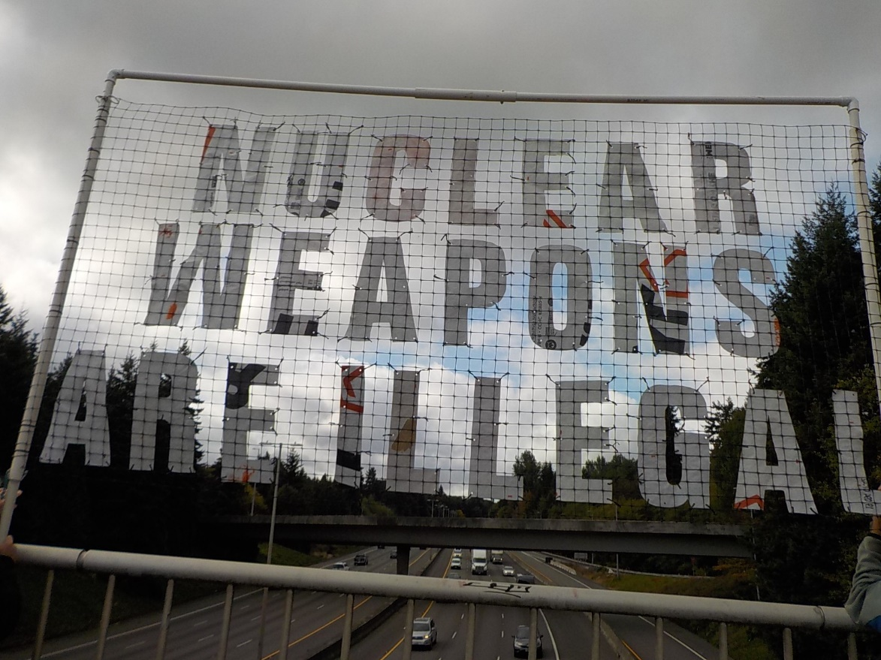
Olympia Committee to Abolish Nuclear Weapons Banners Thursdays 11 AM - Noon at Eastside St. Overpass of I-5.
Since 1968, arms races and positioning nuclear weapons near borders of adversaries have created conditions for starting a nuclear war. This is the problem with NATO expansion that not only positions troops but also nuclear weapons of the US on borders of Russia as a threat. This was done in the 1990’s by the Clinton Administration. Five European NATO Nations and Turkey currently have US nuclear weapons. Recently US allies Japan, Ukraine, and South Korea are pushing to get nuclear weapons. The pool of countries with nuclear weapons continues to increase.
We have intersecting existential crises with climate change and nuclear weapons.
Migration forced by climate change and sea level rise could trigger a war between nuclear armed nations. This potential is great in Bangladesh where 18 million people live in lowlands and sea rising and floods could force migration into India and the border is militarized to prevent that. This could trigger a war between India and Pakistan, already adversaries that could go nuclear as both have nuclear weapons.
In a nuclear war today, nuclear explosions are expected to cause severe drought resulting in death of billions far from the conflict sites from mass starvation. So it is not just the blasts and radiation that would kill but associated climate impacts according to recent studies.
The US Defense Department Nuclear Posture Review (NPR) is the Nuclear Planning tool and rationalization of developing new and more dangerous nuclear weapons. We are set to spend $2 trillion to accomplish this. The start of an ever-increasing nuclear weapons arms race decreasing stability and encouraging a first strike and the US even retains the option of striking first.
Oppenheimer – the Movie directed by Christopher Nolan – displays dangers of nuclear weapons.
Director Christopher Nolan discussed his reasons for the movie and his concerns with nuclear weapons, not just in times of crises but in general very dangerous things to have at any time. He expressed his concern about the ambivalence in peoples’ attitudes toward nuclear weapons and accepting tactical nuclear weapons as ok for war.
“So, we’ve got generations of people giving intellectual context to the idea of Armageddon, which disguises it and makes it all feel a bit more acceptable as part of the life…”
“Every gun that is made, every warship launched, every rocket fired signifies, in the final sense, a theft from those who hunger and are not fed.” - President Dwight D. Eisenhower
“Nuclear Weapons Rob from the Poorest Among Us

“Does the nuclear weapons industry really benefit New Mexicans as a whole rather than a privileged few? The evidence indicates no. During the 79 years the nuclear weapons industry has been in New Mexico, Census Bureau data shows that our state has slipped in per capita income from 37th in 1959 to 49th in 2019…

“According to U.S. Census Bureau data, New Mexico is 48% Hispanic and 12% Native American. Los Alamos County is 79% non-Hispanic White and has more millionaires per capita than any other county in the U.S. In contrast, New Mexico has the highest percentage of children and seniors living in poverty. Further, the Land of Enchantment was recently ranked as 49th among all states in overall child well-being. All of this is evidence of the economic inequality and institutional racism that is endemic to our country. . .

“More, the reality of catastrophic climate change means we can no longer waste our resources on preparing for nuclear war when the whole planet is facing global destruction. . .”

- Conversation: Toward Nuclear Disarmament, by John C. Wester, Archbishop of Santa Fe, NM Jan. 11, 2022

Nuclear Weapons – another Climate Issue
University of Nebraska Study, 2017 Liska, A.J et al Nuclear Weapons in a Changing Climate: Probability, Increasing Risks, and Perception, Environment: Science and Policy for Sustainable Development
This study points out that 100 15-Kiloton nuclear explosions would reduce temperatures and rainfall resulting in a billion deaths from starvation from this climate impact largely in the southern hemisphere.
2022 Study: Up to 5 billion die in nuclear war between US and Russia
“Atmospheric soot loadings from nuclear weapon detonation would cause disruptions to the Earth’s climate, limiting terrestrial and aquatic food production… we demonstrate that soot injections . . .would lead to mass food shortages, …We estimate more than 2 billion people could die from nuclear war between India and Pakistan, and more than 5 billion could die from a war between the United States and Russia—underlining the importance of global cooperation in preventing nuclear war.” Nature Food, Volume 3 (2022) pp 586-596: Global food insecurity and famine from reduced crop, marine fishery and livestock production due to climate disruption from nuclear war soot injection.

The Oppenheimer movie exposes the risk of nuclear weapons. Now it is up to citizens to pressure for an end of this madness. We have before in stopping above ground testing and disarmament treaties and chemical and biological weapons.
International Efforts to End the Nuclear Threat – United Nations Treaty to Prohibit Nuclear Weapons – signed by 92 Nations and ratified by 68 but not yet the US or other nations with nuclear weapons. It bans the use, possession, testing and transfer of nuclear weapons under international law. It came into effect as International law when 50 nations signed Jan. 2021. See www.icanw.org

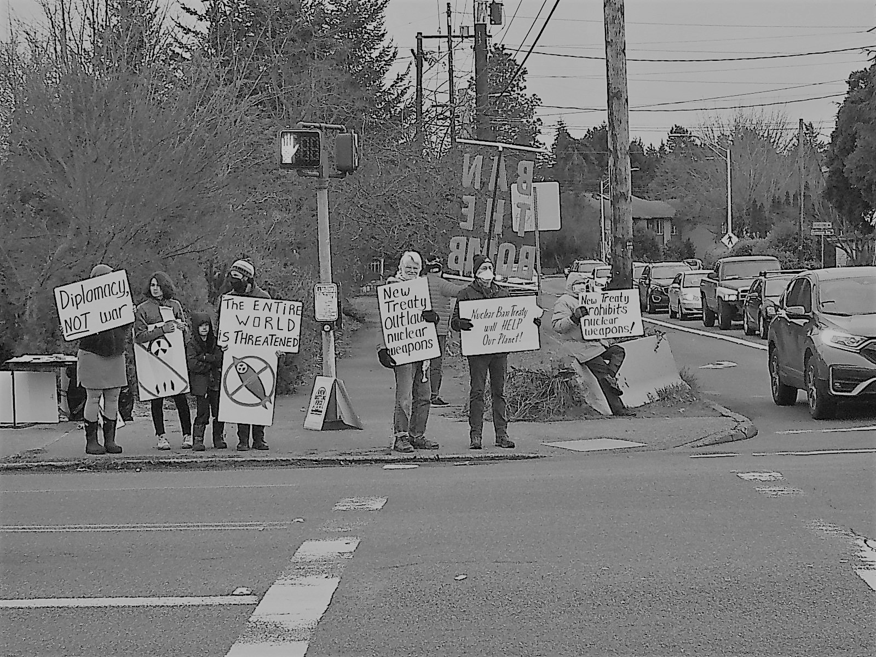
January 2023 Vigil Celebrating the 2-year anniversary of Treaty to Prohibit Nuclear Weapons by OCANW
In January Rep. McGovern (MA) sponsored a bill that has 35 co-sponsors: H.Res.77 - Embracing the goals and provisions of the Treaty on the Prohibition of Nuclear Weapons.

H.R. 2775: Nuclear Weapons Abolition and Conversion Act of 2023 would have the US sign the UN Treaty. It was introduced by Representative Eleanor Norton and has 9 cosponsors.

H.R. 669 Restrict first use of nuclear weapons act of 2023. This bill prohibits funds for First Strike without a declaration of war. Sponsored by Rep Ted Lieu and has 19 cosponsors.
Congresswoman Pramila Jayapal is the only WA State Congressperson co-sponsor these bills and signed on to H. Res. 77 and H.R. 669.
National US Efforts to prevent Nuclear War
“Back from the Brink” is a national grassroots campaign in the US that aims to prevent nuclear war and fundamentally change U.S. nuclear weapons policy. The campaign is a coalition of individuals, organizations, and elected officials working together toward a world free of nuclear weapons and advocating for common sense nuclear weapons policies to secure a safer, more just future. Back from the Brink | Bringing Communities Together to Abolish Nuclear Weapons See: preventnuclearwar.org.
Washington Against Nuclear Weapons (WANW):
monthly meetings (Zoom 6:00 pm the second Thursday of each month).
Tues. Sept 26 is an international day of action against nuclear weapons. WANW encourages people to protest at local offices of our members of Congress. For more info about WANW’s statewide efforts for that day, contact WANW’s Organizer, Sean Arendt at sean@wpsr.org or 253-363-0843.
Thurston County Effort: Locally, the Olympia Coalition to Abolish Nuclear Weapons works to inform people and conduct activities opposing nuclear weapons.
Zoom meeting from 5:00 to 7:00 pm third Thursday of each month
For more information – and/or join OCANW e-mail list – contact glen@parallaxperspectives.org or phone (360) 491-9093.

