**What is the Treaty on the Prohibition of Nuclear Weapons?**

In 1945 the U.S. dropped atomic bombs on two cities in Japan. No other nation has ever done that, but after the U.S. did that, eight other nations – (currently nine) fearing for their own “national security” – have developed nuclear weapons. Since the 1940s the U.S. has led each step in escalating the nuclear arms race. Ironically, instead of “security,” a nuclear war could destroy human civilization.

The 1970 Nuclear Non-Proliferation Treaty (NPT) was a grand bargain in which the non-nuclear nations agreed never to get them and the nations that did have nuclear weapons agreed to promptly stop the nuclear arms race and to follow up with “a treaty on general and complete disarmament under strict and effective international control.” But the nuclear nations continued to escalate and have failed to disarm. **For half a century the nations with nuclear weapons have been violating the NPT,** although they have adopted some treaties reducing dangers.

**The rest of the world feels it is being held hostage by the nine nations that now have nuclear weapons, so they created the Treaty on the Prohibition of Nuclear Weapons (TPNW).** In July 2017 it passed the United Nations General Assembly by an overwhelming vote of 122 of the 193 nations there. This victory allowed the world’s nations to start signing and ratifying the Treaty. By early May 2023, 68 nations have ratified it and are making it part of their national laws. **The Treaty went into effect on January 22, 2021**, and now more nations also can ratify it.

The worldwide non-profit organization that has been promoting the Treaty is the International Campaign to Abolish Nuclear Weapons (ICAN, [**www.icanw.org**](http://www.icanw.org)). Their efforts won them the 2017 Nobel Peace Prize.

**This Treaty Takes Bold Actions!**

The TPNW was written with insights from the highly successful treaty outlawing chemical weapons worldwide. That treaty’s power came from using a number of active verbs, so the TPNW specifies that when a nation ratifies the TPNW, the Treaty prohibits that nation from developing, testing, producing, manufacturing, transferring, possessing, stockpiling, hosting, using or threatening to use nuclear weapons. It prohibits any kind of support whatsoever. It is amazingly comprehensive and powerful.

The world recoiled in horror when the U.S. bombed Japan in 1945. The International Committee of the Red Cross was one of the first organizations to recognize the horror of atomic bombs. International Humanitarian Law (the Geneva Conventions) made their use illegal in 1949. In 1996 the International Court of Justice (the World Court) also said that using them would likely violate international law. The world opposes “weapons of mass destruction,” as shown in the graphic below.

ICAN has been encouraging more worldwide support for the Treaty. By early 2023, more than 600 cities worldwide have formally supported it, including 61 in the United States, including Walla Walla WA. All nine nations with nuclear weapons oppose the Treaty, which would require them to abolish their nuclear weapons, but popular sentiment around the world is growing in promoting the Treaty. Learn more at ICAN’s website, [**https://www.icanw.org**](https://www.icanw.org). We urge you to build the grassroots movement among your friends and organizations – and to contact your federal elected officials to support it. In the 2023-24 Congress, H.R. 77 supports the TPNW’s purposes.

**Yes, we can do it! The world has already banned these “weapons of mass destruction, so we can ban nuclear weapons too:**

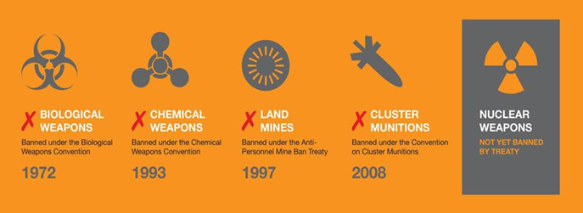

The Olympia Coalition to Abolish Nuclear Weapons, an all-volunteer grassroots organization, has been working in the greater Olympia WA level since May 2017 in a variety of strategically savvy ways. Contact our chairperson at (360) 491-9093 or [**glenanderson@integra.net**](mailto:glenanderson@integra.net). We are one of about 60 local organizations in the statewide coalition Washington Against Nuclear Weapons, (206) 547-2630 or [**www.wanwcoalition.org**](http://www.wanwcoalition.org). Many organizations and sources of information exist. A good list was compiled and posted to this site: [**https://parallaxperspectives.org/nuclear-weapons-good-sources-of-information**](https://parallaxperspectives.org/nuclear-weapons-good-sources-of-information)