Nuclear Weapons NUMBERS and COSTS
NUMBERS:
In 2021, about 13,000 nuclear warheads existed worldwide, according to the Arms Control Association, www.armscontrol.org. Nine nations own them. About 90% of these belong to the United States and Russia.
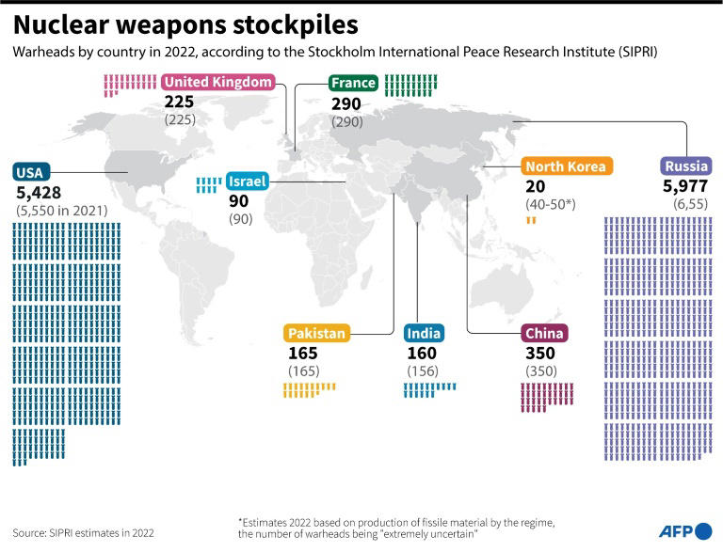
After George W. Bush and Donald Trump destroyed several important treaties that limited nuclear weapons of the U.S. and Russia, the New START Treaty was practically the only one left between the U.S. and Russia. Trump was allowing New START to expire too, but in January 2021 Joe Biden extended it for 5 years. New START caps each country at 1,550 strategic deployed warheads. See information at this link: the provisions of the New START agreement

The numbers of deployed warheads in both Russia and the U.S. are below New START’s limit of 1,550 each. Each nation also has a few thousand missiles not currently ready to launch.

Russia (6,257 total) has 1,458 ready-to-launch: These strategic nuclear warheads are deployed on 527 intercontinental ballistic missiles, submarine-launched ballistic missiles, and strategic bombers.

The United States (5,550 total) has 1,389 ready-to-launch: These strategic nuclear warheads are deployed on 665 intercontinental ballistic missiles, submarine-launched ballistic missiles, and strategic bombers. The U.S. also has an estimated 100 B-61 nuclear gravity bombs that are forward-deployed at six NATO bases in five European countries.

While Russia and the U.S. each has about 1,400, the other 7 nations have far fewer. China has 350, France 290, the UK 225, Pakistan 165, India 156, Israel 90, and North Korea 50.All together those 7 nations have only about 10% of the world’s deployed nuclear weapons, while 90% are owned by the U.S. and Russia.
COSTS:
In 2019 the nine nations that have nuclear weapons spent $72.9 billion on them, and the U.S. spent about half of that total. The International Campaign to Abolish Nuclear Weapons (ICAN, www.icanw.org) issued a report about this in May 2020.
You can download the report from ICAN’s website, www.icanw.org. The direct link is: https://d3n8a8pro7vhmx.cloudfront.net/ican/pages/1549/attachments/original/1589365383/ICAN-Enough-is-Enough-Global-Nuclear-Weapons-Spending-2020-published-13052020.pdf?1589365383

In 2019, the 9 nations with nuclear weapons spent these amounts
on nuclear weapons You can see that the U.S. spent about as much as all other nations combined:
