“Glen’s Parallax Perspectives” is a series of TV programs offering fresh ways for people to see issues such as foreign policy, social and economic justice, governmental functioning, the environment, and so forth. We provide voices and viewpoints that are rarely heard in mainstream media.
Mainstream media, politicians, and culture see the world in conventional ways. Therefore, in order to solve problems, we need to see things in fresh ways. Glen Anderson created this TV series to help people see things differently so we can solve problems at all levels from the local to the global.
This series title refers to “parallax,” which is the view you get by looking from a different perspective. For example, put one finger in front of your nose and another finger farther away. Close one eye. Then open that eye and close the other. Your fingers will seem to move. This is called a “parallax” view. This TV series invites you to look at issues from fresh perspectives.

Each program airs three times a week (currently every Monday at 1:30 pm, every Wednesday at 5:00 pm, and every Thursday at 9:00 pm) for the entire month on Thurston Community Television (TCTV), channel 22 for cable TV subscribers in Thurston County, Washington. TCTV is part of Thurston County Media. You can see their schedule at www.tcmedia.org
You can also watch the program summarized below through your computer at www.parallaxperspectives.org. All episodes of “Glen’s Parallax Perspectives” are posted on this blog’s “TV Programs” part and also in one or more of the categories listed in the right side of the blog home page. Also, see information about various issues at the category headings at www.parallaxperspectives.org.
Glen Anderson (360) 491-9093 glenanderson@integra.net
I saved this document in Word format with live links. If this document does not load or print properly for you, please e-mail me at glenanderson@integra.net and I’ll promptly send you the links you request.
Please invite other people to watch this video and/or read this thorough summary through these parts of my blog, www.parallaxperspectives.org: “TV Programs” and “Military Spending” and “Peace” and Race” and “Nuclear Weapons.”

“Spending for Military and Nuclear Weapons Makes Poverty Worse”

Glen’s Parallax Perspectives TV Series

October 2022
Glen Anderson (360) 491-9093 glenanderson@integra.net
Glen introduced our topic:

This month’s program on “Glen’s Parallax Perspectives” TV series “connects the dots” between poverty in the United States and excessive military spending, including the costs of nuclear weapons:
- This TV program begins by recognizing the extent of poverty in the United States – the richest nation on earth. Poverty is a serious crisis – and it is getting worse.
- Next, we recognize how excessively expensive the U.S. military has become. The U.S. spends a gigantic amount on the military – much, much more than is necessary. Both political parties keep increasing military budgets far, far beyond reason.
- We spend a few minutes examining nuclear weapons. We have far too many nuclear weapons – and their costs are outrageously excessive.
- After we have looked at these hard realities, I invite us to consider what the American people feel about these disparities – escalating poverty and escalating military spending. We also consider what the American people’s best values are. What do our nation’s people really need and want?
- The second half of this program will propose some solutions that are humane and sensible.

The peace movement and the Civil Rights movement have been raising these concerns for many decades.
In the past few years, a new Poor People’s Campaign has arisen and mobilized for economic and racial justice.
In the 1960s, Rev. Dr. Martin Luther King Jr. and many others were calling for our nation to undertake a bold “revolution of values.” In 1968 they were building a broad-based movement to unite poor people and other people into a new movement to solve our nation’s problems.

The TV screen showed the websites for the new Poor People’s Campaign:
Nationwide: www.poorpeoplescampaign.org
In Washington State, visit www.washingtonppc.org

Nowadays, a new Poor People’s Campaign describes itself as “A National Call for Moral Revival.” Their national website is www.poorpeoplescampaign.org. On Saturday June 18, 2022, people from all over the U.S. convened in Washington DC for a new March on Washington.
Here in Washington State, the statewide Poor People’s Campaign has this website: www.washingtonppc.org.

Marches on Washington – Poor People’s Campaigns:
During the TV program I said I would post to my blog the video of this TV program – and also a transcript of what I said during the hour and all of the images I’m sharing on the TV screen. You are reading that document now at the “TV Programs” part of my blog, www.parallaxperspectives.org.

I showed on the TV screen two photographs from 1963’s March on Washington:

Then I showed a photo from the Saturday June 18, 2022 March on Washington:
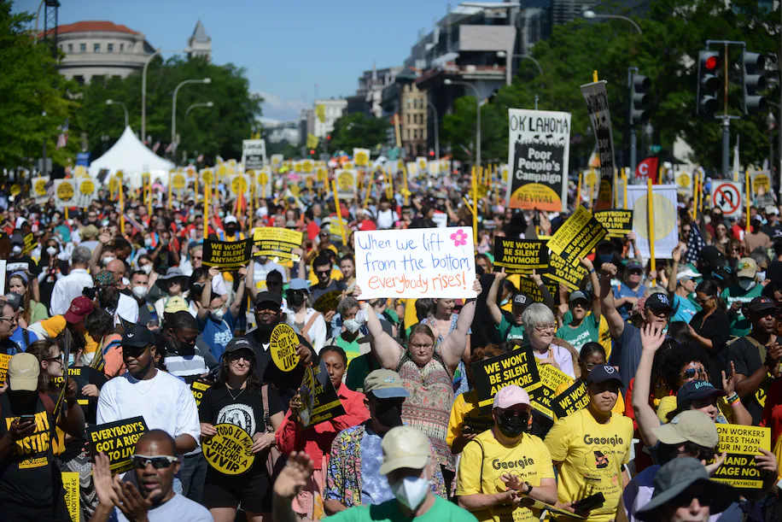

The Poor People’s Campaign links many issues and movements, including poverty, peace issues and the peace movement. In that spirit, my October 2022 TV program discussed the relationship between poverty and our militaristic foreign policy, which includes a deadly addiction to nuclear weapons. Glen discussed this on Kim Dobson’s “Parallel University radio program on KAOS 89.3 FM on Thursday June 9, 2022. Here is a link to the recording: Parallel U 6-9-2022.mp3 Glen Anderson Poor People's Campaign
Militarism – including nuclear weapons -- diverts the vast wealth of America away from the legitimate needs of housing, medical care and education.
Let’s join with the Poor Peoples Campaign’s nationwide effort to move the U.S. away from all kinds of cruelty and oppression – such as poverty and war – and replace those with public policies and an economic system that will be morally good, humane, and sustainable.

The first half of this TV program invites us to consider the recent and
current realities about poverty, military spending, and nuclear weapons:

Poverty, economic inequality, etc.:

Many millions of Americans are very poor, and many millions more are just barely getting by.
In the past few decades, the gap between very rich people and everybody else has been getting much wider. There is horrible inequality in incomes – and also horrible inequality in wealth. Many Americans have negative wealth (more debts than assets). Meanwhile, billionaires and multi-millionaires keep getting even more rich.
The latest figures from the US Department of Agriculture show that more than 38 million people in the United States experienced hunger in 2020. Households with children were even more at risk. Now, as many as 1 in 6 kids are facing hunger this year. Federal intervention could help – if Congress would fund it – but Congress does not help enough.
On August 12, 2021, I received an article reporting that nearly half of American workers do not earn enough to afford a one-bedroom rental – and reporting that a minimum wage job is not enough to afford a two-bedroom rental anywhere in the U.S.
During the pandemic, about one in seven Americans fell behind on rent payments while housing costs continued to increase.
Poor people find it very hard to pay rent: https://www.theguardian.com/society/2021/aug/12/housing-renter-affordable-data-map?utm_term=fe7dbf2c1843ea560294d8f4da39daaf&utm_campaign=GuardianTodayUS&utm_source=esp&utm_medium=Email&CMP=GTUS_email
On August 2, 2021, I received an article explaining that poor Americans pay an invisible “time tax” – hours of work to apply for “safety net” programs. Applications for benefits across key parts of the so-called “safety net” – from food stamps to unemployment insurance to Medicaid – require individuals to waste hours of their life proving eligibility, completing confusing paperwork, taking drug tests, or otherwise battling with federal and state bureaucracies to get benefits supposedly meant to help them.
In these ways, the government punishes poor people themselves for being poor, instead of recognizing the systemic causes of poverty. We need straightforward remedies for poverty caused by public policies – instead of the current “blame-the-victim” programs. (See pages 10- 11 about homelessness.)
And, as with many of the U.S.’s problems, this time tax hits people unevenly: poor Americans and people of color are more likely to spend their hours navigating the system, while wealthier (often white) Americans are rarely asked to, say, pee in a cup to get the benefits that they receive.
The result of this institutional runaround is fewer people getting the benefits they need. For example, only 1 in 6 eligible persons receives food stamps. Also, people who are oppressed by poverty have less control over something pretty basic – their time. Annie Lowry wrote an article about this in the July 2021 issue of The Atlantic: https://www.theatlantic.com/politics/archive/2021/07/how-government-learned-waste-your-time-tax/619568/

I showed on the TV screen the box below, which lists some of the U.S.’s failures to take ethical actions for peace, human rights, and so forth.
The U.S. is the only (or almost the only) modern industrial nation that fails to help its
people and the world in these important ways:
The U.S. health care system keeps ranking LAST among rich nations.
The U.S. does not offer paid leave for new mothers, but 186 other nations do.
The U.S. has not ratified the Cluster Munitions Treaty.
The U.S. is one of only 14 members of the United Nations that have failed to ratify the Convention on the Rights of Persons with Disabilities.
The U.S. is the only nation in the U.N. that has failed to ratify the Convention on the Rights of the Child.
The U.S. and Israel are the only members of the U.N. that voted to continue the U.S. embargo of Cuba in 2021.
The U.S. and Ukraine were the only members of the U.N. that voted against a 2020 General Assembly resolution condemning the glorification of Nazism, neo-Nazism, and other practices that promoted intolerance.
The U.S. ranks high in world opinion polls as threatening democracy.
Regarding International Law, the U.S. has not ratified two Geneva Convention protocols from 1977:
- Relating to the Protection of Victims of International Armed Conflicts
- Relating to the Protection of Victims of Non-International Armed Conflicts
The U.S. has FAILED to ratify four important environmental treaties:
- The United Nations Convention on the Law of the Sea
- The Convention on Biological Diversity
- The Stockholm Convention on persistent organic pollutants
- The Basel Convention, which restricts moving hazardous waste between countries
In 2018 at the United Nations, 181 nations voted to help refugees. Only the U.S. and Hungary voted no.
In 2018, the U.S. was one of only five nations opposing a U.N. agreement on the environment.

I showed on the screen some of the U.S.’s horribly low rankings in health care:
The U.S. is the world’s richest nation, but we rank low on health outcomes:
Among 11 other rich, advanced nations, U.S. health care system ranks dead last in healthcare outcomes, access,
equity, and efficiency, even though Americans spend much more per person on health care.
Read www.tinyurl.com/y8ehsfev
- Among the world’s developed nations, the United States stands at or near the bottom in most important rankings of access to and quality of medical care.
- A 2000 study rated the US 37th, “just behind Dominica and Costa Rica.”
- Life expectancy for people who have reached the age of 60 is bad in the US, compared to other rich countries. A 2006 Commonwealth Fund study of 23 nations had the US tied for last.
- The US ranked last of 23 nations in keeping newborns alive. Other nations offer free prenatal and neonatal care for every mother and every baby.
- “Avoidable mortality” is a meaningful measure. A study of nineteen wealthy countries showed the U.S. ranked LAST in curing people who could be cured with decent care. The U.S. death rate was nearly twice as high as in France, Japan and Spain.
- Americans with chronic diseases (asthma, diabetes, etc.) fared badly compared with other nations.
- Americans have a comparatively terrible rate of dying from surgery.
- More people die young in America than in other rich countries.
- In Japan, Germany, the Netherlands, Canada and Switzerland, NOBODY goes bankrupt because of medical bills, but in the US it’s 700,000 per year.

Military spending:
The U.S. spends much, much more on the military than any other nation on earth. In 2020, the U.S. spent THREE TIMES AS MUCH as China did – and the U.S. spent TWELVE TIMES AS MUCH as Russia did.
The screen showed the amounts the top 10 nations spent on their militaries in 2020:
The U.S. spends much, much more on the military than any other nation on earth.
In 2020, the top 10 spenders on their militaries were:
- The United States — $778 billion.
- China — $252 billion [estimated]. The U.S. spent THREE TIMES AS MUCH as China did.
- Russia — $61.7 billion. The U.S. spent TWELVE TIMES AS MUCH as Russia did.
Each of the next 7 nations that spent a lot on their militaries spent less than $73 billion in 2020.
- India — $72.9 billion
- United Kingdom — $59.2 billion
- Saudi Arabia — $57.5 billion [estimated]
- Germany — $52.8 billion
- France — $52.7 billion
- Japan — $49.1 billion
- South Korea — $45.7 billion
Except for China and Russia, all of the other top 10 spenders were U.S. allies.

These realities of military spending destroy the arguments of people who want us to be afraid of China and Russia – and want us to keep escalating our military. The U.S. outspends both China and Russia many times over. The proportions are even more lopsided when you include our allies’ military spending.
On January 31, 2022, the National Priorities Project (www.nationalpriorities.org) – a savvy non-profit organization that contrasts the budgets for military spending with the budgets for humane civilian purposes – sent out information about the federal budget. Their information came from a publication produced by the Poor People’s Campaign (www.poorpeoplescampaign.org) and some other good organizations. The publication contrasted what they called “A Moral Budget” vs. “A War Budget.”
They reported that at the end of 2021, Congress FAILED TO PASS a $170 billion-a-year investment in families, child care, and climate, while a vast bi-partisan majority APPROVED a Pentagon budget more than four times as high. Here is the link to that report: https://www.nationalpriorities.org/analysis/2021/moral-budget-vs-war-budget/?emci=ad4731c1-ba74-ec11-94f6-c896650d4442&emdi=1f160995-ce82-ec11-94f6-c896650d4442&ceid=3993183
The publication I mentioned just now lists what the “Build Back Better” funding would have accomplished and what’s in the National Defense Authorization Act. Congress failed to pass the “Moral Budget,” but a huge bi-partisan majority did overwhelmingly pass the “National Defense Authorization Act,” which lavishly funds military violence. These two bills represent diametrically opposed views of how to address the challenges of our time: a moral budget vs. a war budget. Congress is NOT on our side!
President Dwight Eisenhower said, “Every gun that is made, every warship launched, every rocket fired signifies, in the final sense, a theft from those who hunger and are not fed, those who are cold and are not clothed.”
On December 20, 2021, several organizations released their publication about this gross injustice. The joint publication came from the Poor People's Campaign: A National Call for Moral Revival; Institute for Policy Studies; Repairers of the Breach; and Kairos: The Center for Religion, Rights, and Social Justice. You can download the report at this link: https://media.nationalpriorities.org/uploads/publications/ppc-bbb-fact-sheet.pdf

On April 5, 2022, Ralph Nader’s organization, Public Citizen (www.citizen.org) sent out some information about military spending. Here are their dollar amounts and my additional thoughts:
- The U.S.’s military budget for this year is a staggering $782 billion. For 2023, President Biden is asking for $813 billion — an additional $31 billion more than the current bloated military budget. Republicans (and some Democrats) in Congress are pressing for even more than that.
- The Ukraine crisis is NOT a valid reason for Biden’s request for $813 billion. It is more than 13 times what Russia spends on its military. In fact, this is more than the combined spending of the next 13 countries on the list: China, India, Russia, United Kingdom, Saudi Arabia, Germany, France, Japan, South Korea, Italy, Australia, Israel, Canada.
- The article sent by Public Citizen said: “Throwing ever more money at the Pentagon is not about supporting the troops, improving national security, or making the world safer for democracy. It is about members of Congress using Russia’s invasion of Ukraine as an excuse to funnel even more of our tax dollars to their friends at Lockheed Martin, General Dynamics, and Northrop Grumman.”

On April 2, 2022, another organization that I trust and support – Roots Action (www.rootsaction.org) – sent out some information – and I edited it slightly for the next few sentences:
- Last year Congress increased military spending. It does that every year. But last year it did it even more stupidly and cruelly than usual: President Biden asked for a $12 billion increase. Republicans asked for a $25 billion increase beyond that. The Democratic Congress ultimately passed even more than the Republicans had proposed.
- This year, Biden proposed increasing military spending by $31 billion over last year’s spending.
- ACTUALLY, THE PUBLIC WANTS TO SPEND LESS because we have better sense than Congress does – and WE ARE NOT CORRUPTED BY CAMPAIGN DONATIONS FROM WEAPONS MANUFACTURERS.
- We should be insisting that each member of Congress publicly and emphatically commit to voting “NO” on any bill that funds military spending at more than 90% of the past year's level.

I keep seeing a familiar pattern that CONTRASTS what politicians keep saying and doing:
- Politicians keep saying that the U.S. cannot afford to clean up the environment or protect the climate.
- Politicians keep saying that the U.S. cannot afford to end homelessness and poverty.
- Politicians keep saying that the U.S. cannot afford to provide good health care for everybody – and cannot afford good education – and cannot afford serious efforts to protect everybody from COVID.
- But – DESPITE THOSE DENIALS – they ALWAYS KEEP SPENDING MORE AND MORE for war, including nuclear weapons.
We must tell the politicians to STOP those horribly immoral budget priorities. Now we must also tell politicians to STOP claiming that Russia’s invasion of Ukraine makes them spend more. The U.S. military spending was ALREADY FAR TOO MUCH for many decades before Russia invaded Ukraine in February 2022. The U.S. military was already spending about twelve times as much as Russia’s military.

Nuclear weapons:
In 2021, about 13,000 nuclear warheads existed worldwide, according to the Arms Control Association, www.armscontrol.org.
I showed on the screen how many nuclear weapons each of the 9 nations has:
Nine nations have nuclear weapons. About 90% of these belong to the United States and Russia.
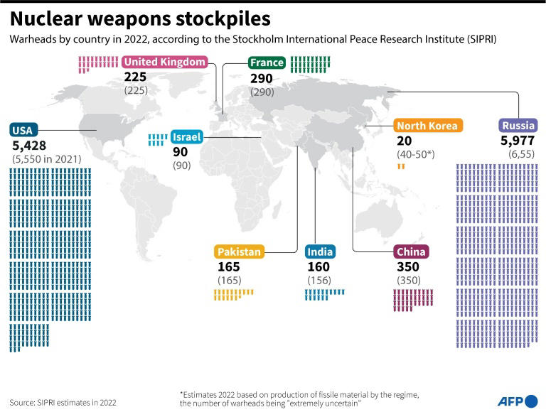

After George W. Bush and Donald Trump destroyed several important treaties that limited nuclear weapons of the U.S. and Russia, the New START Treaty was practically the only one left between the U.S. and Russia. New START caps each country at 1,550 strategic deployed warheads. See information at this link: the provisions of the New START agreement
Trump was allowing New START to expire too, but in January 2021 Joe Biden extended it for 5 years.

The numbers of deployed warheads in both Russia and the U.S. are below New START’s limit of 1,550 each. Each nation also has a few thousand missiles not currently ready to launch.

Russia (6,257 total) has 1,458 ready-to-launch: These strategic nuclear warheads are deployed on 527 intercontinental ballistic missiles, submarine-launched ballistic missiles, and strategic bombers.

The United States (5,550 total) has 1,389 ready-to-launch: These strategic nuclear warheads are deployed on 665 intercontinental ballistic missiles, submarine-launched ballistic missiles, and strategic bombers. The U.S. also has an estimated 100 B-61 nuclear gravity bombs that are forward-deployed at six NATO bases in five European countries.

While Russia and the U.S. each has about 1,400, the other 7 nations have far fewer. China has 350, France 290, the UK 225, Pakistan 165, India 156, Israel 90, and North Korea 50. All together those 7 nations have only about 10% of the world’s deployed nuclear weapons, while 90% are owned by the U.S. and Russia.

I showed on the screen how much money 9 nations spent on nuclear weapons:

In 2019 the U.S. spent very nearly as much on nuclear weapons as ALL OTHER nations combined.
In 2019, the 9 nations that have nuclear weapons spent a total of $72.9 BILLION on them.
The U.S. spent about as much as ALL OF THE OTHER 8 nations combined.

In 2019 the nine nations that have nuclear weapons spent $72.9 billion on them, and the U.S. spent about half of that total.
The International Campaign to Abolish Nuclear Weapons (ICAN, www.icanw.org) issued a report about this in May 2020. You can download it from their website, www.icanw.org. The direct link to this information is: https://d3n8a8pro7vhmx.cloudfront.net/ican/pages/1549/attachments/original/1589365383/ICAN-Enough-is-Enough-Global-Nuclear-Weapons-Spending-2020-published-13052020.pdf?1589365383

See the next page for a compelling visual image
of nuclear weapons spending by the 9 nations that have them.

I showed this bar graph, which shows that the U.S. spent about as much as all other nations combined:
In 2019, the 9 nations with nuclear weapons spent these amounts on nuclear weapons.
You can see that the U.S. spent about as much as all other nations combined:
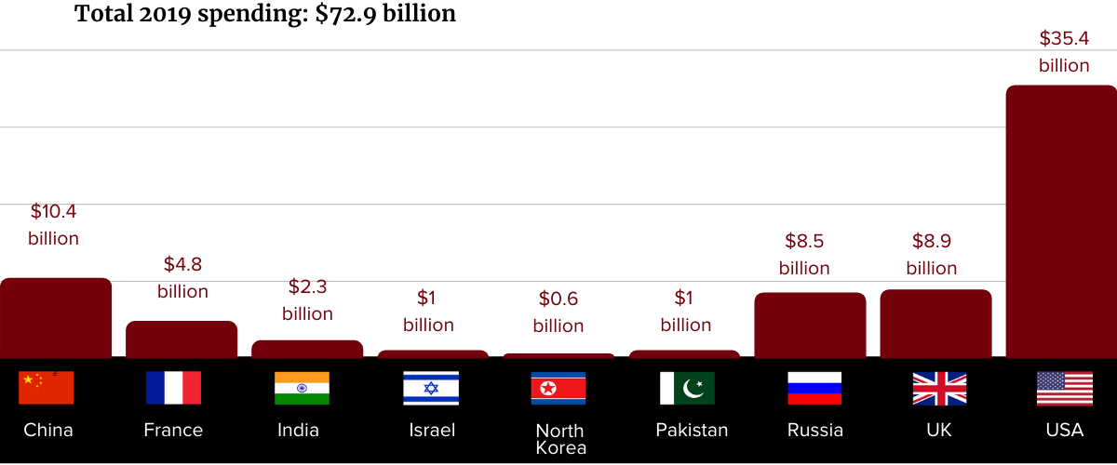
To download the report about these numbers, click this link: Download the report

At this point in the TV program, we have laid out the FACTS.
How do you FEEL about these hard realities.

For 4 years, Trump kept escalating military spending to an unconscionable level. Now in each of 2 years, Biden has HORRIBLY ESCALATED military spending beyond that!
In Congress, BOTH political parties keep escalating military budgets even beyond the reckless escalations that Biden has proposed in each of the past two years. Congress keeps escalating military budgets even while Congress keeps saying we can’t afford to feed hungry children or reduce poverty or protect the environment.
The American people STRONGLY OPPOSE these huge, BI-PARTISAN military budgets!
Only a few members of Congress have spoken up boldly against this reckless cruelty.
In February 2022 Rep. Pramila Jayapal denounced Biden’s $770 BILLION Pentagon budget proposal as “absurd.”
An article from February 16, 2022, includes these three points:
- “The expected budget request, first reported by Reuters Wednesday, is tens of billions of dollars more than former Republican President Donald Trump ever requested and contrasts with widespread public demand for increased investment in middle- and lower-class Americans and an end to bloated military budgets.”
- “The American Friends Service Committee (AFSC) pointed to recent polling by the organization which showed that 54% of adults in the U.S. want ‘the exact opposite’ of increased military spending.”
- The article also quotes William Hartung, one of our nation’s best-informed experts on military spending, who said, “Devoting this enormous sum to the Pentagon at a time when the greatest challenges to our security—from pandemics to climate change—are not military in nature is both misguided and counterproductive.”
You can read the article at this link: https://www.commondreams.org/news/2022/02/16/bidens-770b-pentagon-budget-proposal-denounced-absurd?utm_campaign=weekendreading&utm_source=weekendreading0219&utm_medium=email&ms=EMA22WR0219&emci=9ef8af22-1590-ec11-a507-281878b83d8a&emdi=53fc3d06-8891-ec11-a507-281878b83d8a&ceid=882844
How do YOU feel about the bi-partisan mania for excessive military spending while the federal government refuses to fund programs to end homelessness, end poverty, provide safe drinking water, protect our health, clean up the environment, and provide high quality education?
I encourage YOU to pay attention to how YOU feel at the HEAD level and at the HEART level.
Besides FEELING, we need to take smart ACTIONS. Let’s organize a strong grassroots movement to help the public move from feelings to smart, compassionate actions based on the public’s values and needs!

The public’s values and needs call for a profound change from the status quo:

The entire concept of militarism is based on the mistaken assumption that killing people in other countries solves problems. (Within the U.S., some people follow the government’s bad example can commit murders here!)
Military violence is cruel – and brings out the worst of people, including racism and hatred of “The Other.” Military violence violates humane values. Governments reject humane values because they prioritize nationalism over life.
We can and must do better than that! Poverty and militarism violate our core values and needs.
Ordinary people strongly need and support profound:
- Fairness
- Compassion
- Respect for living beings
- Safety and security for all people and for our global environment

Let’s solve the problems in smart ways:

We must fix our nation’s unjust systems!
We need smart and compassionate remedies!
Americans like to THINK we live in a democracy. Actually, we live in a REPUBLIC, where we elect other people to run local, state and national governments. If we REALLY had a DEMOCRACY, then “WE THE PEOPLE” would be DIRECTLY DECIDING what our governments would do – at the local, state and federal levels.
The American people WANT MORE DEMOCRACY – and MORE HONESTY. Instead, Congress and the U.S. Supreme Court have been allowing extremely rich people and big businesses to BRIBE political candidates with Big Money donations for their campaigns, and those economic elites spend many millions of dollars lobbying the politicians after they are elected.
Solving the problems about excessive military spending – and the government’s refusal to end poverty – requires that we REFORM ELECTIONS AND GOVERNMENTAL FUNCTIONING IN SEVERAL WAYS. These reforms are necessary in order for us to convert to a peaceful foreign policy and humane budget priorities
My June 2022 TV program focuses on how Big Money corrupts our elections – and it also proposes some solutions. People EVERYWHERE can visit my blog to watch this TV interview at ANY TIME – and read the thorough summary I typed up (with links to more information). Visit www.parallaxperspectives.org. Click “TV Programs,” and scroll down to that episode’s title, “Big Money in Elections Corrupts Our Government.” The direct link is https://parallaxperspectives.org/big-money-in-elections-corrupts-our-government

Too often we hear ordinary people and politicians blame the victims of our economic system. Trump specialized in this. He kept calling people “losers.” He did not mean that they were losing because capitalism is unfair – or that they were being hurt by systemic social injustice and discrimination. No, Trump’s accusation of “loser” was personal blame against the individuals who have been victimized by cruel systems in our society and our economy.
In order to solve the problems, we must recognize that OUR POLITICAL AND ECONOMIC SYSTEMS cause the problems and make people poor.
Also, OUR POLITICAL AND ECONOMIC SYSTEMS divert our nation’s resources into military violence and corruption.
Here is a good example from our local level: The Thurston County WA Voters Pamphlet for the August 3, 2021, primary election included statements from candidates. A number of candidates addressed homelessness in ways that blame the victims – blame homeless people themselves. Those candidates complained about substance abuse and mental illness.

Why do almost no candidates recognize systemic problems that cause homelessness?
I showed on the screen some actual SYSTEMIC causes of homelessness:
The systemic problems that cause homelessness include:
- The horribly widening gap between very rich people and everybody else
- Stagnant wages (relative to inflation) since the mid-1970s
- Real estate developers’ exploitation and gentrification that force people
into homelessness because they can’t afford to pay the escalating rents
- Persistent biases (against racial minorities, LGBTQ persons, young people,
low-income people, and so forth)
- Congress’s persistent refusal to create a system that would
provide high quality health care at affordable prices for every person in America

Smart and ethical information does exist. But ALMOST NO candidates publicize the smart, ethical information! Also, ALMOST NO candidates go beyond “lip service” and actually push hard for legislation that would strongly promote and protect our best values, such as truth, fairness, compassion, and social/economic justice to end poverty.
I invite people to visit my blog to watch some of my TV programs (and/or read the thorough summaries I have typed up) about these persistent, underlying problems. The TV programs’ topics provide fresh information and insights into homelessness, systemic economic injustices, local government abuses that serve real estate developers at the expense of people who need affordable housing, local environmental abuses, and so forth.
My May 2021 TV program featured national experts addressing nationwide economic justice issues in bold, informative ways: https://parallaxperspectives.org/economic-justice-a-bold-new-agenda-watch-video-and-read-summary-more-info
Two previous TV programs had addressed the “Missing Middle” and related exploitations by the real estate development sector and some local governments, including the City of Olympia: March 2019: “What’s Wrong with the Missing Middle” “What’s Wrong with the Missing Middle” – Glen's Parallax Perspectives AND April 2020: “Affordable Housing: Facts vs. Myths about the ‘Missing Middle'” “Affordable Housing: Facts vs. Myths about the ‘Missing Middle’” – Glen's Parallax Perspectives
You might also appreciate the insights in my July 2019 TV program about homelessness: “Houselessness, Human Dignity, and the Right to Survive” “Houselessness, Human Dignity, and the Right to Survive” – Glen's Parallax Perspectives
Our society can solve our problems only if we:
- Understand the problems and the solutions
- Organize strategically savvy nonviolent grassroots movements.
- Empower ourselves to make the necessary political changes
New legislation in Congress asserts that it’s not only possible to end poverty, but also morally necessary. In June 2021, I read about a new plan to end poverty in the U.S. and posted it to my blog’s “Economics” category: https://www.nationofchange.org/2021/06/08/a-plan-to-end-poverty-in-the-united-states/ This article was written by Sarah Anderson, a nationwide expert on economic justice. I interviewed her for my May 2021 TV program. You can watch this interview through the “TV Programs” part of his blog. Here is the direct link: https://parallaxperspectives.org/economic-justice-a-bold-new-agenda-watch-video-and-read-summary-more-info
Sarah’s article begins with these paragraphs:
“Amidst partisan haggling over President Biden’s infrastructure proposal, the Poor People’s Campaign and several lawmakers recently outlined a comprehensive moral vision for the nation. They believe it’s not only possible to end poverty in this country, but morally necessary.
“’It’s unforgivable that 250,000 people die every year in this country from poverty and inequality,’ said Rep. Barbara Lee during a press conference to unveil a sweeping congressional resolution for a “Third Reconstruction.”
“The resolution’s title draws on the transformational history of the First Reconstruction following the Civil War and the Second Reconstruction of the 20th century civil rights movement — two periods during which multi-racial coalitions achieved significant strides towards racial and economic justice.
“Rep. Pramila Jayapal stressed that a new era of transformational change will require new policy choices. ‘We allow poverty to continue,’ she said, ‘when 55 of the largest corporations paid not one dollar in taxes last year, when we let our health system be focused on profits — not patients.’
“Lee and Jayapal were flanked by Poor People’s Campaign co-chairs Rev. Dr. William Barber II and Rev. Dr. Liz Theoharis.
“’What is the cost of inequality?’ asked Barber, pointing out that billionaire wealth has increased by more than $1.3 trillion during the pandemic while millions have fallen into poverty. ‘This is a moral issue, rooted in the moral commitments of our Constitution. The first thing we had to do is establish justice, promote the general welfare, and to ensure equal protection under the law.’”
“The congressional resolution lays out a roadmap for achieving those lofty goals.”

More information about changing the federal budget:

In late December 2021, more information about the federal budget came out. I mentioned this information earlier in this article (just after I discussed nuclear weapons spending) and provided the web link from a different co-sponsoring organization. Now here is similar information about the federal budget from another organization that researches and reports on such matters, the Institute for Policy Studies (www.ips-dc.org). You can read the report at this link: https://ips-dc.org/fact-sheet-moral-budget-war-budget/?emci=8bfcfcad-605f-ec11-94f6-0050f2e65e9b&emdi=d20c4fc1-755f-ec11-94f6-0050f2e65e9b&ceid=3993183
Since the 1970s, I have been reading materials researched and written by the Institute for Policy Studies – and I have been donating financial support. The article I mentioned just now (linked above) contrasts the “Build Back Better Act” and the “National Defense Authorization Act.” It calls these – respectively – a “Moral Budget” and a “War Budget.” Congress failed to pass the “Moral Budget,” but it passed the “War Budget” with a gigantic bi-partisan majority. We must keep putting pressure on Congress to fund human needs instead of military violence
The peace organization World Beyond War produced a powerful billboard about military spending and hunger. It says, “3% of U.S. military spending could end starvation on earth.” A document explaining the numbers is at this link: https://worldbeyondwar.org/explained/
We can help the public push to cut military spending. On February 21, 2022, a Quaker-based organization, the American Friends Service Committee (AFSC, www.afsc.org) produced a document titled, How to build support for cutting Pentagon spending:. A new AFSC poll found most people want to reduce military spending—and reinvest that money in programs that benefit everyone. AFSC offered some tips (Here are some tips) you can use in talking with other people to build more support for cutting U.S. spending on weapons and war. I copied AFSC’s 4 suggestions here, along with some supporting information:

I showed on the screen AFSC’s 4 suggestions for moving the public to cut the military budget:
AFSC suggests 4 ways to move the public toward cutting military budgets:
1. Remind people that war is a way to divide us—and that we must
reject false divisions along lines of race and class.
2. Remind people that when we work together, big changes are possible.
3. Share the truth about how this money is spent.
4. Remind people about what’s important—things like health care,
economic opportunity, and housing.

AFSC fleshed out these four suggestions with some bullet points:
#1. Remind people that war is a way to divide us—and that we must reject false divisions along lines of race and class.
- The United States should be a place where everyone can thrive. That means we cannot let politicians divide us based on what we look like, where we come from, or how much money we have.
- And yet, when the U.S. bombs communities abroad, buys weapons instead of paying for health care, and invests in military contractors instead of sustainable jobs, that’s exactly what they’re doing–dividing us.
- When you’re talking with others about Pentagon spending, remind them that war is the product of artificial division. It's up to us to recognize the dignity of each human being, no matter what. Once we do that, we can all work together to make life better for everyone.
#2. Remind people that when we work together, big changes are possible.
- Going up against Congress and special interests feels intimidating, but we’ve done it before! When people have joined together across divisions, we’ve won big changes like civil rights and higher wages.
- Today individuals, community groups, and organizations are collaborating to reduce military spending. Last year, 26,000 people signed AFSC’s petition calling for cuts to the Pentagon budget. And over 30 faith groups signed our letter to President Biden asking that his budget include less money for the military.
- By coming together, we can demand our leaders deliver better health care, schools, and jobs—instead of more money for weapons, war, and defense contractors.
#3. Share the truth about how this money is spent.
- The Pentagon’s bloated budget is more than a number. It represents massive human suffering, corporate and political corruption, and a waste of taxpayer dollars.
- Since 9/11, more than 929,000 people have died due to global military conflict, and 38 million more have been displaced. The human suffering caused by war is compounded by militarism's contribution to climate change. The U.S. military is one of the world’s top producers of greenhouse gasses and the largest institutional consumer of oil.
- Corruption runs rampant in the war machine. Each year, about half of the money spent on the Pentagon goes to private defense contractors that build weapons, surveillance systems, and other tools of war. These defense contractors spend millions of dollars each year lobbying the government to make decisions that are good for their bottom line—not for our communities.
- Despite the massive amount of spending each year on the military, the Pentagon has never passed an audit. Waste, fraud, and abuse run rampant within the department.
#4. Remind people about what’s important—things like health care, economic opportunity, and housing.
- True safety for our communities happens when we invest in health care, economic opportunity, and housing. When we ensure people have the resources they need to thrive, we can create safer, healthier communities for all.
- If Congress had chosen to spend money on our communities instead of weapons and war this year, we could have paid for over 21 million four-year university scholarships or created over 10 million clean energy jobs!
- So the next time you’re talking about Pentagon spending, say something like: “Our strength comes from our ability to work together—bringing together people from different places and different races. For the U.S. to be a place where everyone can thrive, we cannot let the 1% and the politicians they pay for divide us against each other based on what someone looks like, where they come from, or how much money they have. We need to join together to build a better and more peaceful future, just like we’ve won civil rights and higher wages in the past. By coming together, we can demand our leaders deliver better health care, schools, and jobs, not more money for weapons, war, and corporate defense contractors.”

More strategies:

Let’s pursue smart strategies for ending poverty, such as challenging capitalism and its systemic abuses.
The “free market” caused the problem of economic inequality, including homelessness – and the “free market” ideology and its political power are making homelessness even worse now. The “free market” cannot solve homelessness or poverty, because the “free market” is what caused the problems.
We must recognize housing as a human right. The federal government must take strong actions. This article provides information and insights for promoting bold federal actions to make housing a human right: https://www.alternet.org/2022/04/housing-is-a-human-right/?utm_source=&utm_medium=email&utm_campaign=10206&recip_id=22838&list_id=2
Taxing extreme wealth could lift 2.3 billion people out of poverty. For years Chuck Collins has been writing very knowledgeable and insightful articles about economic inequality. Chuck Collins directs the Program on Inequality for the Institute for Policy Studies (www.ips-dc.org), an organization that I have been financially supporting since the 1970s. Chuck Collins co-edits www.Inequality.org at that organization.
Chuck Collins’ article summarizes important information and urges us to vigorously tax rich people: https://www.cnn.com/2022/01/19/perspectives/inequality-poverty-wealth-tax/index.html?emci=e3d071d9-e57a-ec11-94f6-c896650d4442&emdi=cb630e18-f07a-ec11-94f6-c896650d4442&ceid=3993183
This article begins with these paragraphs:
“The pandemic has shone a spotlight on how inequality kills. As inequalities in income, wealth and access to health care have accelerated, the world's most economically precarious people have suffered far more than their fair share of death and economic loss.
“As a new Oxfam report points out, inequality contributes to the deaths of more than 21,000 people each day. And make no mistake — the pandemic is making inequality worse. Oxfam reports that 99% of the world's workers earned less money than they would have if the pandemic hadn't happened.
“Meanwhile, the world's 500 richest people saw their wealth increase by $1 trillion last year. And here in the US, the combined wealth of our 745 billionaires has increased by over $2 trillion since the pandemic began.”

On February 16, 2022 the Statewide Poverty Action Network (www.povertyaction.org) sent information explaining that Washington State needs a Guaranteed Basic Income. Their article says each of us is the expert in our own lives and knows how to take care of our needs better than anyone else – if we only had the necessary money. Direct, unrestricted cash provides the dignity and choice to be able to care for ourselves and our families.
During the 2022 Washington State Legislative Session, House Bill 2009 was introduced to start a statewide Guaranteed Basic Income program. But because legislative sessions are shorter in even-numbered years, the Housing, Human Services, and Veterans Committee prioritized renter protection bills, so there was not enough time for a public hearing on HB 2009. Here is some information about HB 2009: https://povertyaction.org/wp-content/uploads/2022/01/GBI-Pilot-Program-Fact-Sheet_HB-2009_2022.pdf?emci=686d7484-b18e-ec11-a507-281878b83d8a&emdi=8b1090ff-548f-ec11-a507-281878b83d8a&ceid=8365
In late July 2021, U.S. Rep. Ilhan Omar introduced a Guaranteed Income Bill to Send American Adults $1,200 a Month. Here is an article about Rep. Omar’s federal Guaranteed Income bill: https://truthout.org/articles/omar-unveils-guaranteed-income-bill-to-send-american-adults-1200-a-month/
This article begins with these paragraphs, which I have edited slightly here:
Rep. Ilhan Omar (D-Minnesota) plans to introduce a bill that would create a guaranteed income program that would send $1,200 a month to most Americans. The bill, she argues, could be a major step toward ending poverty in the U.S.
The SUPPORT Act would send $1,200 a month to U.S. adults making up to $75,000 a year, or a head of household making up to $112,500 a year, with supplemental income for children, according to HuffPost. The bill would phase out payments at higher income brackets.
The bill strives to include groups that are traditionally left out of government aid like the recent COVID stimulus checks. Undocumented immigrants who file taxes with an ITIN would be included. People without banking accounts or people experiencing homelessness could also access payments through a banking system run by the United States Postal Service.
The SUPPORT Act has been cosponsored by Reps. Cori Bush (D-Missouri), Pramila Jayapal (D-Washington), Dwight Evans (D-Pennsylvania) and Jamaal Bowman (D-New York). It faces long odds in Congress.
An article at HuffPost says Rep. Omar said: “For too long we have prioritized endless growth while millions are homeless, hungry or without healthcare. … We as a nation have the ability to make sure everyone has their basic needs like food, housing and healthcare met.”
A study by the Federal Reserve published in 2019 found that almost 40 percent of Americans did not have $400 in savings, leaving them vulnerable if unexpected expenses were to arise.
If you are finding this article about the October 2022 TV program informative, please share it with your friends. Anyone can visit www.parallaxperspectives.org and watch this TV program’s video and/or read this article. I posted these to several of my blog’s issue categories: “Peace,” “Military Spending,” Nuclear Weapons,” “Race,” and Economics.”

Glen’s closing encouragement:

I thanked all of the people who have been watching this TV program.
I said our society is plagued by a variety of systemic injustices. We really can solve those problems if we inform ourselves and each other – and if we empower ourselves and take strategically smart actions.

You can get information about a wide variety of issues related to peace, social justice and nonviolence through my blog, www.parallaxperspectives.org or by phoning me at
(360) 491-9093 or e-mailing me at glenanderson@integra.net

I end each TV program with this invitation to help make progress:
We're all one human family, and we all share one planet.
We can create a better world, but we all have to work at it.
The world needs whatever you can do to help!

