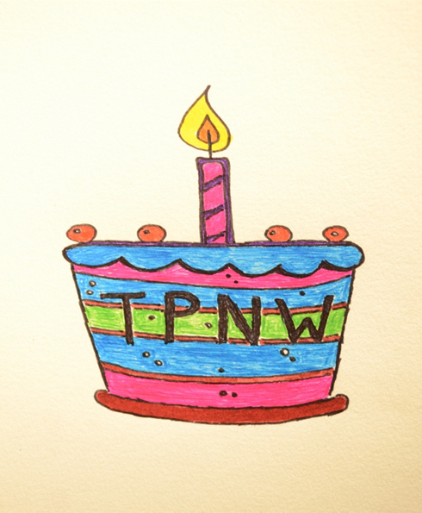The Treaty on the Prohibition of Nuclear Weapons went into effect one year ago today – on January 22, 2021.

In 1945 the U.S. dropped atomic bombs on two cities in Japan. No other nation has ever done that, but other nations – fearing for their own “national security” – have developed nuclear weapons. Since the 1940s the U.S. has led each step in escalating the nuclear arms race. A nuclear war could destroy human civilization.

The 1970 Nuclear Non-Proliferation Treaty (NPT) was a grand bargain in which the non-nuclear nations agreed never to get them and the nations that do have nuclear weapons agreed to promptly get rid of theirs. **For half a century the nations with nuclear weapons have been violating the NPT.**

**The rest of the world feels it is being held hostage by the nine nations that now have nuclear weapons, so they created the Treaty on the Prohibition of Nuclear Weapons (TPNW)**, and in July 2017 it passed the United Nations General Assembly by an overwhelming vote of 122 of the 193 nations there. This victory allowed the world’s nations to start ratifying the Treaty. The Treaty’s wording specified that 90 days after the 50th nation ratified it, the Treaty would go into effect for the nations that have ratified it. **The Treaty went into effect one year ago, on January 22, 2021, so today we’re celebrating its first anniversary.** As of today, 59 nations have ratified it.

The worldwide non-profit organization that has been promoting the Treaty is the International Campaign to Abolish Nuclear Weapons (ICAN, [**www.icanw.org**](http://www.icanw.org)). Their efforts won them the 2017 Nobel Peace Prize.

What the Treaty does:

For any nation that has ratified the TPNW, the Treaty prohibits that nation from developing, testing, producing, manufacturing, transferring, possessing, stockpiling, hosting, using or threatening to use nuclear weapons. It prohibits any kind of support whatsoever. It is amazingly comprehensive and powerful.

Why the Treaty is powerfully important:

**We have banned other kinds of weapons of mass destruction.  We must ban nuclear weapons too.  See this graphic:**

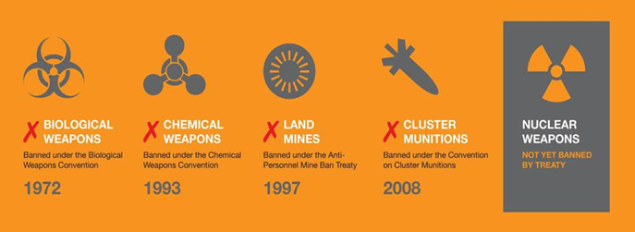

How you can learn more and take action:

The U.S. government and mainstream media have failed to inform the public about the Treaty. Ordinary people need to inform themselves. Peace organizations are working hard to provide the necessary information.

**JOIN US THIS AFTERNOON: Saturday January 22, 2022, from 4:30 to 5:30 pm** for a celebration with information, Holly Gwinn Graham’s music, the Olympia City Council’s proclamation, and more. Join as early as 4:15 for this 4:30 event through this Zoom link: [**https://us02web.zoom.us/j/3339624020?pwd=NWFGcTd2ZzJKcjZJelFHSHVBK0puQT09**](https://us02web.zoom.us/j/3339624020?pwd=NWFGcTd2ZzJKcjZJelFHSHVBK0puQT09)

Read a good article on the TPNW on pages 5-6 of this newsletter: [**https://orepa.org/orepa_newsletters/2414/**](https://orepa.org/orepa_newsletters/2414/)

When the Treaty went into effect, Glen Anderson interviewed Joanne Dufour for a February 2021 TV program. You can WATCH THE VIDEO and/or READ THE PRINTED SUMMARY here: [**https://parallaxperspectives.org/the-treaty-on-the-prohibition-of-nuclear-weapons-is-a-powerful-step-toward-peace**](https://parallaxperspectives.org/the-treaty-on-the-prohibition-of-nuclear-weapons-is-a-powerful-step-toward-peace)

See this list of many good sources of information: [**https://parallaxperspectives.org/nuclear-weapons-good-sources-of-information**](https://parallaxperspectives.org/nuclear-weapons-good-sources-of-information)

Locally, the Olympia Coalition to Abolish Nuclear Weapons has been organizing and conducting many strategically smart activities since 2017. To reach OCANW and/or get onto their informative e-mail list, contact Glen Anderson at either (360) 491-9093 or [**glenanderson@integra.net**](mailto:glenanderson@integra.net)

We are part of a savvy and effective statewide coalition, Washington Against Nuclear Weapons, which includes dozens of organizations throughout our state. Contact WANW at [**www.wanwcoalition.org**](http://www.wanwcoalition.org) or (206) 547-2630

An excellent source of worldwide information is the International Campaign to Abolish Nuclear Weapons (ICAN, [**www.icanw.org**](http://www.icanw.org)). Their efforts to win the U.N. General Assembly’s victory won them the 2017 Nobel Peace Prize.