P R O C L A M A T I O N

WHEREAS, the City of Olympia is a Nuclear Free Zone; and

WHEREAS, the City of Olympia is part of the world community; and

WHEREAS, national defense policy calls for retaliation in kind for any nuclear attack on the United States; and

WHEREAS, any use of nuclear weapons would result in innumerable deaths and casualties of innocent persons as victims of said use; and

WHEREAS, indiscriminate killing violates International Humanitarian Law and all moral principles at the heart of it's notion of humanity; and

WHEREAS, a conflagration threatening world wide death can result from involuntary errors, accidents or the reckless decisions of world leaders; and

NOW, THEREFORE, BE IT RESOLVED, the Olympia City Council, does hereby proclaim January 22, 2022, as the celebration of the first anniversary of the

UNITED NATIONS TREATY ON THE PROHIBITION OF NUCLEAR WEAPONS

SIGNED IN THE CITY OF OLYMPIA, WASHINGTON THIS 21st DAY OF JANUARY 2022.
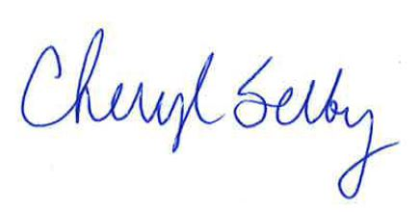
OLYMPIA CITY COUNCIL

Cheryl Selby, Mayor

