Little Blue Top
Dearly Beloveds:
Let’s change course as a Sentient Species and return to Being in exquisite harmony with the Fabric of Existence of which we are woven,
Before We
Cause the nuke-war we are lavishly preparing,
Slip into irreversible climate catastrophe,
Deepen the Anthropocene extinction,
…Shall we Agree to
Help gather a 100 million people to:
Declare Peace, Stop building killer robots,
Cease weaponizing diseases in secret factories,
Investigate evidence of controlled demolition on 9/11,
Raise taxes on the 1%, Strip corporations of Human Rights,
Join the International Criminal Court charged to try war crimes,
Quit using chemicals wreaking havoc in humans, birds, bees, whales,
Safely lay down nuclear weapons designed to “win” an atomic endgame,
Shrink the Military-Industrial-Scientific-Congressional-Drug-Thug Complex,
Repair government’s ability to regulate the safety of microwave communication,
Harness tides, wind and sun, hugely less dangerous than nuclear power!
Build windmills not warheads, solar panels on every roof, electric cars,
Clean up the battlefields, Shut down the weapons factories,
Fund a MIGHTY-FINE Green New Deal, AND
Leave fossil fuels in the ground.
As we connect our heart to our mind, we will
Discover our emotional body is part of Mama Gaia’s heart-song
and heal our inner homo hostilis’ post-traumatic stress.
Our growing intuition will help us KNOW whom to trust
among the voices competing to influence our thinking.
As Mark Twain said “It’s easier to fool someone
than to convince them they’ve been fooled.”
“If you never change your mind
why have one?”
Our brother-sister species
Pray we return to the sacred marriage,
celebrating our honored place in the dance,
as caretakers, co-creators of this earthly Paradise.
“All for one and one for all, united we stand divided we fall.”
Oh, Mystery – Help us awaken the “Better Angels of our Nature,”
and go forth singing with the Spring of Living Water on our planet,
Letting go of What’s in it for me? Instead, asking

…How can We Help Heal
Our Rainbow-blessed living Earth, Little Blue Top, spinning in space,
Traveling through the Milky Way with our Moon and Sun?

Happy Holidays 2021 dear People: I hope you resonate with “Little Blue Top.” I’ve included the following songs, internet links and sourcing of quotes and concepts to help explain my choice of words in the poem. I dedicate Little Blue Top to Greta Thunberg who said at the World Economic Forum, Davos, January 21, 2020: “We are telling you to act as if you loved your children above all else.”
Doug Milholland, Port Townsend

Artwork: peakpxwallpaper “nautilus-stars-planets-birth-creation…..
https://i.pinimg.com/originals/68/4d/68/684d68a790fd085c64963870b4e92ad9.jpg

There is work to be done, there is work to be done
with these hands, this heart, this mind.
there is work to be done, there is work to be done:
I’m on, on your side…
Sarah Nutting of Ma Muse
https://soundcloud.com/thebirdsings/work-to-be-done

Oh when we come into our calling
We become bells
Calling to everyone else
Oh come
Come into to your calling
Laurence Cole
https://www.laurencecole.com/

This life is a courtship
This life is a song
This life is the dance
of the place we belong…
Don’t ask what the world needs
Ask what what what what makes you come alive
Then go out and do it, go out and do it
Go out and do it now
Gretchen Sleicher
https://songsforthegreatturning.net/

https://www.youtube.com/watch?v=1x3RRrqJWKA The looking planet
https://www.youtube.com/watch?v=eAZRQI50gzE UN treaty prohibiting nuclear weapons
https://www.lyrics.com/track/1074854/Paul+Robeson/Ballad+for+Americans Mighty Fine!
https://www.youtube.com/watch?v=09maaUaRT4M Inducing Mass psychosis
https://www.youtube.com/watch?v=Aw16LPVnNco On the danger of glyphosates
https://www.youtube.com/watch?v=wL5ucB3AbUs Ocassio Cortez & Sanders
https://www.youtube.com/watch?v=D6tKg8WQ3ts playing flute to humpback whale
Top of Form
Bottom of Form
https://www.youtube.com/watch?v=wih8Y6Lyz8I pianist plays to sheep
https://www.youtube.com/watch?v=NoxC5QLIUdo Are we being communicated with???

Quotes & concepts in the poem:
Mark Twain “It’s easier to fool someone than to convince them they’ve been fooled.”
Edward Debono “If you never change your mind - Why have one?”
Alexander Dumas “All for one and one for all, united we stand divided we fall.”
Paul Robeson “Mighty Fine” found repeatedly in his epic poem “Ballad for Americans.”
Abraham Lincoln “Better Angels of our Nature,”

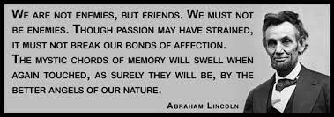

“…our emotional body is part of Mama Gaia’s heart-song:”
“The world is not a problem to be solved; it is a living being to which we belong. The world is part of our own self and we are a part of its suffering wholeness. Until we go to the root of our image of separateness, there can be no healing. And the deepest part of our separateness from creation lies in our forgetfulness of its sacred nature, which is also our own sacred nature. — Llewellyn Vaughan-Lee”
― Joanna Macy, Coming Back to Life: The Updated Guide to the Work that Reconnects

“As we connect our heart to our mind…” “As you bring your physical, mental and emotional systems into coherent alignment, you begin to experience increased access to your heart’s intuitive guidance. Tuning into your heart’s wisdom creates a profound shift within that helps you approach situations with more emotional balance, compassion, clarity and personal confidence. “Dare to connect with your heart. You will be lifting not only yourself and those you love and care about, but also the world in which you live.” – Doc Childre, HeartMath Founder https://www.heartmath.com/

“…And go forth singing with the Spring of Living Water on our planet:” the term Water of Life refers to the Holy Spirit. https://en.wikipedia.org/wiki/Water_of_Life_(Christianity)

The Military Industrial Complex:
“Dwight Eisenhower … warned in the speech about the “military-industrial complex.” But in the original draft, Eisenhower was to warn not only of a “military-industrial complex” but of a “Military-Industrial-Scientific Complex”…. …People must be “alert” that “public policy could…become the captive of a scientific technological elite.” …the Manhattan Project, was—and is—the base for much of the scientific establishment about which Eisenhower was concerned. After the war’s end, …the push was on for all sorts of other things atomic..—anything to bring more activity and money to the vested interests established during the war.”
http://karlgrossman.blogspot.com/2009/03/military-industrial-scientific-complex.html
The Military Industrial Scientific Congressional Complex
“Congress, as usual, went where the money was. Defense-related jobs served as a major determinant of congressional defense decisions for both liberals and conservatives. Members of Congress strove to steer contracts and subcontracts to favored constituents, who rewarded them in turn with lavish campaign contributions, votes, and other payoffs. Congressional micro-management of the defense program grew ever more elaborate as lawmakers grasped new opportunities to control the disposition of defense resources.”
https://www.independent.org/publications/article.asp?id=141
The Military Industrial Scientific Congressional Drug complex
“From statements by U.S. Ambassador [to Iran] Richard Helms, there was little heroin production in Central Asia by the mid 1970s,” Professor Alfred McCoy, author of “The Politics of Heroin: CIA Complicity in the Global Drug Trade,” told MintPress. But with the start of the CIA secret war, opium production along the Afghanistan-Pakistan border surged and refineries soon dotted the landscape. Trucks loaded with U.S. taxpayer-funded weapons would travel from Pakistan into its neighbor to the west, returning filled to the brim with opium for the new refineries, their deadly product ending up on streets worldwide. With the influx of Afghan opium in the 1980s–Jeffrey St. Clair, co-author of “Whiteout: The CIA, Drugs and the Press,” alleges–heroin addiction more than doubled in the United States. https://mronline.org/2021/06/29/geopolitics-profit-and-poppies-how-the-cia-turned-afghanistan-into-a-failed-narco-state/
The Military Industrial Scientific Congressional Drug Thug Complex https://www.youtube.com/watch?v=2pT7-Lep6-0
In August 2002, the UN published a report which cited a series of international laws and conventions breached by the use of DU weapons, including: the Universal Declaration of Human Rights; the UN Charter; the UN Genocide Convention; the Convention Against Torture; the four Geneva Conventions of 1949; the Conventional Weapons Convention of 1980; and the Hague Conventions of 1899 and 1907 which all forbid the deployment of “poison or poisoned weapons” and “arms, projectiles or materials calculated to cause unnecessary suffering”.
According to a recent CNN report, Pentagon and UN experts have estimated that US-led military forces used between 1,100 and 2,200 tonnes of depleted uranium during the invasion of Iraq. The amount far exceeds the 300 tonnes of depleted uranium used in the 1991 Gulf War and the 10 tonnes used by NATO forces during the bombing of Serbia in 1999. https://www.wsws.org/en/articles/2003/05/depu-m29.html
Hence the phrase “Military-Industrial-Scientific-Congressional-Drug-Thug Complex”

“Join the International Criminal Court charged to try war crimes”
The International Criminal Court, established in 2002, seeks to hold to account those guilty of some of the world’s worst crimes. https://www.cfr.org/backgrounder/role-international-criminal-court
CIA “black sites”—secret locations where covert actions, such as interrogations, can take place—in Lithuania, Poland, and Romania, again primarily in 2003–04 but in some cases stretching back to mid-2002. https://www.cfr.org/article/iccs-probe-atrocities-afghanistan-what-know https://www.counterpunch.org/2021/12/21/confirmation-bias/
https://www.google.com/search?client=firefox-b-1-d&q=american+war+crimes+book
https://www.youtube.com/watch?v=2pT7-Lep6-0

“Investigate key evidence of controlled demolition on 9/11”
https://www.ae911truth.org/evidence/evidence-overview
https://www.amazon.com/11-Dr-David-Ray-Griffin/dp/B000O0YV7O#customerReviews

“Cease weaponizing diseases in secret factories,” “In this century, it is widely predicted that advances in biology and biotechnology will revolutionize society and life as we know it. The “next generation” of biological weapons made possible through genetic engineering will be asymmetric weapons par excellence” https://irp.fas.org/threat/cbw/nextgen.pdf
https://www.google.com/search?client=firefox-b-1-d&q=bioweapons+books

“the Anthropocene extinction”
The planet's biodiversity is plunging, with a quarter of species facing extinction, many within decades. Numerous experts believe we are living through, or on the cusp of, a mass species extinction event, the sixth in the history of the planet and the first to be caused by a single organism—us.^{[67]}
https://en.wikipedia.org/wiki/Holocene_extinction

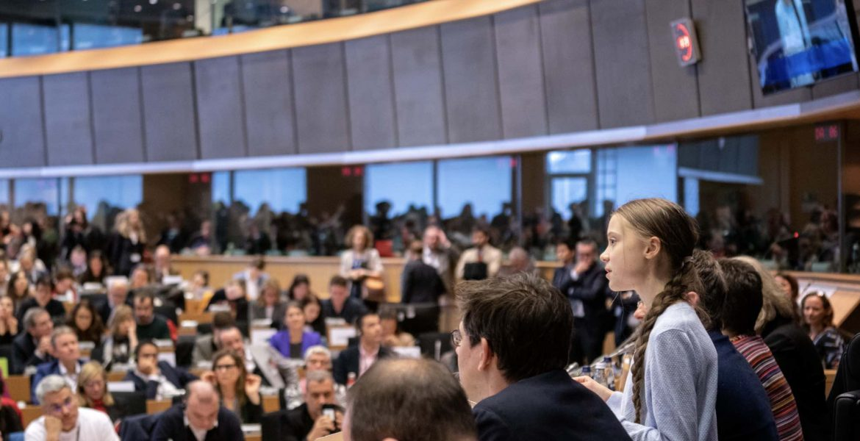
“On climate change we have to acknowledge that we have failed. All political movements in their present form have done so. And the media has failed to create broad public awareness. But Homo sapiens have not yet failed… We are facing a disaster of unspoken sufferings for enormous amounts of people. Now is not the time for speaking politely. Now is the time to speak clearly.
Solving the climate crisis is the greatest, most complex challenge that Homo sapiens have ever faced. The main solution is so simple that even a small child can understand it. We have to stop the emission of greenhouse gases… The bigger your carbon footprint is, the bigger your moral duty. The bigger your platform the bigger your responsibility.
Adults keep saying we owe it to the young people to give them hope. But I don’t want your hope, I don’t want you to be hopeful. I want you to panic… I want you to act as if you would in a crisis. I want you to act as if the house was on fire, because it is.”
Greta Thunberg, World Economic Forum, Davos, January 25, 2019

