“Glen’s Parallax Perspectives” is a series of TV programs offering fresh ways for people to see issues such as foreign policy, social and economic justice, governmental functioning, the environment, and so forth. We provide voices and viewpoints that are rarely heard in mainstream media.
Mainstream media, politicians, and culture see the world in conventional ways. Therefore, in order to solve problems, we need to see things in fresh ways. Glen Anderson created this TV series to help people see things differently so we can solve problems at all levels from the local to the global.
This series title refers to “parallax,” which is the view you get by looking from a different perspective. For example, put one finger in front of your nose and another finger farther away. Close one eye. Then open that eye and close the other. Your fingers will seem to move. This is called a “parallax” view. This TV series invites you to look at issues from fresh perspectives.

Each program airs three times a week (currently every Monday at 1:30 pm, every Wednesday at 5:00 pm, and every Thursday at 9:00 pm) for the entire month on Thurston Community Television (TCTV), channel 22 for cable TV subscribers in Thurston County, Washington. TCTV is part of Thurston County Media. You can see their schedule at www.tcmedia.org
You can also watch the program described below through your computer at www.parallaxperspectives.org. All episodes of “Glen’s Parallax Perspectives” are posted on this blog’s “TV Programs” part and also in one or more of the categories listed in the right side of the computer screen. Also, see information about various issues at the category headings at www.parallaxperspectives.org.

This summary includes some information and insights that we did not have time to include during that hour. Many of these are ideas that a guest or Glen had generated while preparing for the interview. These additional insights are added under the relevant topic headings below.
I’m saving this document in two formats: Word and .pdf. The Word format’s links are live. The .pdf format retains the detailed formatting. If you’re reading the .pdf format and want me to e-mail you any of the links I mention here, e-mail me at glenanderson@integra.net and I’ll promptly send you the links you request.
Please invite other people to watch this video and/or read this thorough summary at these parts of my blog, www.parallaxperspectives.org: “TV Programs” and “Climate” and “Young People.”

“Teenagers for Climate Action”

March 2021 Program in the “Glen’s Parallax Perspectives” TV Series
by Glen Anderson, the TV series’ producer and host
(360) 491-9093
glenanderson@integra.net
www.parallaxperspectives.org

Glen introduced the viewers to this month’s interview topic and guests:

This month’s interview on “Glen’s Parallax Perspectives” helps us move ahead toward solving the climate crisis. The interview helps people of all ages understand why young people are so deeply concerned – and it informs us of some of the positive ways teenagers are taking action.
Our guests are two juniors at Capital High School in Olympia, Washington. Glen has enjoyed working with them in the past, and he is delighted Rebecca McMillin Hastings and Karina Greenlee are the guests for this interview. They introduced themselves:
Rebecca said she is a junior at Capital High School and is president of her school’s Climate Club. She said she has been a climate activist for a year or two now, and she is excited about serving as a guest for this TV interview.
Karina said she is 16 years old and is vice president of Capital High School’s Climate Club. She said she has been a youth climate activist as long as Rebecca has.
Glen said he very much enjoyed working with Rebecca, Karina, and about ten other high school students who care strongly about the climate when they took his series of workshops last spring about how to organize nonviolent grassroots movements for good issues. He said all of the students in those workshops were amazingly bright and had great wisdom and positive attitudes toward solving the climate crisis and other problems around us.

What have scientists been saying about what has been happening?

Glen said he would start by making sure our TV viewers understand the basic scientific information about the climate crisis.
The scientific evidence of the climate crisis is very clear – and very powerful. It is important for ordinary people to understand the reasons why the climate has been suffering. He said he would summarize the problems in clear, easy-to-understand ways and show some visual images. Then after these first few minutes, our guests will share the rest of our hour discussing their experiences, their activities, and their recommendations.
Glen said all three of us in this interview – and probably all of the people watching this TV program – care about the world we live in. We all care about the beautiful, intricate natural world and want to protect its sustainable ecosystems of diverse plants and animals. We all want to protect a healthy world where younger people will be able to thrive long into the future.
He urged us to recognize that all life on earth is part of one interconnected system. What we do to any part of earth’s environment affects everything else. This helps us recognize the need to protect every part of earth’s ecosystems – and the climate that supports us all.
He summarized the realities that scientists agree upon – summarized the facts briefly in an easy-to-understand way – and showed on the TV screen some visual images illustrating what scientists have learned about the climate crisis.
The end of this document provides links additional information about the climate. He said he would post this interview and the document you are reading now to two parts of his blog – www.parallaxperspectives.org at both the “TV Programs” part and the “Climate” part.
He said these next few minutes summarize information he had compiled five years before (in January 2016) to explain the climate crisis to an audience of dozens of senior citizens. They understood the message. Now – five years later – the scientific data have gotten even worse than they were five years ago. We need to understand this in our hearts as well as in our heads.

IMAGE #1:
People talk about “global warming.” Since 1880, temperatures have indeed risen worldwide, as this graph from NASA shows rapidly increasing temperatures since about 1900:
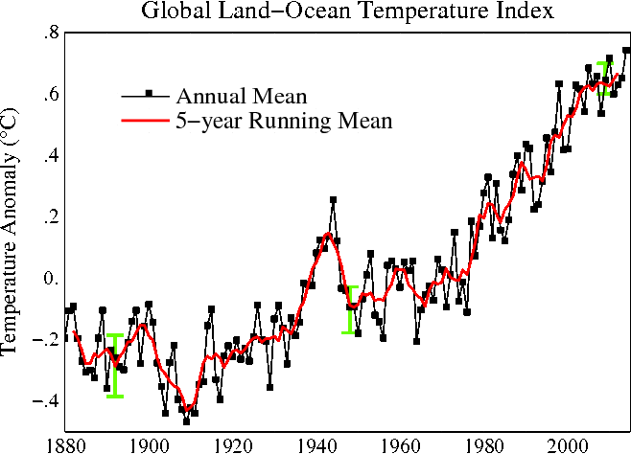
The source for this graph is http://data.giss.nasa.gov/gistemp/graphs_v3/Fig.A2.gif
IMAGE #2:
If you look longer back into history – the past 2,000 years – you see temperatures rose very sharply and very rapidly only after about 1900. The trend got even worse after this graph’s data ended in 2004. (Ignore the color coding.):
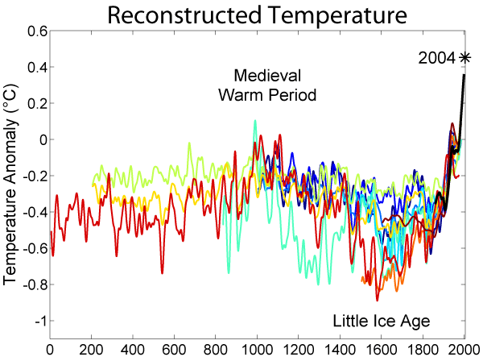
Source: https://en.wikipedia.org/wiki/Temperature_record_of_the_past_1000_years#/media/File:2000_Year_Temperature_Comparison.png

In the natural world, changes occur over VERY, VERY LONG periods of time. We must understand why the earth’s temperatures suddenly increased so very sharply and suddenly in just about the past 100 years.
Burning fossil fuels such as coal, oil or natural gas produces carbon dioxide (CO₂) as a waste product. When carbon dioxide (CO₂) pollutes our atmosphere, it acts like a blanket that traps heat within earth’s atmosphere so it cannot escape into cool space. Trapping the heat close to earth’s surfaces heats up the land and heats up the oceans too.
Heat makes water evaporate. Warmer oceans cause more water to evaporate, so more water vapor goes into the atmosphere and increases the amount of rain that falls – sometimes in extremely heavy downpours that cause flooding.
Changes in the atmosphere disrupt global weather patterns. They cause more storms and stronger storms. They disrupt the atmosphere’s jet streams, and cause a variety of disruptions all over the world, including extreme heat waves and droughts. These prevent many farmers from growing food, so they force people to migrate to other parts of the world. Climate disruptions also have disrupted ocean currents and caused problems for fish migrations.
People might wonder how much carbon dioxide in the atmosphere is too much. Scientists say anything above 350 parts per million is too much. (See three graphs on pages 4 and 5.)
Since the beginning of human civilization, our atmosphere contained about 275 parts per million (PPM) of carbon dioxide. Life on earth adapted to 275 parts per million, and civilization was able to develop and sustain itself. But increasingly since the 1800s, humans began to burn so much coal, oil and natural gas that we have disrupted the chemistry of our atmosphere and our oceans. Now oceans have so much acid in them that fisheries and coral beds are dying.
For millions of years, Mother Nature has been storing carbon in the earth as fossil fuels (coal, oil and natural gas). But now in a very short of time we have been digging up those ancient fossil fuels and burning them and polluting our atmosphere with carbon dioxide. We have rapidly – in effect – thrown a climate-disrupting blanket over the earth and warmed our climate to an extent that is more extreme than humans have ever experienced on earth.
Nearly all scientists agree that our atmosphere could tolerate an increase of carbon dioxide from the natural level of 275 parts per million to a maximum of 350 parts per million (PPM).
In December 2015 we blew through the 350 maximum and reached more than 400 parts per million!
The amount of CO₂ kept rising rapidly to nearly 410 PPM in 2019. This is extremely, extremely dangerous to life on earth! The last time our atmosphere had this much CO₂, humans did not even exist! This graph shows we now have the highest CO₂ level ever in the past 800,000 years!

IMAGE #3:
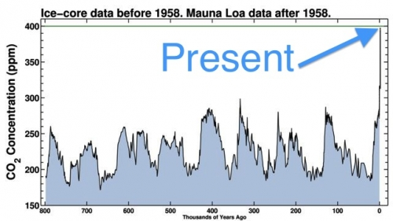
IMAGE #4:
The data in this next graph go only to December 2015. It got much worse in the five years since then to nearly 410 PPM in 2019!
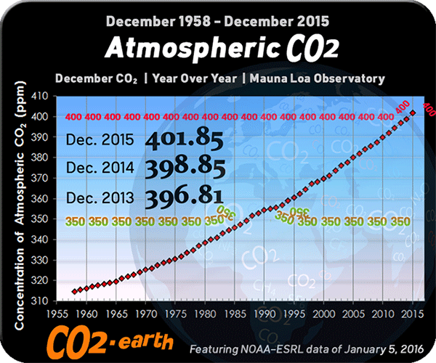
Source: http://co2now.org/

The climate crisis is NOT ONLY a future disaster. We are ALREADY seeing the results of rapid climate disruption! The trend is still going up! EVERY YEAR:
- We are experiencing even worse record-high temperatures all over the world.
- We are breaking records in naturally hot areas – and we are experiencing heat waves even in the Arctic. (See page 15)
- We are seeing massive melting of ice in the Arctic, Antarctic, Greenland, and the world’s glaciers.
- We are experiencing record-high droughts, rainstorms, and hurricanes.
- We are triggering a variety of tipping points and irreversible impacts. (See image on page 6)
All over the world, scientists – and people of all ages – including millions of young people – are telling us we must take strong actions immediately.
The world’s politicians and business leaders say nice things, but they refuse to take the very strong actions that are necessary. (See youth reactions on pages 16-17)

IMAGE #5:
In order to maintain a livable earth, it is absolutely necessary to take bold, immediate actions to sharply reduce CO₂ pollution and return to below 350 parts per million. (The crisis is worse now at 410 PPM than this 5-year-old graph shows.)
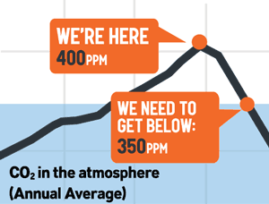
Source: www.350.org

Let’s consider the words we use – and the realities hidden by those words:
- The term “global warming” might sound pleasant to people who live in areas with cold winters.
- The term “climate change” might sound neutral, because “change” can be either good, bad, or merely different.
But BOTH of these terms are misleading euphemisms, because the reality is so much worse!
What is really happening is not merely “warming” or “change.” What is really happening is climate disruption and climate chaos. The climate patterns that have existed for many hundreds of thousands of years – to which plants, animal and humans have adapted over many hundreds of thousands of years – are being rapidly torn up and thrown around.
The jet stream is sending some people’s weather to other places. Plants, animals and people are suffering by no longer being able to survive in their seriously disrupted environments.

IMAGE #6:
Climate disruption is already causing many feedback loops that are causing a variety of very serious problems for people and environments all over the world.
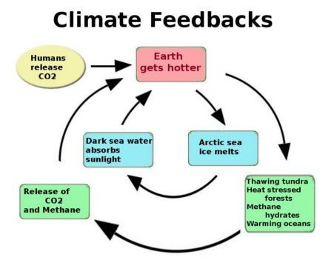
We did not have time to say this during the TV program:

The world’s leading scientific authority on climate change – the Intergovernmental Panel on Climate Change (IPCC) – has been issuing statements affirming that the world’s climates are being disrupted. Over the years – based on more and more scientific proof – the IPCC’s statements have been expressing greater and greater certainty that it is happening – and also increasing the certainty of the IPCC’s conclusion that humans are causing it. Also, the IPCC’s statements have been expressing increasing alarm about the seriousness and urgency of the climate crisis.
Insurance companies are very rational and conservative. They devote huge amounts of effort and resources into measuring and calculating the likelihood that they will have to pay out for various kinds of claims. Insurance companies’ calculations of risk are very accurate.
For a number of years insurance companies have become increasingly afraid of climate chaos. They worry that the climate crisis will cause damage that will cost them many hundreds of billions of dollars. Climate chaos would not only cause immediate damage claims from storms, floods, landslides, and so forth, but would also result in claims for serious droughts and crop losses, damage resulting from food riots, and so forth.
Insurance companies are hard-core capitalists, NOT radical left-wing organizations!
Scientists are in consensus that humans caused the climate crisis!
The consensus among scientists is very strong. Learn about it by visiting the website of The Consensus Project at www.theconsensusproject.com
Several years ago they analyzed 21 years’ worth of peer-reviewed papers (scientific reports reviewed and critiqued by other scientists) dealing with “global warming” or “global climate change.” They reviewed 12,465 papers and more than 4,000 abstracts authored by more than 10,000 scientists that stated a position about whether humans have caused this. They found that 97.1% of the abstracts and 98.4% of the scientists endorse the consensus.
Their website www.theconsensusproject.com has solid information and states it clearly.
Think about this: If you are experiencing serious health problems and ask 100 doctors diagnose your symptoms, and 98 of the 100 agree on the diagnosis and agree that your life depends on urgent treatment, would you deny those 98 doctors’ warnings because 2 other doctors out of 100 were not yet sure? Climate “deniers” are risking our safety in that way.

Glen apologized for talking so long. He said that fortunately our guests will do most of the talking during the rest of the interview.
He said that when we were preparing for this interview, Rebecca urged everybody to educate themselves and make their own decisions based on the evidence. Now she expressed appreciation for Glen’s summary of the scientific realities. She emphasized the fact that scientists really do agree about the climate facts, but the media and popular culture fail to assert this. The most important climate facts are not really contentious among scientists. Temperatures really are rising. Ocean acidity, sea level rise, and other facts are confirmed by many scientific sources. She said these facts “are widely accepted in the scientific community.”
Glen added that climate scientists have the same amount of consensus about the basic climate facts as medical experts do about the health dangers of smoking tobacco. He said that many of the few “climate deniers” are funded by oil companies or other conservative entities. They say, “We don’t really know yet. Let’s wait and figure this out later.”

Climate crisis is NOT ONLY for the future.
What has been happening RECENTLY and NOW – globally, nationally, locally?
How is the climate crisis ALREADY affecting us?

Glen said some people think about the climate crisis as a problem that might arise in the future. They think young people can solve the problem after they grow up. Actually, the public needs to understand the scientific facts he presented a few minutes ago that prove that climate disruptions have ALREADY been happening – both in the U.S. and around the world.
Karina said climate disruptions are ALREADY happening in various parts of the world. The public has probably heard about ice melting in the Arctic and hurricanes and other natural disasters all over the world that have been caused by climate disruptions.
She said people living locally here in Olympia might not feel connected with these global events, but the climate crisis has already been affecting our community. Recent wildfires are one example. She said when she was little she never had to stay inside because of wildfire smoke. She has watched the problem get worse in the past few years. She said this past summer the smoke prevented her from doing her cross-country running – or even being outside very much. The climate crisis is already affecting us here in the Olympia area, and she emphasized that it is affecting people much more seriously in other parts of the world.
Rebecca agreed with what Karina said, and she added that Arctic ice melting has already been hurting the habitat that animals need, and it has already been interfering with Native people’s hunting. Within our own nation the hurricanes and wildfires have been getting more severe.
She said locally the wildfire smoke has been severe. Glen expressed empathy for both Karina and Rebecca, who enjoy a lot of cross-country running – except when smoke from wildfires prevents that.

Rebecca’s experience high up in the Andes Mountains in Peru:

Rebecca said that for a few months in early 2018 she and her family lived in the high Andes Mountains of Peru. Their small rural community relied heavily on agriculture for its livelihood.

Local people there said they were having a lot of problems because they did not have enough rainfall.

Also their glaciers were receding, and the glacier water had been an important source of water for their agriculture.

The local residents did not have enough water for their own needs, let alone the water that their agriculture. This helped her understand how serious the climate crisis is and how it affects people.

This is everybody’s present and future! How do young people feel about what has been happening recently – and what is likely in the future?

Glen expressed appreciation for previous opportunities to work with Karina and Rebecca and other young people. He said that all around the world – and here locally – young people have shown leadership in organizing to protect the climate. Both of our interview guests have been working with students at their high school to deal with the climate crisis. Students at other high schools have been working too.
Karina said many teenagers she knows are very, very scared about the climate crisis – and are really depressed.
She said the more she involved herself in learning about the climate and working on it, she moved from an initial concern to discovering how complicated it is. “We try to do so much for this planet, but when we think about the reality of what we’re facing, it feels like we’re doing so little.”
She said, “When I look around, I see all of these people in power doing so little compared to what they could be doing and what they should be doing. It’s a really scary place to be.”
She added, “I think it’s really hard for teenagers right now to look at their futures because – honestly – we don’t know, and what we honestly expect our lives to be like – if there is no action taken to protect the climate – it’s a pretty scary thought.”
She also said that teenagers here are afraid for what their futures might be, but “there are so many teenagers in other parts of the world who are experiencing right now what we are fearing.” She summarized that there is a lot of fear among people her age about the climate crisis.
Rebecca agreed with everything Karina said, and she added the word uncertainty as a major factor. The climate crisis causes young people to feel uncertain about what the world will look like and what their futures will be.
She also said, “We as privileged individuals don’t know what other people are going through right now – and we’re worried that that’s what’s going to happen to us.” The climate crisis is “already affecting so many people across the world.”
Glen said he had worked with both of these teenagers and other people about big scary issues. He said he tells people that when we work with big scary issues such as the climate crisis or nuclear weapons or whatever, we need to empower ourselves so we can solve those problems. People who are in denial and try to run away from paying attention are disempowering them even further. We must inform ourselves and empower ourselves in order to solve the problems.
He expressed appreciation for the efforts of Karina, Rebecca, and other people who confront the big scary issues head-on and empower themselves and take practical actions to solve them. This approach actually does empower people, which is what we need in order to succeed. Empowering ourselves is a great way to counter the fear that is out there, so we can put ourselves more in control of our own lives, because we are doing good things. He said he conveys this approach in the workshops he conducts about grassroots organizing.

What NEEDS and VALUES motivate you to deal with the climate crisis?

Glen said that usually when anyone of ANY age volunteers to work on ANY important issue, they are motivated not only by the facts out there in the world, but also how that issue affects them personally, and also by the NEEDS and VALUES they hold in their hearts that cause them to get involved and take action. He invited Rebecca and Karina to share the needs and values that have motivated them to deal with the climate crisis.

Rebecca said the wildfires caught her attention strongly. Three years ago when the smoke first affected Olympia, that was very scary because she recognized personally that the climate crisis was not just an abstract concept, but it was affecting her directly along with everybody else. She recognized that it is a big problem already.

When she sought out more information about the climate crisis she discovered how much people are already suffering. She applied her own personal values to work on the issue because the people who are suffering the worst are the people who were least responsible for causing the problems. The people who were not suffering were those who were primarily responsible. She said this did not seem right to her.

Glen said a lot of the climate activism has come out of the global south more than from the rich industrial countries.

Karina said she could not pinpoint a specific time when she started to care about the climate. She said her childhood was extremely connected with the outdoors. She went to a school that was primarily outdoors. Her parents did a lot of things outside with her. When she grew older she gradually learned about the climate crisis. She knew this planet was important and we need to protect it, but not everybody was protecting it.

Nor was there any point when Karina decided to become an activist. This is part of how she has always been. She recognizes that she has privilege that many people do not have, so she is in a position where she can make change. She has always felt responsible for taking necessary actions, while many other people do not have as much power or responsibility. “I have power to make the world a better place.”

Before discussing Rebecca’s and Karina’s local activities, we summarized what young people have been doing elsewhere in the U.S. and worldwide.

Glen affirmed the wider nationwide and international context in which our two young guests have been acting. Other young people all over the U.S. and all over the world have been taking positive actions for the climate.
Rebecca said everybody has heard of Greta Thunberg and other people who have taken bold actions worldwide and inspired the youth climate movement. In 2018 when 15-year-old Greta Thunberg began a school strike for the climate, a global climate student strike movement started. Rebecca mentioned the sponsoring organization www.fridaysforfuture.org. Rebecca mentioned Jamie Margolin, co-founder of Zero Hour (www.thisiszerohour.org). These and other youth climate activists around the world have been influential in inspiring other young people to organize wherever they live.
Rebecca said she had the privilege of working with youth climate activists from South America (most of them Spanish speakers). Their youth climate group helped her learn about international youth climate activism.
Glen said some bold, exciting lawsuits have been filed in the U.S. and in other countries. He said some of these lawsuits made good progress, but some were thrown out of court for technical legalistic reasons. The legal struggles are ongoing. These lawsuits raise important, compelling issues. He said, “Basically, they intend to hold legally accountable the adult world that has been screwing over the futures of the younger portion of the world’s population.” (See page 16 at the end of the document you are reading now for links to articles about these.)

LOCALLY, what have YOU and other high school students been doing?

Glen said he met Rebecca and Karina – and some of their friends – a few years ago on one of the days when young people in Olympia and around the world were conducting a “climate strike.” High school students were holding signs in downtown Olympia. He said some of his friends participated in a rally at the State Capital steps that young people had organized.

1. “Listen Up!” webinar with TCAT on Saturday September 26, 2020:

Glen said that on Saturday, September 26, 2020, Karina, Rebecca, and three other high school students shared their information and insights with the public in a Zoom video webinar titled “Listen Up! Youth Voices on Climate Action.” This project was supported by the Thurston Climate Action Team (TCAT), which includes several groups with special focus (trees, agriculture, transportation, and young people (“Youth Education Community Outreach”).
TCAT’s website, www.thurstonclimateaction.org, has the video available for people to watch nowadays at this link: https://thurstonclimateaction.org/youth-education-community-outreach/. The direct link to their webinar video is https://www.youtube.com/watch?v=t1w-hys19A0 Glen said he watched it live last September and again recently. It’s a good program.
Karina said they organized the “Listen Up!” webinar in order to communicate young people’s concerns about the climate to adults who care about the climate, and also to all other adults.
She said youth climate activists wanted to share their unique issues and unique perspectives. She said some adults praise young climate activists in rather dismissive, patronizing ways rather than listen to what the youths are actually saying.
Their “Listen Up!” webinar discussed what young people are feeling about the climate and the pressure they feel to solve this huge problem. They discussed how they want their future to be – and what they fear is very likely if people do not take strong enough actions now. They encouraged bold actions now by adults in order to prevent terrible things from happening.
Glen said he appreciated seeing early publicity promoting their “Listen Up!” webinar far enough in advance that he was able to publicize it widely. During the Zoom event, he saw the faces of many people to whom he had sent his publicity, so they actually did participate.

2. High school climate clubs at Olympia, Capital, etc. – and their various activities:

The Capital High School Climate Club includes a number of active students, including Rebecca (President) and Karina (Vice President). Rebecca said her school’s Climate Club has been going for about a year and a half. She said this year they are focusing on activities that can be repeated year after year, so they can form a base or structure from which future activities can be launched. They are committed to strengthening their Climate Club so it will continue long after the current group of students has graduated.
When Earth Day occurs in April, they want to hold a virtual assembly, since an in-person assembly won’t be possible. They want Earth Day assemblies at their school to continue every year.
Last year they participated in the youth-organized Climate Strikes. She described these as incredible and amazing, with about 2,000 students participating in one of them.
She said the Climate Club’s mission includes communicating among themselves, educating, organizing, and working in various ways to solve climate problems, promote climate justice, and make the world a better place.
People can e-mail their high school’s climate club at capitalclimateclub@gmail.com. Contact the club through Instagram in this way: @capitalclimateclub
Glen mentioned that Olympia High School has a Climate Action Club that advocates for good legislation and public policies, and they also have an Earth Corps that conducts activities that help our local community. Probably some other high schools have clubs too, but he said he has had the most contact with students in the clubs at Capital and Olympia.
Rebecca sees great potential for high school students to organize for the climate with school-based clubs. She said the system of clubs within high schools creates opportunities for students to reach out to each other and join together in organized ways to work for the climate.
She also is enthusiastic about reaching out to other community organizations and creating bonds across high schools too. She said the climate clubs at Capital and Olympia have informal but very close working relationships. They have collaborated to accomplish a number of activities and events, including the “Listen Up!” webinar that we mentioned a moment before. Some organizations that are not limited to young people can connect them with other organizations, including youth-oriented ones.
Glen said that capitalclimateclub@gmail.com is a good way to contact them, and Karina reinforced this invitation.

3. Mentoring younger kids:

Glen said adults are interested and inspired to learn that high school students are informing and empowering themselves to deal with the climate crisis. He said he is encouraged also to discover that Karina, Rebecca, and other high school students are planning how they might mentor people who are younger than themselves. He said that in relation to our two TV guests, he is an old geezer, but those two teenagers – in relation to younger kids – are “the big kids.” He said this is exciting and encouraging.
Karina said she is very enthusiastic and could talk about this all day, but she would speak only briefly now. She said they started discussing this potential last summer. She agreed with Glen that adults think about teenage climate activists as “the future,” but they recognize that people younger than them are really the future, so they need to reach out now to middle school and elementary school students, “who are even more of the future than we are.”
She said she and Rebecca and their friends started working on the climate while they were in high school. She said, “We had to get our own bearings and make our own connections” and figure out how to proceed. So she continued, “What if there could be a program where high school students mentored the next wave of climate activists – the ones who will follow in our footsteps when we leave and go to college?”
Then she said, “When they are high school climate activists, they will know so much more than we do.” She said younger kids might see high school climate activists in public settings holding signs or on this TV program and feel inspired to do what they can do to help the climate. She, Rebecca, and other high schoolers want to help these younger students.
She suggested a starting a mentoring program this year either one-to-one or with small groups (as COVID might allow) and expanding it next year. They are thinking of calling it “In Our Hands.” She said Elsie Sabel, another high school climate activist who helps to lead Capital Climate Club, thought of that name. People keep saying the future is in the hands of young people, so this sense that “the future is in our hands” creates the opportunity to hold the hands of younger people who are now in middle school or elementary school, “so the future can be in their hands as well.” They are working with the school board and hoping to start a pilot program next semester.
Glen said he was happy to hear Karina mention Elsie Sabel’s participation. He enjoyed reading Elsie’s article in the January 2021 issue of Works in Progress, a local publication that covers many issues. It was part of the creative writing project we discussed next. (See the next page.)

4. Creative writing project:

Glen said a few months ago he heard that Karina and other folks had organized a project so teenagers could produce creative writing about the climate, and he was excited about the possibilities. This project was coordinated through the youth group within Thurston Climate Action Team (TCAT, www.thurstonclimateaction.org). The direct link is www.thurstonclimateaction.org/youth-education-community-outreach/

Two of their writings appeared in the January 2021 issue of Works in Progress, as he had mentioned just now. Karina and TCAT’s Youth Education Community Outreach (YECO) arranged for a booklet containing a number of writings from this project. Read the booklet at this .pdf link: Cli-Fi-YECO-1.pdf (thurstonclimateaction.org)

Karina said Capital High School’s Climate Club created this opportunity as a challenge for teenagers in the Olympia area to write fiction that would raise people’s awareness of the climate crisis. They knew stories could be very powerful, so they encouraged teens to write fiction about experiences with the climate crisis – perhaps current experiences or future experiences after we have solved the climate crisis or fears about experiences if we fail to solve the climate crisis.

She said she was fascinated to read the stories because every writer had very interesting perspectives. She said she was struck by the fact that most of the stories were grounded in fears of what might happen. She said “this really drove the point home for me of the existential dread that we’re all feeling.”

Karina said the booklet was becoming available, and Glen said he would provide the link so everyone can read the booklet. Here is the link to TCAT/YECO’s booklet of student writings: www.thurstonclimateaction.org/youth-education-community-outreach/

We did not have time to say this during the TV program:

Glen appreciates the insights and creativity that people can express through any kinds of creative arts (creative writing, music, visual arts, and so forth). Glen especially appreciates the power of humor and satire.

He created two satirical items and posted them to his blog. See these links:
#1: Now you can STOP WORRYING about Sea-Level Rise. Glen wrote and posted this to his blog. The next time you buy a new vehicle, order the Sea-Level Rise Suspension Package. Click the link in this ad at Glen’s blog: Now you can STOP WORRYING about Sea-Level Rise. – Glen's Parallax Perspectives
#2: When sea level rise drowns downtown Olympia, here is a creative vision: When sea level rise drowns downtown Olympia, here is a creative vision. – Glen's Parallax Perspectives

Our society needs to empower young people:

Glen said he is 72 years old now. When he was a teenager, it was very common for adults to dismiss and trivialize teenagers as if our thoughts and feelings did not matter. People talked about a “generation gap” then, and a “generation gap” still exists.

He expressed appreciation for young climate activists’ efforts to communicate across age groups. He asked how to improve the communication.
Rebecca said the adults she and her colleagues have been working with have been amazing, respectful and supportive. She said communication is very important, and sometimes it is hard. Talking effectively – as we are doing during this interview – helps people find common ground. Some adults remember things about the environment that they enjoyed during their childhoods that they want their children and grandchildren to be able to enjoy still. Older people want to protect environmental quality they enjoyed when they were young, so this is a way to find common ground across the generations.
Glen emphasized the need to listen carefully to people who are different from ourselves in age or in other ways and to empower all kinds of people, so we white old geezers don’t hog all the power. Let’s share the power across generations and help young people discover their own power. He affirmed that young people are already doing that on their own, even without our help.
He said our economy, our politics, and other sectors of our society are stuck, so “we need to get off the stuck points” and move things along, so we need to listen to what young people and other kinds of people need in order for them to empower themselves.

Climate connects with other issues too, including race, economic class, etc.
The “climate justice” movement points this out.
We discussed “climate justice” and other issue connections.

Glen said that everybody who understands the environment knows that within an ecosystem everything is interconnected with everything else. All of the land, plants, animals, air and water interact in various ways – and they are sustainable if we don’t interfere and mess them up.
Likewise, he said, people who work to protect the climate recognize that the climate interacts with all kinds of people in a variety of ways. The climate affects various local communities and races and economic classes differently. So our organizing to protect the climate must also organize to protect people who are disproportionately hurt by the disruptions of the climate.
Karina discussed this sense of “equity” and “climate justice.” She emphasized that we must understand that “the communities that are hurt the worst by the climate crisis are the communities that have done the least to cause it. While this is our future, this is their present.” The climate crisis is deeply interconnected with social justice movements. “We really can’t solve one without also solving the other.”
She suggested a very short definition of “climate justice” as “equitable climate policy.” She said that specifically “climate justice” must include the voices of marginalized groups and must benefit the marginalized groups that are most affected by climate change.
Glen added that it has been inspiring and encouraging to see that the many non-Native people who went to the Standing Rock protests against the Dakota Access Pipeline willingly accommodated themselves to the leadership of the Sioux tribal members. Participants grounded their protest in Native concepts and practices of nonviolence, spirituality, respect, and other positive ethics and values in order to be effective in helping tribal members protect the Native community and their waters from the oil pipeline. The non-Native people who went there to help practiced genuine solidarity and found this to be a very positive and powerful experience that deepened their own ethics and understanding. He said this is a good example of accepting leadership from people who are not white or middle class.

Strategies to help our nation make progress for the climate:

We need to protect the climate from further disruption and also heal the damage that has already been caused. We need some big-scale, macro-level strategies – and also some specific, smaller niche strategies.

Karina urged everyone to keep two things in mind:

#1: The climate crisis is a political issue now. Why is it a political issue? It should be so obvious – as science – rather than devolving into a political controversy. It should not be distracted by polarization or politicization. She urged people to put partisanship aside and just do what is necessary.

#2: “Now is the time for bold action.” We must stop taking only small cautious steps toward the right direction. “We are past that. We should not be cautious anymore. We are in this situation now because we did not do enough in the past. The only way to solve the climate crisis is to treat it like the crisis that it is.”

Glen agreed. “When World War II came along we just stopped our civilian economy so we could throw everything into the war effort. The public supported that. Automobile assembly lines shut down and converted to making military vehicles, tanks and so forth. We rapidly converted our economy into a war economy. Now we need to have that kind of mentality because the climate crisis is so huge and so urgent that we need to stop doing all this baloney crap and start doing things that we need for our survival.”

Rebecca said that when Glen asked the question about overall strategy the first thing that came to her mind was education. She urged us to listen to scientists and implement what the scientists urge us to do. Also she urged significant cooperation among nations through treaties and other cooperative actions that can help us all accomplish a lot more, including – but not limited to – rejoining the Paris Climate Accord. She urged making neighborhoods more walkable in order to reduce the use of cars that burn fossil fuels throughout our neighborhoods.

Glen said the before we started this interview one of our guests said that more actions are possible now that Joe Biden is in the White House, and he seems open to doing some of the actions that are necessary, so we must push on President Biden to listen to the good advice some people are giving him, and to “go bold,” as Karina suggested just now, so the government can take much stronger actions than it has ever taken before. Don’t settle for the little timid steps. Send messages to Biden through www.whitehouse.gov/contact/.

He agreed with Karina that the time for making cautious, small incremental reforms had passed long ago. We need very strong actions immediately. Some people want to restrain our boldness and limit our actions to a few that are “politically feasible” and defer actions by setting goals for the distant future (e.g., 2040 or 2050). No, we need to be taking very strong actions immediately so we can achieve those bold goals by 2030, long before 2040 or 2050.

We did not have time for Glen to say this during the TV program:

Our economic system – capitalism – gives absolute top priority to maximizing profits. It especially focuses on short-term profits, so the stock price will go up during the current economic quarter. Drilling and selling oil now makes perfect sense to an oil company. However, damage to the environment or the climate in the future does not figure in to the business’s short-term selfish interests. The business’s top executives must increase profits for the stockholders during the current economic quarter or else the Board of Directors might fire them.
We need a totally new economic system that recognizes values other than money – a totally new system that values the long-term future instead of just short-term profits. We need an economic system that actively prioritizes and protects the environment – and climate – and human rights – and local communities worldwide, instead of sacrificing them so American stockholders can make huge profits.
We must create strong, enforceable limits. Some “free market” supporters want to create complicated “cap-and-trade” schemes that allow climate pollution to continue by buying and selling pollution credits among various businesses. These schemes would create complex evasions and loopholes to exempt them from serious limits and accountability, and play various kinds of economic games for their own advantage while failing to obey strong limits.
A long-standing problem is that businesses “externalize” some of their costs so other people – especially poor people – pay for them through their suffering. For example, if a factory had to actually trap its air pollution or water pollution and cure it on-site, that would cost them money, so the business allows pollution to flow out of its smokestack into the neighborhood’s air – or flow out of its drain pipes into a nearby river – so it can avoid paying the costs of stopping the pollution on-site.
This “externalizes” the costs by imposing them upon people downwind or downstream. People downwind are forced to suffer respiratory diseases, and they suffer from the acids and toxic chemicals that destroy the paint on their houses so the homeowner has to pay to repaint the house more often. People downstream suffer by not being able to eat fish in the river – and they get sick from diseases caused by the water pollution. We need strong laws, regulations and enforcement to prevent businesses from “externalizing” their costs. “Externalizing” those costs hurts people, hurts the environment, and hurts the climate.
We must create solutions that are necessary and practical. Let’s reject many of the high-tech “geo-engineering” proposals that are really science fiction and would very likely cause serious problems that are not anticipated. Some of the “geo-engineering” schemes could cause horrible unforeseen problems. We need to practice the “precautionary principle.” which urges us to avoid doing things that could easily go haywire and cause serious unanticipated new crises.
We must push vigorously on all levels of government to take very strong, immediate actions for the climate.
Washington State’s Legislature has a very user-friendly website, www.leg.wa.gov, which lets us track legislation and communicate with our state legislators.
People can send messages to President Biden through www.whitehouse.gov/contact/.
Let’s pay attention to climate-related problems and opportunities throughout many different parts of our society, our economy, and our culture. Let’s connect non-profit organizations, faith-based congregations, and networks of friends and family members – including people of ALL ages, races and classes – to take strategically smart actions.

We did not have time during the TV interview to mention these excellent organizations:
Connect with these excellent organizations:

A great number of organizations that work on the climate are very well informed and highly competent. Some are active at the global level, some at the national level, and some at regional and local levels.

Many organizations have been working to protect specific geographic areas and to stop specific climate-disrupting projects such as oil pipelines and fossil fuel export facilities. Native American tribes have been especially active – and especially effective. You can search the internet for the names of pipelines and tribes so you can learn information and make connections and provide support.
- Thurston Climate Action Team (TCAT): Rebecca, Karina and Glen have been working with Thurston County’s excellent county-wide organization, TCAT, www.thurstonclimateaction.org. Their youth group, Youth Education Community Outreach (YECO), meets every month. See www.thurstonclimateaction.org/youth-education-community-outreach/. Please join the e-mail list of TCAT, YECO, and/or TCAT’s other specific groups.
- TCAT/YECO collected local teenagers’ creative writings about the climate into the booklet whose .pdf version you can read here: Cli-Fi-YECO-1.pdf (thurstonclimateaction.org)
- Capital High School’s Climate Club has this email: capitalclimateclub@gmail.com
- Capital High School’s Climate Club has this Instagram: @capitalclimateclub
- www.350.org is an excellent nationwide organization with local chapters such as www.350seattle.org. and www.350tacoma.org
- Carbon WA (www.carbonwa.org) has been working statewide for a tax on carbon.
- Climate Hawks (www.climatehawksvote.com) mobilizes voters to urge elected officials to help the climate.
- Climate Reality Project (www.climaterealityproject.org) was founded by Al Gore with serious facts, etc. The Climate Reality Project posted this recently about the youth climate movement’s past and future: https://tinyurl.com/1ko1tawi and this about why the climate movement must also be an equity movement: https://tinyurl.com/apfx420e
- Climate Solutions (www.climatesolutions.org) has been working in our NW region on climate issues.
- Greenpeace (www.greenpeace.org) has been working worldwide for the environment, climate and peace.
- Interfaith Power & Light (www.interfaithpowerandlight.org) mobilizes diverse people of faith for the climate.
- Next Gen Climate (www.nextgenclimate.org) works especially with young people.
- Oil Change International (www.priceofoil.org) works on oil-related issues.
- Power Shift (www.powershift.org) works on changing our nation’s energy policies.
- Public Citizen (www.citizen.org) was founded by Ralph Nader half a century ago and works well on many issues.
- Zero Hour (www.thisiszerohour.org) is a youth-led nationwide nonprofit organization that advocates for climate action and environmental justice. It was co-founded by Jamie Margolin, a teenager from Seattle.

We did not have time during the TV interview to mention these additional sources of information:

More sources of information:

Page 10 above mentions Olympia High School’s Climate Action Club. This club supported the Thurston Climate Mitigation Plan, which our county and the cities of Olympia, Lacey and Tumwater adopted. The photo shows Olympia High students supporting the TCMP:
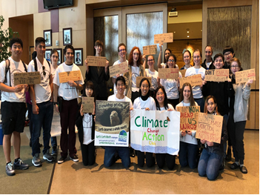

People in Thurston County WA can watch this TV interview with Rebecca and Karina 3 times a week throughout March 2021 on cable channel 22: Mondays at 1:30 pm, Wednesdays at 5:00 pm, and Thursdays at 9:00 pm.
People ANYWHERE can watch this interview at ANY TIME through Glen’s blog – www.parallaxperspectives.org – through the blog’s sections for “TV Programs” and “Climate” and “Young People.” Also, those blog links will include the document you are reading now, which very thoroughly summarizes what we said during this interview and includes links to many organizations and other sources of information. (The blog post’s .pdf version retains the complex formatting, and the Word version’s links are live and user-friendly.) Please share the blog link, video, and thorough summary with your friends and e-mail lists.

During the interview (see page 11 above), Karina told us about local teenagers’ creative writing about the climate. Those writings were compiled into a booklet. You can read the .pdf version of that booklet (through TCAT’s Youth Education Community Outreach group at this link: Cli-Fi-YECO-1.pdf (thurstonclimateaction.org)
On page 9 above you saw information about the Zoom video webinar titled “Listen Up! Youth Voices on Climate Action,” which occurred live on Saturday, September 26, 2020, featuring Karina, Rebecca, and three other high school students sharing their information and insights with the public. You can watch it at any time from anywhere through this link: https://www.youtube.com/watch?v=t1w-hys19A0
On page 11 above, after discussing the teenagers’ creative writing project, this document urged us to use humor and satire in our outreach. We can creatively communicate with various constituencies by using various kinds of creative arts (writing, music, visual arts, and so forth). Here again are links of two satirical pieces that Glen wrote and posted to his blog: #1: Now you can STOP WORRYING about Sea-Level Rise. This blog post says the next time you buy a new vehicle, you should order the Sea-Level Rise Suspension Package. Click the link in this ad at Glen’s blog: Now you can STOP WORRYING about Sea-Level Rise. – Glen's Parallax Perspectives #2: When sea level rise drowns downtown Olympia, here is a creative vision: When sea level rise drowns downtown Olympia, here is a creative vision. – Glen's Parallax Perspectives

Seattle's teen climate activist Jamie Margolin's new book (Youth to Power: Your Voice and How to Use It) provides 6 tips for becoming a youth activist. See this article: https://grist.org/justice/6-tips-for-becoming-a-youth-activist-jamie-margolin/?utm_medium=email&utm_source=newsletter&utm_campaign=daily

News keeps informing us of the crisis. For example, see this very recent news about ice:
- “Experts Say Burst India Glacier Shows 'Catastrophic' and Deadly Cost of Inaction on Climate Crisis.” On the day we taped our interview, this article was published about a massive collapse of a glacier in the Himalaya Mountains that caused massive flooding and many deaths in India: https://www.commondreams.org/news/2021/02/08/experts-say-burst-india-glacier-shows-catastrophic-and-deadly-cost-inaction-climate?cd-origin=rss&utm_term=AO&utm_campaign=Daily%20Newsletter&utm_content=email&utm_source=Daily%20Newsletter&utm_medium=Email
- Earth is now losing 1.2 trillion tons of ice each year, and it is getting worse. Ice is melting faster worldwide, with greater sea-level rise anticipated, studies show. https://www.washingtonpost.com/climate-environment/2021/01/25/ice-melt-quickens-greenland-glaciers/
- We keep seeing news of ice melting in the Arctic and Antarctic. In September 2020 this article reported that some of Antarctica’s glaciers are breaking up: https://www.cnn.com/2020/09/15/weather/antarctica-pine-island-thwaites-glacier-climate-intl-hnk/index.html
- In December 2020 NOAA issued this important report on the crisis in the Arctic: https://yaleclimateconnections.org/2020/12/noaa-report-card-arctic-is-having-more-and-more-difficulties/?ct=t(EMAIL_CAMPAIGN_WEEKLY_120720) and this: 2020 Arctic air temperatures continue a long-term warming streak | NOAA Climate.gov
- During the week Glen was typing this document, extremely cold, stormy weather devastated Texas, the South, and all the way to Canada. This does NOT disprove “global warming.” Rather, it is evidence of “climate disruption” or “climate chaos, as we said at the bottom of page 5.
- See recent years’ information and resources at Glen’s blog: http://parallaxperspectives.org/category/climate

Young people speak out and take action to protect the climate. EXAMPLES:
- See information about young people at that part of Glen’s blog: http://parallaxperspectives.org/category/young-people
- In 2019 Uganda’s First Fridays for Future climate striker, Vanessa Nakate, joined the COP25 protests in Madrid: https://www.democracynow.org/2019/12/12/cop25_vanessa_nakate_uganda?utm_source=Democracy+Now%21&utm_campaign=4287c94214-Daily_Digest_COPY_01&utm_medium=email&utm_term=0_fa2346a853-4287c94214-191704661

- Swedish teenager Greta Thunberg has spoken repeatedly to some of the world’s most powerful political and economic leaders. See these news items and resources:
- In 2019 she sharply criticized COP25 and said their response to the climate crisis is “clever accounting and creative PR.” https://www.democracynow.org/2019/12/12/greta_thunberg_speech_cop_time_magazine?utm_source=Democracy+Now%21&utm_campaign=4287c94214-Daily_Digest_COPY_01&utm_medium=email&utm_term=0_fa2346a853-4287c94214-191704661
- More than a year ago at Davos she urged global economic leaders to take strong immediate actions: https://www.commondreams.org/news/2020/01/21/act-if-you-loved-your-children-above-all-else-greta-thunberg-demands-davos-elite
- A year ago she was nominated for the Nobel Peace Prize: https://www.dailykos.com/stories/2020/2/3/1916145/-Climate-activist-Greta-Thunberg-nominated-for-the-Nobel-Peace-Prize?detail=emaildkre
- In 2020 she and thousands of other young people wrote a strong letter to world leaders. The letter includes this sentence: “We are facing an existential crisis, and this is a crisis that we cannot buy, build, or invest our way out of.” https://www.commondreams.org/news/2020/07/16/thousands-join-greta-thunberg-letter-telling-global-leaders-its-time?utm_term=AO&utm_campaign=Daily%20Newsletter&utm_content=email&utm_source=Daily%20Newslet
- Greta Thunberg criticized leaders who set climate goals decades away but balk at taking the actions that are necessary now: https://www.theguardian.com/environment/2020/nov/09/hypocrites-and-greenwash-greta-thunberg-climate-crisis?fbclid=IwAR3b2kHt--Lyta2C8HEg7PQ4OJWOe6M7MnMY0KTP5mOJVG85CBGS3iRmgV4
- Greta Thunberg’s 3-minute video in December 2020 made a compelling case for very strong actions now. Instead of vague goals for 2035 or 2050, we must take CHANGE ENTIRE SYSTEMS NOW because in just 7 years the climate crisis’s feedback loops will be locked into place. She really nails it in the 3-minute video embedded in this brief article: https://www.ecowatch.com/greta-thunberg-paris-agreement-2649450989.html?mc_cid=f3f77e7dc2&mc_eid=58bffd4d51 Here is another link to her 3-minute video in December 2020 is clear and important: https://www.facebook.com/gretathunbergsweden/videos/203986638056117 -- and another link urging ordinary people to take action because world leaders have been so negligent: https://www.youtube.com/watch?v=Dlk3fkqc5RI...
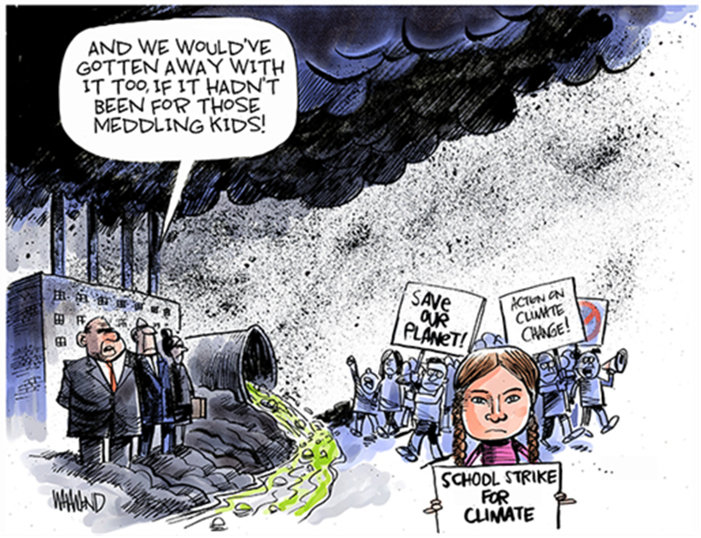
- Young people organize and can also help make climate policy: https://grist.org/fix/young-people-climate-policy/?utm_medium=email&utm_source=newsletter&utm_campaign=daily
- Youth climate movement demands immediate action after “empty promises” – and announces next global strike: https://www.ecowatch.com/youth-climate-movement-2021-2649940870.html?rebelltitem=1#rebelltitem1 and https://truthout.org/articles/youth-climate-movement-announces-next-global-strikes/
- In the U.S., Portugal, and perhaps elsewhere, young people have filed lawsuits to hold adults accountable for screwing their future. See page 9 above and these news items:
- Portuguese young people file climate case against 33 countries: https://www.commondreams.org/newswire/2020/09/03/portuguese-young-people-file-ground-breaking-climate-case-against-33-countries
- In the U.S., the federal 9th Circuit court threw out young people’s lawsuit for lack of standing. See this: https://insideclimatenews.org/news/17012020/children-climate-change-lawsuit-appeals-court-fossil-fuel?utm_source=InsideClimate+News&utm_campaign=cb94a65f69-&utm_medium=email&utm_term=0_29c928ffb5-cb94a65f69-327502737 – and SEE THIS: https://www.commondreams.org/news/2020/01/18/our-planet-seriously-burning-and-adults-keep-letting-us-down-ninth-circuit-throws?cd-origin=rss&utm_term=AO&utm_campaign=Weekly%20Newsletter&utm_content=email&utm_source=Weekly%20Newsletter&utm_medium=Email
- But a judge wrote a blistering dissent about the dismissal of the young people’s climate lawsuit: https://grist.org/climate/judge-writes-blistering-dissent-as-kids-climate-lawsuit-gets-tossed/?utm_medium=email&utm_source=newsletter&utm_campaign=daily
- After 9th Circuit decision, the youths and their attorney want to take their case to the Supreme Court. See this news from February 11, 2021: https://www.commondreams.org/news/2021/02/10/after-9th-circuit-decision-youth-climate-campaigners-vow-take-landmark-case-supreme?cd-origin=rss&utm_term=AO&utm_campaign=Daily%20Newsletter&utm_content=email&utm_source=Daily%20Newsletter&utm_medium=Email
- Here is news from September 2020 about a youth lawsuit in Washington State: https://www.commondreams.org/newswire/2020/09/10/young-washington-plaintiffs-argue-appeal-constitutional-climate-change-case
- A few weeks before the November 2020 election, some middle school activists in the U.S. pressured Joe Biden to strengthen his climate plans: https://grist.org/politics/outside-bidens-town-hall-middle-school-activists-demand-climate-action-sunrise-movement/?utm_medium=email&utm_source=newsletter&utm_campaign=daily
- This October 2020 article reports on the “Youth Climate Leaders” group that his helping young people build careers as climate leaders. The organization helps them access training, mentorship, and networking opportunities. https://yaleclimateconnections.org/2020/10/youth-climate-leaders-helps-young-people-careers-as-climate-leaders/?fbclid=IwAR2O0sRlx9sXmz1nvHWNKRDSjq6SiOLot16FxYKO3LIIbcXDHtONRiN--SQ
- Most Americans want K-12 schools to teach students about the climate, but many, many schools are failing to do that adequately. This article was posted on February 2, 2021, by an organization of scientists who are deeply concerned about the climate crisis: https://thebulletin.org/2021/02/america-is-too-often-failing-students-on-climate-change/?utm_source=Newsletter&utm_medium=Email&utm_campaign=ThursdayNewsletter02042021&utm_content=ClimateChange_Students_02022021

These two macro-level encouragements can move us ahead:
- Now in early 2021 most American voters want strong climate action. On Feb. 4, 2021, a highly respected Quaker-based organization that works on many issues (Friends Committee on National Legislation, FCNL, www.fcnl.org) shared information about a new survey showing that a majority of registered voters, including 23% of Republicans, think that addressing global warming should be a high or very high priority for the president and Congress. There was also strong bipartisan support for developing sources of clean energy, renewable energy research, stronger vehicle fuel efficiency standards, and just transition programs for unemployed coal workers. See this article from the New York Times: https://www.nytimes.com/2021/01/15/climate/climate-change-survey.html
- Our personal consumer choices cannot save the planet. We must change the economic system! The big business corporations that have seriously disrupted the climate want to avoid taking responsibility. They want to distract us from the real causes of the climate crisis and put the responsibility on us to change light bulbs and ride bikes instead of holding them accountable and making profound changes in our systems (energy, economics, politics, etc.). Worldwide and in the U.S. the rich are getting fabulously richer while everybody else gets poorer. Economic inequality provokes climate disaster because rich people consume much more than other people. Part of the solution to the climate crisis is to redistribute wealth from very rich people to serve the broad public interest, including funding education, health, housing, energy conservation, appropriate technology, and elimination of poverty, so humans and ecosystems can survive and thrive. Beyond that, we must rein in the giant business corporations themselves, eliminate “Big Money” corruption of politics, and so forth. The article linked at the end of this paragraph states that 100 companies have been responsible for some 71 percent of global emissions since 1988. When we focus on individual consumers, the remedies are limited to personal choices. But if we see the climate crisis as systemic, we must change the economic system! Here is the article: http://billmoyers.com/story/personal-choices-cant-save-the-planet/

Glen’s closing encouragement:

Glen thanked Rebecca McMillin Hastings and Karina Greenlee for sharing their information, their insights, and their inspiration with us during this hour.
He said the climate crisis is extremely serious. It is rapidly getting worse. Governments and businesses offer nice words but have been FAILING to take the very strong, urgent actions that we need in order to solve the problems and achieve sustainability. He said we must stop settling for wishful thinking and vague sentiments. He said we need real, live people to accomplish specific actions. During this interview, Karina urged us to accomplish bold changes to public policies, and Rebecca urged us to pay attention to what the scientists have been telling us – and to implement the solutions they say we need.
He said planet earth needs to efforts of people of any age and every age whether 16 or 72 or younger or older. Let’s all connect with the many excellent organizations that are working on these issues.
Glen said he conducts free online workshops in “Nonviolent Grassroots Organizing” with information, inspiration, resources, and practical strategies. People of all ages – from teenagers to people in their 80s – have taken these workshops and strengthened their effectiveness in working on whatever issues they care about (climate, peace, human rights, economic justice, etc.).
For information about these free, online workshops, contact him by phone or by e-mail. You can sign up NOW for the next series of free online workshops (mid-March to late April 2021) so you can make more progress on issues YOU care about. Glen will offer the series again during the summer, fall, and in the future. See information at http://parallaxperspectives.org/sign-up-now-for-free-online-workshops-so-you-can-make-more-progress-on-issues-you-care-about-2

We did not have time for Glen to say this during the TV program:

People who pay attention to a hard, scary issue such as the climate crisis can feel terrified and hopeless. But instead of feeling powerless, we can empower ourselves with solid information and smart strategies so we can take strong, effective nonviolent actions to solve the problems.
Rebecca and Karina and millions of young people around the world are organizing among themselves and with people of all ages. We refuse to be victims. We are empowering ourselves now to build grassroots movements that devise smart strategies and bold, creative actions, across all ages and nationalities.
We can indeed solve the problems!
In 1980s when President Reagan was recklessly escalating nuclear weapons and adopting policies likely to destroy the world in nuclear war, many people were feeling terrified and hopeless. But one child said, “I’m not as stressed as other young people because I know my parents are working to stop the nuclear arms race.”
Now I enjoy working with young people who are working to solve the climate crisis. They are working with smart strategies and positive attitudes, so I am confident that they will make good progress.
Also, other people of all ages and all races and all nations around the world are working for a healthy, sustainable climate. Let’s all work together!

You can get information about a wide variety of issues related to peace, social justice and nonviolence through my blog, www.parallaxperspectives.org or by phoning me at
(360) 491-9093 or e-mailing me at glenanderson@integra.net

Glen ends each TV program with this encouragement:
We're all one human family, and we all share one planet.
We can create a better world, but we all have to work at it.
The world needs whatever you can do to help!

