“Glen’s Parallax Perspectives” is a series of TV programs offering fresh ways for people to see issues such as foreign policy, social and economic justice, governmental functioning, the environment, and so forth. We provide voices and viewpoints that are rarely heard in mainstream media.
Mainstream media, politicians, and culture see the world in conventional ways. Therefore, in order to solve problems, we need to see things in fresh ways. Glen Anderson created this TV series to help people see things differently so we can solve problems at all levels from the local to the global.
This series title refers to “parallax“ – the view you get by looking from a different perspective. For example, put one finger in front of your nose and another finger farther away. Close one eye. Then open that eye and close the other. Your fingers will seem to move. This is called a “parallax” view. This TV series invites you to look at issues from fresh perspectives.

Each program airs three times a week (currently every Monday at 1:30 pm, every Wednesday at 5:00 pm, and every Thursday at 9:00 pm) for the entire month on Thurston Community Television (TCTV), channel 22 for cable TV subscribers in Thurston County, Washington. TCTV is part of Thurston County Media. You can see their schedule at www.tcmedia.org
You can also watch the program described below through your computer at www.parallaxperspectives.org. All episodes of “Glen’s Parallax Perspectives” are posted on this blog’s “TV Programs” part and also in one or more of the categories listed in the right side of the computer screen. Also, see much information at the issue category headings at www.parallaxperspectives.org.

Please invite other people to watch this video and/or read this thorough summary at the
“TV Programs” part of www.parallaxperspectives.org.
In addition to summarizing what we said during this article, this article also includes some ideas we did not have time to mention or discuss. Explicit notes identify those as such.

Here is the November 2019 program:

“Solutionary Rail Is a Win-Win-Win
for Climate, Workers, Communities”

by Glen Anderson, the TV series’ producer and host
(360) 491-9093
glenanderson@integra.net
www.parallaxperspectives.org

Glen introduced the viewers to this interview topic:

He said this month’s interview on “Glen’s Parallax Perspectives” explores a truly creative and exciting solution for several of our nation’s problems. This solution would significantly reduce fossil fuel use and air pollution. It would protect our environment, climate, and public health. It would create jobs and help local communities – including seaport areas, transportation hubs, cities, freeways, and rural farming areas all throughout our nation.
Our topic is Solutionary Rail. The website promoting it – www.solutionaryrail.org – describes it as “a people-powered campaign to electrify America’s railroads and open corridors to a clean energy future.”
During this hour we will explore many of Solutionary Rail’s benefits – and we’ll also explore how to build the growing movement for Solutionary Rail.

Our guest – Bill Moyer – is a key organizer of Solutionary Rail. He also is the Executive Director of the Backbone Campaign (www.backbonecampaign.org), a non-profit organization based on Vashon Island in Washington State’s Puget Sound.

Bill is a very savvy organizer whom I have known and respected for a number of years. He thinks strategically. Bill and the Backbone Campaign help people organize strategically smart movements for social change and creative activities he calls “artful activism.”

Bill was the guest for my December 2017 TV program about Solutionary Rail, and now – two years later – our November 2019 program shares more information and some exciting updates, so there is not much overlap between these two interviews. It’s good to watch both.

We need changes that are more systemic than merely converting to electric cars and trucks:

Glen said that many climate supporters emphasize converting our transportation to electric cars and electric trucks. But the Solutionary Rail movement sees the need for more profound changes to our transportation system. Before discussing Solutionary Rail specifically, he invited Bill to briefly explain why we need systemic changes to our transportation system, not merely converting to electric vehicles.
Bill said we need to think of our transportation system as “an ecology of how we move things.” He urges our society to adopt a number of systemic changes in various sectors of our society, and Solutionary Rail is part of building an infrastructure for how we can make these systemic changes.
He said, for example, we need to localize our economies, and this requires ways for local communities to get better access to moving people and goods. When progressives think about transportation, they get excited about bullet trains like other countries have, but he said that does not take into account the fact that we need transportation not only for moving people but also for moving goods. Also, he said we can’t think only of how to transport goods on trains without also thinking about how those goods are also transported on trucks. Solutionary Rail creatively addresses that challenge.
At this part of the interview we did not have time to orally say these points from Solutionary Rail’s website, www.solutionaryrail.org:
- Rail Transportation requires 1/3 the energy of highway transportation, regardless of the source of energy. Merely moving highway traffic to rail without electrification results in that reduction. Rail electrification thereafter further reduces emissions and opens synergies with renewable energy transmission and vast renewable energy development.
- Electric vehicles are not a practical solution to the climate crisis. Merely converting to electric vehicles does not reduce current congestion, the need to build additional highway infrastructure to accommodate population growth, nor take advantage of the energy efficiencies of rail transportation.
- About 2/3 of a vehicle battery is not recyclable/reusable. In the 1950s nuclear generation of electricity was promoted as the energy source of the future promising virtually free electricity. Nobody thought of the waste problem. 50 years later, nuclear waste is a serious problem. Wide distribution of vehicle batteries will produce a similar outcome in about 20 years.
- Electric vehicles are only a climate or environmental solution when there is no rail alternative and when used as a complement to rail for delivery of goods or people for the “last mile” (or last 75 miles as the case may be).
- We must consider environmental aspects about how we move freight. We must shorten the distances that trucks must travel. It is not enough to simply electrify long-haul trains, nor to simply electrify trucks.

Bill briefly summarized Solutionary Rail as a creative and practical alternative:

Bill said, “Solutionary Rail is a “just transition” strategy for decarbonizing our transportation and energy infrastructure.” He said the “just transition” would consider workers and all segments of our population in devising win-win solutions for moving from where we are now to where we want to be.
Glen said that two years ago he bought Bill’s book about Solutionary Rail, he enjoyed reading it, he found that its 100 pages make a compelling case with a very readable writing style, and he has been encouraging people to buy it through www.solutionaryrail.org.
Bill said a team of people spent several years researching and writing the book, so it was not just his accomplishment. He said he relies on a large and growing team of experts to build the Solutionary Rail movement.

This short, informative, persuasive video summarizes Solutionary Rail:

At this point in the interview we watched a video that – in less than four minutes – makes a very clear and compelling case for why we need Solutionary Rail.
I encourage you to watch the very short but informative video at this link: https://www.solutionaryrail.org/video

Bill summarized “intermodal freight systems” and the railways’ business model:

Earlier in this interview Bill explained that we need systemic changes to our transportation system, not merely switching to electric vehicles. Now we explored that further. Glen explained that much of our freight system is “intermodal” – transferring freight from ships to trucks, trucks to trains, trains to trucks, and back and forth, using railroads only sometimes and for longer distances, but trucks also are used inappropriately for very long distances too.
Bill summarized the problems in our “intermodal” freight system and the railroad companies’ current business model. He said that when the U.S. created the interstate freeway system, trucks began to carry more freight for very much longer distances on freeways. Railroads began to focus more on moving very heavy bulk items slowly over long distances on longer and longer trains. High-value freight that needed faster transportation was increasingly moved onto trucks.
But Bill said that steel wheels on rails are more efficient than tires on highways, so trucks waste a lot of energy. Railroad tracks are at least three times more efficient, but – unfortunately – the railroad companies have been reducing the capacity of the railroad infrastructure so they pay less in property taxes and simply focus on main routes hauling heavy bulk cargoes such as coal.
He said that is the opposite of the direction we need to go if we want trains to be competitive with trucks. He said we need Amazon, the U.S. Postal Service, and other major shippers “to move their goods quickly and reliably on tracks. We need the efficiency of tracks.” Also, he said we can’t afford to continue letting trucks burn diesel, destroy our roadways, and pollute our communities.
Bill said, “Unless we shift the business model of freight so that it actually allows things on trains that are going for shorter distances we’re not going to be able to electrify trucks.” A truck going 800 miles in a day is hard and expensive to electrify. “We need to help the railroad industry make a pivot away from the long, heavy, slow trains to a faster, more reliable freight that stops more often and restores service to communities along the route.” Trucks need to access those trains at those local stops so a truck will run only 150 miles a day instead of 800 miles a day. Only when we reduce truck distances to 150 miles a day will we be able to reliably decarbonize trucking. Trucks are a worse climate polluter than trains. This systemic change in the railroad/truck business model will be at least as important as the electrification of the trains.
Glen added that the big trucks wear out the freeways at a much worse rate than passenger cars do, but the trucks’ fuel taxes do not pay for the full damage they do, so passenger cars’ owners are actually subsidizing the big long-haul trucks. He said we taxpayers could save a lot of money if we used the rails better instead of hauling so much freight in big, heavy trucks. Bill agreed.
Bill said many railroads are dominated by the concept of “precision-scheduled railroading,” which does not really make sense. They do the opposite. They are “mining the infrastructure capacity” in order to reduce costs and achieve short-term corporate profits on a quarter-by-quarter basis for Wall Street’s stockholders. This is not OK. The climate crisis is very serious and needs to be turned around in just eleven years, so we cannot allow the railroad companies to continue dismantling their crucial infrastructure.
He said people who live in small communities in the middle of our nation are suffering financially, and people are fleeing those small mid-American communities. Their tax base is declining, and the trains no longer stop there or serve their communities. You have to pay more to ship your crops on trucks longer distances before they can find a train depot that will accept the freight you need to ship. “We’re going in the exact opposite direction” from where those communities need.”
Glen said we need to think sustainably, and Solutionary Rail is a good way to do that.

Solutionary Rail would be good for workers in railroads, trucks and warehouses:

Glen asked Bill how converting from our current system to Solutionary Rail would affect the workers in our railroads, our trucks, and our warehouses.
Bill said most railroad workers do not have regular work schedules. They are on-call 24 hours a day, 7 days a week, 365 days a year. This causes chronic fatigue and safety problems for the workers and also for the communities where the trains travel. He said the pressure is always to push the workers hard in order to increase profits. That pressure puts a lot of stress on the railroad workers. We need to change how railroads operate so the crews will have safe and sensible schedules.
We need to stand in solidarity with the workers who are fighting against management’s efforts to reduce crew sizes. He said each train used to have five workers, but management reduced that to three and then down to only two workers on each train. Now the railroad companies want to reduce it to only one crew member for each train.
He said the truckers – and the railroad workers in diesel yards – are continually breathing diesel fumes. We need to rapidly transition to electrified ports, electrified trains, and electrified trucks, forklifts and other and cargo-handling equipment. We need these changes for warehouses too.
Warehouses have increasingly become located in giant warehouse district “hubs” that are very far apart from each other. Because these hubs are far apart from each other, the trucks that arrive in them are almost always diesel trucks. Those trucks spew diesel fumes in the warehouse areas, polluting the air breathed by the workers and also by the local communities where people live around those warehouse locations. He said the hubs need to be closer together in order to use transportation other than diesel trucks.
Glen agreed and said his reading showed that more and more warehouses are located in gigantic “warehouse ghettoes” with each ghetto consisting of many truly gigantic warehouses. The trucks cause massive amounts of diesel exhaust pollution that saturate the air that is breathed by warehouse workers, truck drivers, and all of the people who live in the surrounding areas.
Bill said he was visiting the Port of Long Beach, California, one of the U.S.’s biggest, busiest ports, and saw – of course – the trains idling in the rail yard, and right across the street from the rail yard was an elementary school. He said some of these warehouse areas get 5,000-15,000 trucks per day polluting their air. Locations include Newark, Kansas City, Chicago, and many other transportation hubs.
Glen said Bill’s insights are interesting, because the people who want to hurt the environment and hurt the climate keep trying to pit environmentalists and workers against each other. But actually, environmentalists and workers have a lot to gain by working together to solve problems instead of letting big corporations use a “divide-and-conquer” strategy to separate us and screw the environment, screw the climate, and screw the workers.
Bill agreed and said some of Solutionary Rail’s most important work has been to bring together railroad workers and impacted communities so they can build productive relationships so labor activists, environmental justice activists, drayage truckers, and other folks can work together to solve the problems that hurt all of them.
At this part of the interview we did not have time to orally say these points from Solutionary Rail’s website, www.solutionaryrail.org, including RailBites #4 at https://www.solutionaryrail.org/unions_rb4
The Solutionary Rail concept would prove highly beneficial for working and retired railroad workers. In contrast to the current operating plan the major rail carriers have embraced, Solutionary Rail could produce:
- more jobs in both passenger rail and freight rail
- more rail infrastructure
- good, family-wage, secure union jobs, and better schedules and working conditions
The railroad industry is the most unionized sector of the economy. Almost all Class One railroad jobs are organized into unions. Since the Solutionary Rail concept applies primarily to the major trunk lines – practically all of which are unionized Class One railroads – the increase in rail employment would necessarily mean an increase in union jobs. Close to 100% of the jobs created by implementing Solutionary Rail would be union, with good pay and benefits.
Long ago, two million people worked on railroads, but for about a century railroad routes and stops have been reduced and many, many railroad jobs have been eliminated. Solutionary Rail would reverse this trend and boost employment in the rail industry in both rural and urban areas. Solutionary Rail would greatly increase track capacity through electrification and multiple tracking of key mainlines. Improving railroads’ ability to handle high priority freight instead of trucking it – and also increasing scheduled passenger trains – would improve employment and working conditions for railroad construction and maintenance workers as well as more railroad engineers and train crew members.

More information about de-carbonizing trucks and railroads:

We did not have time to orally say the following points, which are based on information from Solutionary Rail’s website, www.solutionaryrail.org. These points are worth mentioning here in this printed summary:
For obvious reasons we need to reduce the amount of carbon dioxide (CO₂) pollution from trucks and railroads. A smart strategy for decarbonizing is to use the efficiency of railroad tracks (steel on steel) instead of truck tires (rubber on concrete or blacktop).
The United Nations’ recent climate report (IPCC Special Report, October 2018: Global Warming of 1.5°C) calls for a 45% reduction in emissions before 2030 in order to avoid catastrophic climate change causing irreversible damage to the world’s ecosystems and the habitability of the planet. See https://www.ipcc.ch/sr15/
Solutionary Rail would quickly reduce highway emissions while concurrently upgrading current rail infrastructure, expanding service, and delivering on a number of other public interest issues described in the book Solutionary Rail.
Governmental efforts have reduced emissions from automobiles, trucks, power plants, and other major polluters, but the government has NOT taken enough meaningful actions to reduce emissions from railroad locomotives. The newest locomotives are much cleaner than older ones, but the lifespan of older, dirtier locomotives is about 20 years, so dirty locomotives will continue polluting for a long time into the future. We need to replace them with locomotives suitable for Solutionary Rail.
Electrify the trains through overhead power lines. Electric cars and trucks use resources for battery manufacture and disposal . Electrifying trains, on the other hand, can take advantage of the fixed infrastructure of rail transport instead of environmentally damaging batteries. Like some bus lines in cities today and in the past, electric locomotives could receive electrical power by catenary wire accessed by a pantograph or an electrified third rail.
Also, design electric locomotives to use for regenerative braking. (Current diesel locomotives generate heat and lose it.) Electric locomotives with regenerative braking can return electrical power to the electrical grid, increasing the efficiency of rail transport.
Wind turbines, photovoltaic arrays, geothermal sources, and other technologies are harnessing renewable energy for rural electrical cooperatives, small-town America enterprises, and tribes. What’s missing is transmission capacity to metropolitan demand centers. Solutionary Rail can fill that gap, by adding an additional set of High Voltage Direct Current power lines above those powering the trains. This interconnection over a vast landscape can solve the problem of the inherent local variability of sunshine, wind and tides.
A further bonus: Electrifying America's rail system will attract more freight and passengers, allowing the railroad to better serve urban, rural, small town, and tribal economies. The air will be much cleaner for trackside communities. The whole world will benefit from megatons less CO₂, methane, and particulate emissions from America's overall transport system!

Solutionary Rail would be good for energy and the climate.
Glen said one of the most exciting benefits of Solutionary Rail is how it would help to solve our energy problems and our climate problems. He showed four images for people watching our interview (and for people reading this thorough summary of what we said). Bill explained each of these four images, which are printed below:

Two kinds of electric lines could run above existing railroad rights of way:

This image shows two kinds of electric lines above a railroad train. This image was in the short video we saw a few minutes earlier in this interview:
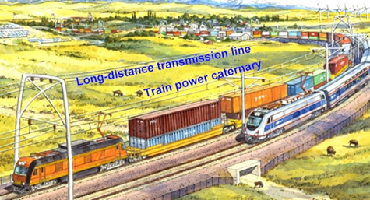
Bill explained that the Solutionary Rail campaign produced this image to show in the book. Several of the persons they have been working with inspired them to produce this concept. One source was a scientific study of how to achieve 80% renewable energy by 2030. Many people assume that the goal would require “distributive renewable energy generation.” That might be useful, but a stronger strategy is illustrated here by using “point-to-point high-voltage DC transmission.” Such as grid would allow solar or wind energy generated in one geographic region to be efficiently transmitted to another region where the sun is not shining or the wind is not blowing.
A major obstacle is the need for right-of-way corridors for the high-voltage DC power lines. Creating new corridors would be horribly expensive and time-consuming because of legal and political battles getting right-of-way easements for using people’s property – or seizing their property through eminent domain. But the railroad companies already have a great network of easements throughout our nation! Let’s co-locate high-voltage DC transmission lines over existing railroad tracks, so we can rapidly install and transmit renewable (solar and wind) energy over the existing rail corridors throughout our nation!
We could rapidly reduce our dependency on fossil fuels. Technology for efficiently and economically storing and transmitting electric energy is becoming more rapidly available. High-voltage DC transmission over existing rail lines would allow us to rapidly convert our nation to renewable energy.
Glen agreed that this is a smart strategy because the corridors already exist, so we can easily and inexpensively run the electric lines over the railroad tracks in the existing corridors without having to identify and buy new right-of-way routes, pay for easements, seize people’s lands, make people get mad at the government, fight long and expensive legal battles over eminent domain, and so forth.
Bill said the other line in the image is for powering the electrified trains. He added that electrified trains could use “regenerative braking” when they are slowing down or going down hills. The “regenerative braking” puts energy back into the lines. Bill said “regenerative braking” is actually an old technology that was used effectively in the past – since 1915. He said Washington State had 759 miles of electrified rail in 1928.

Solar power:

Next we showed this map showing the potential for converting sunlight into electricity in various parts of the U.S.:
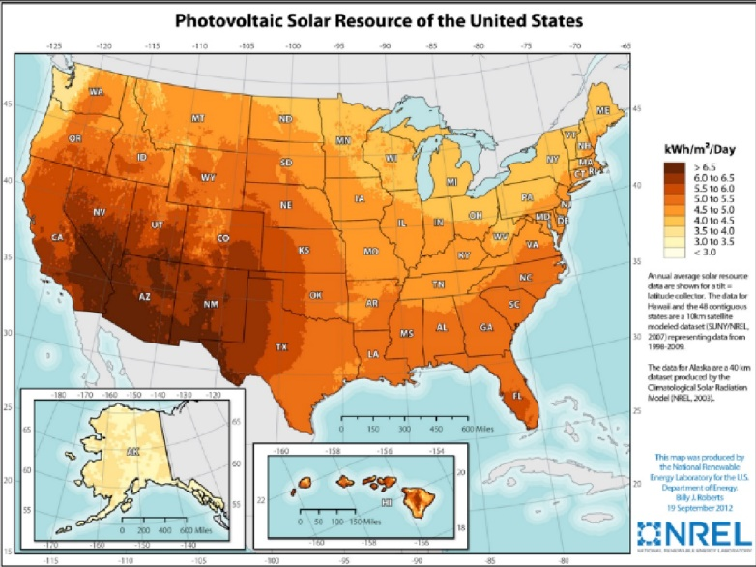
The entire nation has some potential, but it is strongest in the Southwest. It could easily power electric trains going to and from southern California. Bill said this could power trains from the ports of Los Angeles and Long Beach (two of our nation’s biggest ports) along the “TransCon” route to Kansas City to Chicago. Much of the West and the Central and Southern states also have enormous potential for using solar power to electrify trains – and to use solar power for many, many other purposes.
Bill also said many tribes have reservations along the route, so they could use solar and wind energy to generate electricity in order to generate income for their tribes.
He said the short video we watched had mentioned the Steel Interstate Development Authority as a way to have a semi-public entity that would be accountable to the public and responsible for developing and running some of the infrastructure we’ve been discussing.

Wind power:

Next we showed and discussed this map of wind speeds 80 meters above ground:
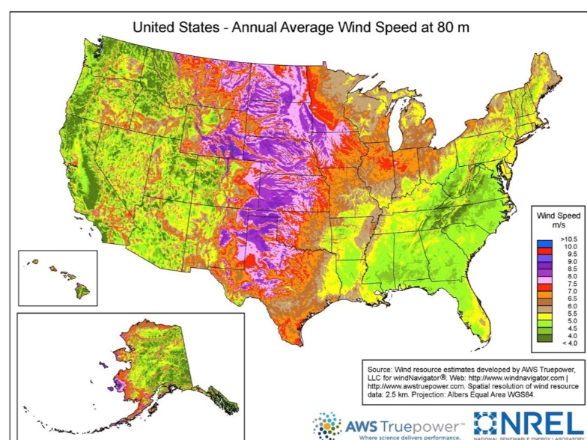
This map shows strong winds especially in the middle of the U.S. from North Dakota down into Texas and good winds at many other parts of the nation. We have huge potential for generating wind energy in much of the U.S. All of the trains that run East-West and West-East run through these high-wind areas, so wind could power much of the U.S.’s railroad transportation.
Also – as with solar – many tribes live in areas where the wind is strong, so they could produce and sell wind energy as a way to financially support their tribes. Standing Rock, North Dakota, was recently the site of a massive protest against an oil pipeline. Those Native Americans don’t need oil pipelines destroying their environment, their drinking water, and their sacred lands. Wind does not pollute. Tribes could generate wind energy, use some of it for their own use, and sell much of it to railroads and utilities and other customers.
Glen added that some of these other high-wind states (Nebraska, etc.) are on oil pipeline routes. Farmers, ranchers, Native Americans and ordinary people have been vigorously protesting oil pipelines. Wind energy would be much more popular and much more safe for the environment and local communities.
Bill said these areas are politically conservative, and Glen said eastern Wyoming is another high-wind area that is politically conservative and highly dependent on coal mining. Glen and Bill said Wyoming has an abundant source of wind. Unlike coal, which gets depleted and then eliminates jobs and depresses local communities when the coal runs out – the wind is perpetual – they’ll never run out of wind. They can export wind energy and help their state’s economy.

Rural Electric Cooperatives:

Glen said many parts of the nation have publicly owned electric utilities – rural cooperatives – that serve rural areas. The next map we showed identifies the locations of rural electric cooperatives throughout the U.S. Without paying attention to the color-coding, just notice all of the locations with any colors other than white.
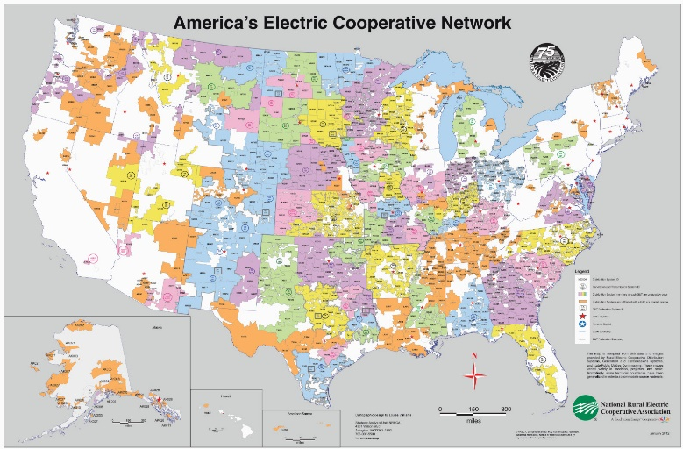
Bill said 70% of the U.S.’s land mass is served by rural electric cooperatives. He said these co-ops had become trapped in debt related to generating electricity from fossil fuels, so he suggested that we devise ways for them to be able to pivot away from fossil fuels and start using solar and wind for generating their electricity. We need to create opportunities for farmers and rural communities to generate income by using solar and wind to generate electricity and sell it to railroads and other customers – as well as using it locally to power their own homes, farms and communities. Glen said it would be wonderful if these rural electric co-ops could earn money by generating electricity from solar and wind sources and selling it to the railroads that run through their local areas. We agreed that they could export the energy to population centers
Bill said the rural electric cooperatives are owned by their local members, and they are democratic entities. He affirmed the great work that some people are doing to further democratize them. He said one organization working on this is called “We Own It,” www.weown.it

Many rural areas are losing population. Solutionary Rail would be good for local communities (farmers, local manufacturers, local businesses, etc.):

Next we showed this map of the many parts of “non-metropolitan” America that are actually losing population. The areas with the darkest red color have been losing the most people. Glen said rural areas are hurting in many ways, including a loss of population and decline of economic vitality. We showed this map:
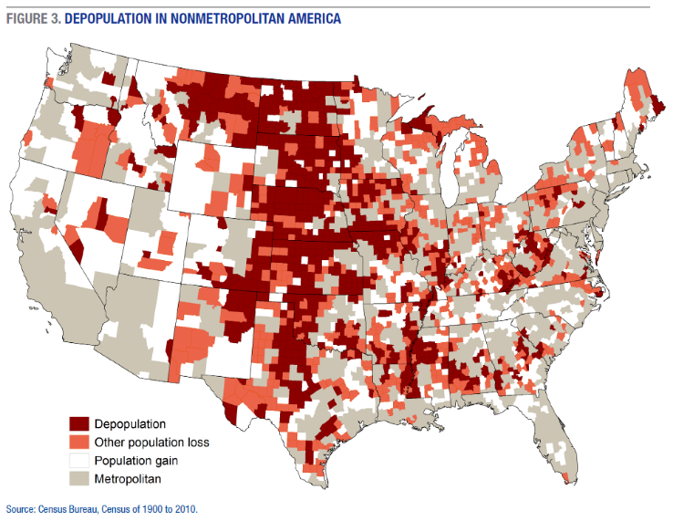
Bill said Solutionary Rail could be part of the solution to these problems. He said 91% of our nation’s counties that are suffering chronic de-population are rural areas that are not near urban centers and do not have good ways of attracting people (e.g., not creating retirement communities or tourist destinations). He said these are mainly agricultural areas. He said trains used to stop in these locations but do not stop there anymore. Glen mentioned that the 4-minute video we watched early in this interview had a photo of an abandoned rail station because the railroad has abandoned passenger service there.
Bill said young people are fleeing these areas. He talked about the problem with demographers who said these areas would benefit by attracting immigrants to rebuild their populations. Without enough young people to become wage-earners, these communities have a hollowed-out gap in the age spectrum. Immigrants of wage-earning age would fill the gap in the age spectrum and generate income for these rural communities.
He said these communities need access to infrastructure including broadband and local rail service. They need trains to stop there so they can put locally produced goods onto the trains for shipment to markets – and also restore local passenger train service so people can move to and from these local communities.
We did not have time for Bill to make these additional points that he could have said:
Rural agricultural communities need “regenerative agriculture” with more human input than fossil fuel input, and we need to get perishable crops to market in a timely way. Solutionary Rail’s service to rural areas could help with this. The national grange (a 157-year-old organization) includes a history of progressive populist movements against abuses by railroads. The Farmers Alliance has many local groups. There is also a Rural Coalition that includes African Americans, Latinos and Native Americans who are farming. Solutionary Rail would be good for all of these constituencies.

Solutionary Rail would promote better passenger service:

Glen said that most of our conversation has focused on railroad freight, but Solutionary Rail would improve passenger service too. Decades ago, before freeways and airplanes became dominant, railroads were the primary way people traveled long distances. Trains were really the default method of passenger transportation.
Bill said passenger service must be “part of our negotiation with the railroad companies.” He said Solutionary Rail would “help them transition to a new business model” that would have a sustainable future. Let’s clarify what we really want from that progress. He said the same right-of-way would allow for a return to significant passenger train service.
He said we need the slow freight trains to move more quickly. This would create more capacity on the rail lines so we could have more trains and increase their speeds and efficiencies. “If you can get the freight trains to move more quickly, you’re going to be able to speed up the passenger trains as well.”
Glen said many people do not realize that the U.S. gives priority to freight trains and makes passenger trains get out of the way and move onto sidings in order to let freight trains – such as long trains carrying coal – to use the main tracks.
Bill said that did not used to be the case. He said we created Amtrak really in order to bail out the railroad companies. Railroads were the U.S.’s first regulated monopoly, and Congress created Amtrak to relieve the companies of their obligation to serve the communities. He said the federal government de-regulated the railroads to such an extent that now they are under-regulated. He added that, “Even when we had the right-of-way for passenger trains, we were not enforcing it.”
Bill urged progressives to “reclaim this incredible infrastructure we have – and insist that it serve the public interest.”

Solutionary Rail would be much better than ultra-high-speed “bullet trains.”
It would be much easier and quicker to create, and much cheaper too:

Glen said that increasingly in recent years, ordinary people and politicians have become infatuated with very high-speed trains – “bullet trains” – as the wave of the future. We do need faster passenger trains, but “bullet trains” are NOT the remedy we need. Glen asked Bill why he is NOT enthusiastic about “Ultra High Speed Rail” – and why Solutionary Rail is a much smarter remedy.
Before we taped the interview, Bill had told Glen that politicians and the corporate interests they serve like flashy terms like “bullet trains”, “High Speed Rail”, and “Ultra High Speed Rail.” These serve as shiny objects that rely on public ignorance to make the politicians seem “progressive” and seem like “climate candidates.”
During our TV interview, Bill explained that this is a major challenge for us to deal with. He urged people to take the time to clarify the real issues apart from the rhetoric.
He said regular trains have a top speed of 79 miles per hour. He said speeds of 80-124 mph for passenger trains are referred to as “higher-speed” rail. This would make sense.
He said Washington State’s rail corridors have been studied for thirty years. He said it has been determined that the optimum service – number of communities served, reasonable costs, use of existing track, reasonable fuel efficiency – would be 110 mph. He said our regular tracks would allow speeds of up to 150 mph, sharing the same rails for passengers and freight. He said this is pretty fast compared to our current speeds. Glen added that this is very, very fast compared to a freeway.
Bill said we could do this with our existing infrastructure. We might need to straighten a few tracks or separate a few grades, but we can avoid these decades-long fights over seizing property through eminent domain.
He said it is important to transition quickly to higher-speed rail instead of wasting decades to acquire and build all new infrastructure. The climate crisis is already upon us, so we do not have the time to fight these long fights and wait for “ultra-high-speed” “bullet trains” to get built. He said developers who do NOT have the climate in mind are obstacles for building the new infrastructure. Also, he said that going 250 mph uses exponentially more energy than the speeds he is advocating. Besides, these “ultra-high-speed” “bullet trains” do not solve the other problems we have been discussing about trucks, freeway congestion, stopping often to serve local communities, and so forth.
Glen agreed and said the “ultra-high-speed” “bullet trains” would require new routes, eminent domain, buying many properties from people who do not want to sell them, long legal fights – and all of this would be phenomenally expensive! He said California is experimenting with something that is far shorter than the route they wanted, and even this very short route is far over budget and far behind schedule. He told Bill, “It’s just a mess, and your remedy is simple and clean.”
Bill said the Solutionary Rail campaign does support higher-speed passenger trains, but they want to do it in smart ways with reasonable steps. In some locations better rail speeds (79 mph and up to 110 mph) are occurring where trains had been running more slowly. These “higher-speed” improvements are practical and working well. They are using existing tracks and sharing the tracks with freight.
He concluded that the distinctions between the “higher-speed” service and the “ultra-high-speed” trains are very important for a number of reasons.
We did not have time for Bill to make these additional points that he could have said:
Solutionary Rail’s website includes links to a few fact sheets (“RailBites”) with more information about several aspects of Solutionary Rail. RailBite 3 provides much information explaining why Solutionary Rail is better than the “ultra-high-speed” “bullet trains. See https://www.solutionaryrail.org/hrsr_rb3
“Bullet trains” are a distraction from what we really need. Solutionary Rail proposes investments to modernize and electrify major US rail corridors for faster speeds, better service, and energy efficiency. The Solutionary Rail approach provides a cost-saving, relatively fast and viable path to efficient decarbonized transportation for passengers and freight, by starting with upgrading and expanding existing infrastructure. We can make this progress much more quickly, cheaply and more efficiency than “bullet trains.”
Also, society can’t afford for rail knowledge to be relegated nostalgic hobbyists. The climate clock ticking, so we need to modernize and increase efficiency. This requires changing how railroad businesses understand their “business model.”
The Green New Deal is relevant, and we did discuss it later in this interview. Also see information about “Pertinent Facts and False Solutions” at Solutionary Rail’s website: https://drive.google.com/file/d/1ejOUXwtHN4-B4HqTewMgnMn_PndhsgKD/view
The Solutionary Rail approach puts freight and passenger rail at the center of an electrified transportation infrastructure with broad access and expanded service to drive high utilization and minimize immediate cost in order to achieve the greatest transportation value for the expenditure. Solutionary Rail does a smart job of dealing with truck freight traffic, impacts, emissions, and access to freight rail transport for rural communities.
In Western Washington State, a North-South “ultra-high-speed” rail project is being proposed, but virtually the entire corridor is either environmentally sensitive or densely developed. Wetland mitigation would be very difficult, expensive, and time-consuming. Solutionary Rail is a much smarter remedy than this unrealistic proposal!
Also, stations for passenger trains traveling faster than 150 mph are too far apart to replace most highway travel. (If one is to drive a long distance to get to the train station, then the whole trip will probably be by auto.) Therefore, although theoretically, “ultra-high-speed” rail might be better than air travel, actually the infrastructure investment is not cost competitive with Solutionary Rail.

Our December 2017 TV program with Bill Moyer explaining Solutionary Rail is still available for people to watch:

Glen said his December 2017 TV program interviewed Bill Moyer about Solutionary Rail. He invites people to watch the program through Solutionary Rail’s website – https://www.solutionaryrail.org/tctv2017. The website’s home page has a tab at the top labeled “In the Press,” and that tab includes a link to watch our December 2017 TV program.
Also Glen invites people to watch that TV interview through his blog’s “Energy” section at http://parallaxperspectives.org/tv-solutionary-rail. That blog post also includes a link so people can read a thorough typed summary of what Bill and Glen said during that 2017 TV interview.
Although the December 2017 program and the current (November 2019) program both discuss Solutionary Rail, the interviews covered several different aspects of the topic and do not overlap too much, so it is worth watching both of them and/or reading both programs’ thorough summaries on Glen’s blog.

The Solutionary Rail campaign is making progress! They are reaching out to the owners of Burlington Northern Santa Fe Railway (BNSF):

Glen expressed delight with the progress that Bill and other organizers for Solutionary Rail have been making since our TV interview from two years ago, so he invited Bill to bring us up to date on the progress since late 2017.
Glen said one of our nation’s biggest railroads – one that serves the Northwest – is the Burlington Northern Santa Fe (BNSF). That railroad is owned by Warren Buffett’s gigantic business conglomerate, Berkshire Hathaway. He told the viewers that Bill and some other people attended Berkshire Hathaway’s 2019 shareholder meeting, where they set up a display outside of the convention center. Inside, Bill asked a question during the shareholder meeting’s Q&A session.
Glen showed this image of Bill asking a question to Warren Buffett and Charlie Munger. The bottom of the image shows Solutionary Rail’s display outside of the conference center.
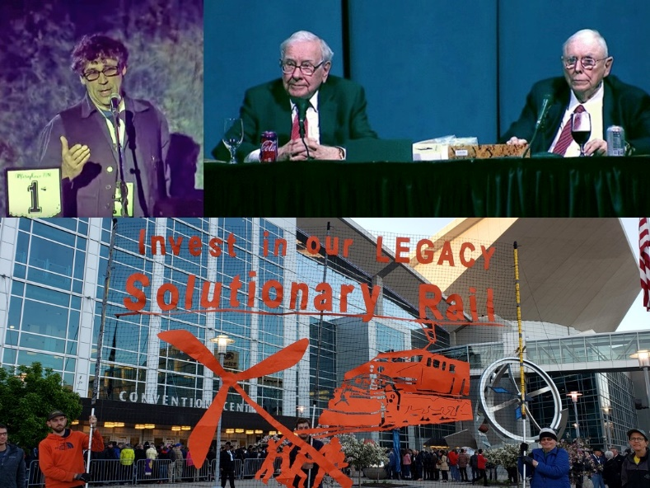
Bill said he asked for a meeting to discuss a how the company and Solutionary Rail might both benefit from a relationship and the possibility of a public-private partnership to electrify BNSF’s railroad routes and to create benefits for Berkshire Hathaway’s other businesses (e.g., Berkshire Hathaway Energy with generates some wind energy) as a result of Solutionary Rail’s great vision.
Bill said that Warren Buffett suggested that Bill talk with Carl Ice, BNSF’s president, and Bill is following up. Bill also said that the man in this photo’s upper right corner is Charlie Munger, who is older than Buffett and speaks in a clear, succinct way. Munger said the questioner is on the side of the angels, railroads are bound to be electrified sooner or later, and Buffett’s likely successor will decide when to electrify.
Bill is following up with the company about the question he had asked at the company’s 2019 shareholder meeting. You can watch Bill’s video with his question and their response during the 2019 shareholder meeting Q&A here. That occurs at time 58:20 in this long video: https://www.youtube.com/watch?v=VCwIAnjAqiM&feature=youtu.be&t=3500 Bill’s question lasted 1:15 minutes, and Charlie’s reply is about 3 minutes.
Bill said he is following up with letters asking for an open dialogue. He knows BNSF studied electrification about a decade ago. He asked what obstacles they found and said he’d like to help BNSF solve those obstacles. He wants to explore a public-private partnership that seriously considers the public interest.
Bill’s ongoing communication with BNSF’s owner Berkshire Hathaway points out that Solutionary Rail could be a victory also for the railroads, as well as the climate, workers and communities – and electric energy generation. Berkshire Hathaway also owns electric generation companies and other businesses that could benefit from Solutionary Rail. Solutionary Rail is a great opportunity for win-win-win solutions.

During our TV interview we did not have time for Bill to make these additional points that he could have said:
Companies that do a lot of shipping (U.S. Postal Service, Amazon, and many others) would benefit from Solutionary Rail. Bill understands that Amazon needs fast, reliable, energy-efficient transportation of freight. Currently, Amazon is causing a number of problems for workers and for transportation.
Bill would like Amazon’s owner Jeff Bezos to dedicate Amazon to leveraging its innovative energy and market share to lead the way on a just transition to a decarbonized transportation and energy future.
Recently Bezos announced his intention to join the Paris Climate Agreement. That’s fantastic, but he needs to do better than buying delivery vans. We need Amazon to partner with US railroads to help them pivot away from their addiction to heavy slow freight and to transform their service model toward fast, reliable and local service, powered by renewable energy. Only this will get long haul trucks off the roads and make electrification of trucking possible.
Amazon needs to prioritize working with Berkshire Hathaway's BNSF to modernize and electrify the Northern and Southern transcontinental railroads, returning service to communities, generating and transmitting renewable energy produced by farmers and tribes.
Solutionary Rail is eager for an alliance of organizations and businesses raising the bar on environmental, climate, and economic justice. A sustainable future is complex, and the role of corporations like Amazon is essential and complicated. Public interests must be our first priority. Actually, win/win solutions are within reach.

Making progress! Bringing more allies together! Expanding knowledge of local and regional rail systems – and other technical knowledge:

Glen said that for several years he has kept in touch with the organizing for Solutionary Rail, and has also participated in some of Solutionary Rail’s organizing video conference calls. These video conferences have included experts from around the country with wide and deep knowledge of the railroad business and operations (including local and regional rail systems) – and community organizing (including organizing local communities that are affected by diesel exhaust and warehouse complexes and labor relations) – and other aspects of what Solutionary Rail’s organizers are pulling together in order to bring Solutionary Rail into reality. Glen said he is very much impressed with the smart way Solutionary Rail’s organizers are connecting people!
He asked Bill to say more about the technical knowledge and human knowledge he is drawing upon and the potential for strengthening the network of support to create Solutionary Rail. Bill said “connecting the dots” for this issue is a natural way to proceed because trains literally “connect the dots.” Bill’s overall Grand Strategy is to bring different kinds of people together and to expand alliances. Instead of simply dumping different kinds of people together in a room where their differences might be off-putting or antagonizing, Solutionary Rail’s organizers brings different constituencies – potential allies – together at a reasonable pace so they can meet each other for the first time and see their strategic connections so they expand alliances in support of Solutionary Rail.
They are bringing together for positive interactions and relationships such diverse kinds of people as railroad workers and environmental justice organizers and rural organizers (the national Grange, etc.) and so forth. They help people listen to each other and understand each other’s interests and needs.
They are bringing Native American tribes together into this alliance, and – in fact – they delayed publication of their Solutionary Rail book until they had included tribal representation and included a section in the book addressing right-of-way justice for tribes. Bill said that when we consider railroad right-of-way issues we have the opportunity “to right some old wrongs.”
Next Glen showed an image from the 4-minute video we watched near the beginning of this TV interview. It illustrates what Bill has been discussing now. The Solutionary Rail campaign has been making exciting progress in bringing more and more allies together to build the movement for Solutionary Rail. This image of “Building an Unconventional Alliance” illustrates the diversity Bill has been discussing: rail workers, passengers, farmers, tribes, trackside communities, green energy developers & rural electric co-ops, the railroad industry, and rural communities.
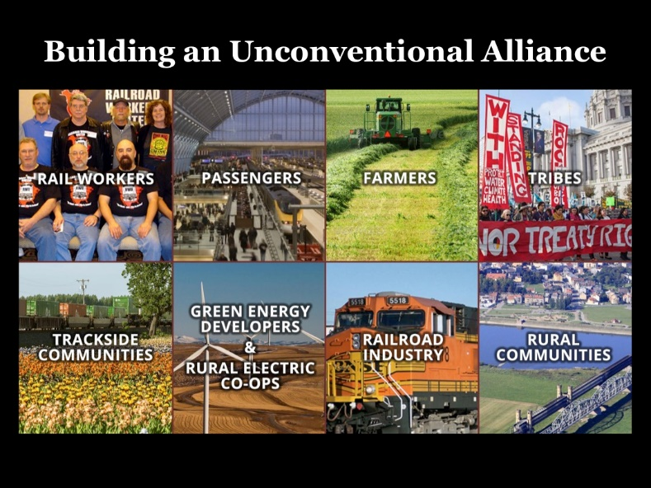
For example, Bill wants to start exploring rural depopulation and the relation with infrastructure and immigration – and regenerative agriculture with more human input than fossil fuel input – so we can get perishable crops to market in a timely way. The national grange (157-year-old organization) includes a history of progressive populist movements against abuses by railroads. The Farmers Alliance has many local groups.
This strategy of attracting many diverse kinds of allies creates a win-win-win for many kinds of people.
Next we showed a map Bill had provided showing the locations of tribes and rail routes. (For this discussion we can ignore the color-coding that identifies different railroad companies.) This map illustrates the great potential Solutionary Rail could offer for tribes throughout our nation.
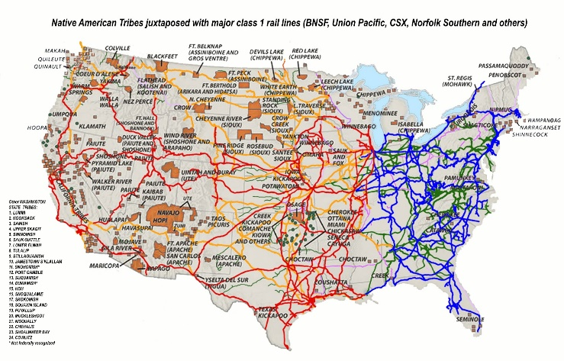

New allies include the Moving Forward Network and the Center for Community Action and Environmental Justice:

Glen said people who live or work in the port areas where huge amounts of pollution come from trucks, railroads know first-hand about those problems. He said the most recent organizing video conference he had participated in included some people who live near port areas or warehouse hubs. He said the most recent video conference included a leader of the “Moving Forward Network” and a leader from the “Center for Community Action and Environmental Justice.” He asked Bill to tell us about each of these grassroots organizations.
Bill said the Moving Forward Network is a community-based organization that works to protect its local community “from the negative impacts of our goods-moving system, our freight system, and most of that has to do with diesel.” Diesel’s pollution includes large particles and small particles that hurt our health in several ways, including heart disease. Diesel fumes are concentrated in certain local communities where poor people and people of color live.
Bill expressed appreciation for a leader in the Moving Forward Network, Angelo Logan, who has been a friend and an ally and advisor in this work. Angelo has been recognized as an expert leader in environmental justice work. This organization deals with the diesel emissions and health and justice impacts of ports and rail yards, etc. People who live or work in the port areas where huge amounts of pollution come from trucks, railroads, and so forth must be empowered to take the lead in devising solutions. The Moving Forward Network, www.movingforwardnetwork.com, helps people do that. Their website describes their work in this way:
“The Moving Forward Network is a national network of over 50 member organizations that centers grassroots, frontline-community knowledge, expertise, and engagement from communities across the US that bear the negative impacts of the global freight transportation system. MFN builds partnerships between these community leaders, academia, labor, big green organizations and others to protect communities from the impacts of freight. Its diverse membership facilitates an integrated and geographically dispersed advocacy strategy that incorporates organizing, communications, research, legal and technical assistance, leadership development, and movement building. This strategy respects multiple forms of expertise and builds collective power.”
Bill also said he appreciates the Center for Community Action and Environmental Justice, www.ccaej.org, which also belongs to the Moving Forward Network. CCAEJ brings together California’s diverse people and communities to protect social and environmental justice.
CCAEJ’s staff includes Andrea Vidaurre, their Policy Analyst, who participated in one of Solutionary Rail’s recent video conference calls. She and CCAEJ have been doing front-line work in areas dominated by warehouses and diesel fumes, especially in the Riverside, California, area, where warehouses have been expanding a lot. Bill said CCAEJ recently held a big protest along with Amazon’s warehouse workers and tech workers and local community members.
Bill said Jeff Bezos bragged about buying electric delivery vans, but really we need workers to be treated well in Amazon’s warehouses and other operations. Bill said we need Bezos, Buffett, and other business titans to put their heads together and figure out how to really solve the problems. He also said grassroots people’s movements need to figure out what we are demanding of those business titans.

Making progress! More insights and next steps in organizing for solutions:

Glen said he likes to “connect the dots” across issues. Solutionary Rail does that very well! It shows connections between issues, and it brings constituencies and organizations together. He said this is a good example of Bill’s strategic “big picture” approach to organizing – his “Grand Strategy” approach that brings unexpected allies together. Glen thanked Bill for organizing that is “interdisciplinary, not myopic,” where issues are separated in different silos.
Bill said this is a real challenge because all of our institutions separate issues into different silos. Academic institutions have different departments for economics, history, each kind of science, and so forth. Each legislative body has different committees for different issues (transportation, commerce, environment, local governments, etc.). It is very hard to get them to talk with each other or create interdisciplinary solutions.
Glen said we need to change overarching systems, so the transportation committee needs to work creatively with the banking committee and the social justice committee, and so forth. Bill said engineering departments have their own different specialties and silos. In reality, everything is interconnected – energy, public health, etc. – “but fragmentation is artificial.”
We did not have time to make these additional points that we could have said:
Instead of bogging down in the problems, let’s imagine what winning would look like. What future do we really want to create and implement?
Railroads need to have confidence that they will have customers into the future. Amazon, the U.S. Postal Service, and other major shippers would benefit from Solutionary Rail. Amazon does many things that are very bad, but they could be part of the useful solution for enabling railroads to change their business model toward Solutionary Rail. Let’s help different constituencies (railroad workers, warehouse workers, truck drivers, environmentalists, etc.) create opportunities to link arms and work for Solutionary Rail.
We need to do this organizing and movement-building continuously, but we can also use election campaign seasons to inform and mobilize people to push political candidates toward Solutionary Rail.

Solutionary Rail and the Green New Deal could be mutually supportive!

Glen said he is very enthusiastic about the Green New Deal because it brings issues together and brings constituencies together for a WIN-WIN-WIN for the climate, for workers, for local communities, and more. The Green New Deal proposes bold new efforts to protect the climate – and bold new efforts to create jobs – and bold new efforts to rebuild our infrastructure – and bold new efforts to help ordinary people and local communities.
He said Solutionary Rail seems to be very similar and compatible with the Green New Deal, so he urges people to include Solutionary Rail as part of the Green New Deal’s agenda.
Bill agreed. He mentioned the wise saying, “If you don’t know where you’re going, any bus will get you there.” He said we have to start with knowing where we want to go, and we have to lead with vision. “The Green New Deal is a framework that we can work with to help describe where we want to go.”
He said in December 2018 some Congress members wanted a committee to work specifically on the Green New Deal. Although that was not created, the House did create a “Select Committee on the Climate Crisis.” This committee exists now but will expire in approximately March 2020, when it will make recommendations to various House committees for actions those committees should consider for dealing with the climate crisis. Bill said that although this is not quite what the Green New Deal supporters were asking, it does have an interdisciplinary breadth of vision that will collect ideas for a number of solutions and deliver them to the various committees.
Bill said that immediately before our current TV interview he was invited to participate in a video conference call with the Select Committee’s staff to explain Solutionary Rail as something for that committee to support.

Sources of information:

Glen held up the Solutionary Rail book and showed it to the TV cameras. He said he bought the book two years ago and very much enjoyed reading it. He encouraged people to buy it for $19.95 through www.solutionaryrail.org and read it to learn much more than we had time to say during this hour’s interview.
Glen urged people to tell their friends about this new TV interview AND our December 2017 TV interview. Solutionary Rail’s website includes a link to watch both. At www.solutionaryrail.org, see the home page’s “In the Press” tab and click on that to see links for watching both of these interviews. The direct link to the December 2017 interview is www.solutionaryrail.org/tctv2017
People an also watch it through Glen’s blog – www.parallaxperspectives.org/tv-solutionary-rail – where they can also read a thorough summary of what we said during our 2017 interview. It is in the “Energy” part of Glen’s blog.
The new (November 2019) interview is posted to the blog’s “Energy” part and the “TV Programs” part. That posting includes a link for watching the video and a link for reading the thorough summary you are reading now.
I urge people to watch and share the short video we saw at the start of this interview. It’s less than 4 minutes and it is featured prominently on Solutionary Rail’s website at www.solutionaryrail.org/video
Glen said he very much likes the thoughtful, informative fact sheets (“RailBites”) that people can read or download from www.solutionaryrail.org/railbites
Please share these resources with your friends!

Glen’s closing encouragement:

Glen said he hopes this TV interview inspires people to learn more about Solutionary Rail and to help build the movement to accomplish it. People can sign up through www.solutionaryrail.org to be kept informed – and to volunteer – and also to donate financial support. He said the movement needs a variety of people, including ordinary folks without much technical expertise. Different kinds of people might be able to help in different kinds of ways; even just informing themselves is significant help.
Glen thanked our guest, Bill Moyer, and he thanked all of the people who have been watching.
Glen said his TV programs often address serious problems and end by recommending solutions. This past hour spent only a little time on the problems, and we have devoted almost the full hour to promoting a very positive and exciting solution to a number of problems.
Solutionary Rail would be good for our environment, good for our climate, good for local communities, good for workers, good for passengers, and good in other ways.
I enthusiastically support Solutionary Rail. Please visit its website, www.solutionaryrail.org to learn more about it and find out how you can help to accomplish it.
You can watch the very short video (less than 4 minutes) that we showed at the beginning of this interview – and the TV program Bill and I produced for December 2017. He’ll post this November 2019 interview there too. Simply visit www.solutionaryrail.org/video to watch the very short video we showed at the beginning of this hour, and click their website’s “IN THE PRESS” tab to watch both of our one-hour TV interviews.
I encourage you to buy the Solutionary Rail book for $19.95 through their website.
Please share these resources and links with your friends. You can help spread the word about this great progressive solution to several problems.
You can get information about a wide variety of issues related to peace, social justice and nonviolence through my blog, www.parallaxperspectives.org or by phoning me at (360) 491-9093

You can get information about a wide variety of issues related to peace, social justice and nonviolence through my blog, www.parallaxperspectives.org or by phoning me at
(360) 491-9093 or e-mailing me at glenanderson@integra.net
I end each TV program with this encouragement:
We're all one human family, and we all share one planet.
We can create a better world, but we all have to work at it.
The world needs whatever you can do to help!

